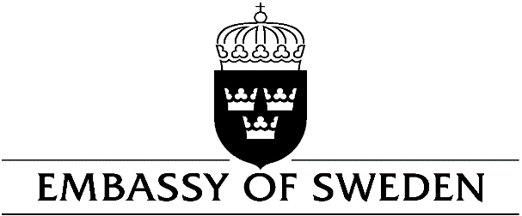

HANOI
FEES APPLICABLE FROM 1 MAY 2018
Application | VND | SEK
Work permit | 5 500 000 | 2 000
Extension of work permit within the same occupation or with the same employer | 2 750 000 | 1 000
Extension of work permit with another occupation or with another employer | 5 500 000 | 2 000
Special fees for certain occupations
Performer | 2 750 000 | 1 000
Au pair | 2 750 000 | 1 000
Athlete or coach | 2 750 000 | 1 000
Visiting researcher | 2 750 000 | 1 000
Self-employed | 5 500 000 | 2 000
Trainee (through international exchange programme or agreement) | 2 750 000 | 1 000
Application for family members of persons applying for or holding a work permit
Adult | 2 750 000 | 1 000
Child under 18 years of age | 1 370 000 | 500
Residence permit to live with someone in Sweden
Adult | 4 130 000 | 1 500
Child under 18 years of age | 2 060 000 | 750
Student residence permit
Adult | 2 750 000 | 1 000
Child under 18 years of age | 1 370 000 | 500
Residence permit to seek employment after having completed studies in Sweden
Adult | 2 750 000 | 1 000
Child under 18 years of age | 1 370 000 | 500
Residence permit for family members of persons applying for or holding a student residence permit
Adult | 2 750 000 | 1 000
Child under 18 years of age | 1 370 000 | 500
Others
Residence card for nationals and relatives of a national in a country included in the European Economic Area (EEA) | No fee | No fee
Residence/work permit for nationals of Switzerland and their family members and Japan | No fee | No fee
Residence/work permit for students who have received scholarships for studies in Sweden from Sida, another Swedish organization or international organization | No fee | No fee
Residence/work permit for students at the World Maritime University in Malmö | No fee | No fee
Visa and visitor's permit
Adult | 1 590 000 | 60 EUROS
Child aged 6-12 | 930 000 | 35 EUROS
Child aged 0-5 | No fee | No fee
Exceptions from visa fees
Students at the World Maritime University in Malmö | No fee | No fee
Students who have received scholarship for studies in Sweden from Sida, another Swedish organisation or international organisation. Scholarship letter must be attached to the application. | No fee | No fee
Holders of Vietnamese Diplomatic passport | No fee | No fee
Visitor's permits for a period longer than 90 days
Adult | 2 750 000 | 1 000
Child | 1 370 000 | 500
Passports
Swedish national passport | 3 850 000 | 1 400
Swedish provisional passport | 4 400 000 | 1 600
Provisional travel document the European Union | 1 370 000 | 500
Alien passport | 2 060 000 | 750
Provisional alien's passport | 1 370 000 | 500
Travel document | 960 000 | 350
Handling out of passport issued by another authority | 410 000 | 150
National ID-card | 3 850 000 | 1 400
Provisional alien's passport for aliens that are transferred to Sweden according to a special decision by the government (Quota refugees) | No fee | No fee
Swedish citizenship
Application for citizenship | 4 130 000 | 1 500
Adopted child under 15 years of age | 480 000 | 175
Notification
Notification of child under 18 years of age | 480 000 | 175
Notification for person between 18 and 20 years of age | 480 000 | 175
Regaining Swedish citizenship | 480 000 | 175
Retaining Swedish citizenship | No fee | No fee
Release from citizenship | No fee | No fee
Other matters
Certification of life and citizenship | No fee | No fee
Delivery of driving licenses | 1 100 000 | 400
Delivery of driving licenses (if the license is initiated and the fee paid in Sweden) | 410 000 | 150
Marriage | 1 650 000 | 600
Translation of Swedish driving license (only) | 550 000 | 200
Certification | 330 000 | 120

