2019-10-18
Budapest

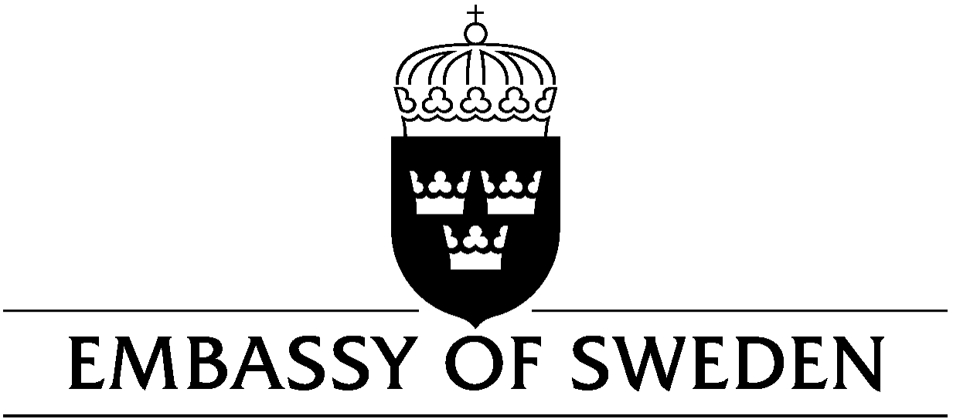
The Embassy of Sweden in Budapest is recruiting an assistant to the Defence Attaché (temporary position)

The Embassy of Sweden in Budapest is currently looking for a person to replace the assistant to the Defence Attaché for a year due to parental leave. The temporary position is for 12 months with a possible renewal of a few months period. The position is a part-time employment, 20 working hours per week. The work schedule is designed in agreement with the employee.

Tasks

The tasks primarily incorporate the following areas:

- Supporting the Defence Attaché in a variety of tasks, for instance: invitations, visitor facilitation, representation, administration, financial reporting, scheduling, coordinating and planning activities, travel booking, contacts with different authorities, document registration and archiving
- Scanning and compiling defence-related information from Hungarian media
- Handling issues regarding requests for different kinds of military visits between Hungary and Sweden
- Translating relevant defence-related information
- On request, functioning as an interpreter
- Helping out with major events at the Embassy

The tasks can be very diverse (the abovementioned tasks are only some examples) and include extensive contacts with a broad range of Hungarian and Swedish authorities and organizations. Therefore, you should be able to establish and maintain a large network of personal contacts.

The work intensity at the Embassy fluctuates over time, and thus you must be flexible and service-minded to be able to effectively manage temporary peaks in workload. You must also be ready to – now and then - work outside normal office hours, and sometimes this demand may emerge with quite short notice (for overtime you will be entitled to compensatory leave).

Basic requirements for the position

Excellent Hungarian and English language skills, both oral and in writing.

Relevant academic education on at least high-school level, paired with good general knowledge of society.

Personal qualities are important, such as social skills, communication skills and a genuine team-player attitude.

We believe you are a pleasant, joyful, efficient, attentive and precise person that shows proactive initiative with sound judgement. We also believe you are a responsible person that confirms given tasks and delivers results on time.

Swedish citizenship and skills in the Swedish language, as well as competence from the area of Defence, will be considered as a merit in the selection process, these are not requirements though.

The employment

The employment is half-time, and formally (administratively) organized at the Embassy of Sweden in Budapest, Hungary. However, most of the work is done for the Defence Attaché who is organized under the Swedish Armed Forces.

If you are a Swedish citizen, we may require that you must pass a security screening process in Sweden before employment.

The Embassy of Sweden is applying local (Hungarian) employment legislation. Salary is competitive in Hungarian terms.

The workplace

The Embassy of Sweden offers an attractive workplace that strives for non-discrimination and provision of equal opportunities for all employees. All applicants that fulfil the basic requirements for the position will be considered for employment, without any regard to ethnicity, religious belief, gender, gender identity, sexual orientation, disability or age.

Application and admittance

Send your CV and a personal letter in which you describe yourself and why you are our right choice for this job. Your application documents should be in English, or in Swedish. Submit names and contact information to at least two personal references.

The application can be sent to the email address:

ambassaden.budapest@gov.se

or the postal address:

Embassy of Sweden
1027 Budapest
Kapás utca 6-12
HUNGARY

Please, write: ”Job Application – Assistant” in the headline of the email (or on the envelope in the snail-mail case).

Deadline for application: 30th October, 2019.

Admittance to the job will take place as soon as possible.

If you have any questions, please contact the embassy on the abovementioned email address.

