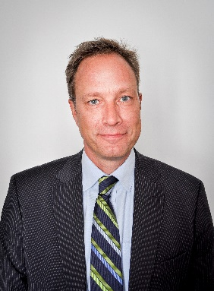
C.V.

Fredrik Jörgensen
1962-09-24

Married to Marianne Jörgensen, 3 children

Work experience:

Embassy of Sweden in Prague, Ambassador 2020 -

Embassy of Sweden in Copenhagen, Ambassador 2015 - 2020

Ministry of Foreign Affairs, 2011 – 2015

Director-General for Administration

Ministry of Foreign Affairs, Deputy Director General 2005 - 2010

and Head of the Department for Consular and Civil Law

Embassy of Sweden in Rome, Minister, 2001 - 2005

Deputy Head of Mission

Ministry of Foreign Affairs, Deputy Director General 1998 - 2001

and Head of Section, Department for the European Union

The Swedish Parliament, Secretary to the 1996 - 1998
Parliamentary Committee of Foreign Affairs

Ministry of Foreign Affairs, Desk Officer, 1995 - 1996

Department for European Security Policy

Embassy of Sweden in Pretoria, Second Secretary 1992 – 1995

Embassy of Sweden in Bonn, Second Secretary 1989 – 1992

Entered the Swedish Foreign Service 1988

Assistant Judge at the City Court in Stockholm 1987 - 1988

French language 20 p. University of Uppsala 1989

Ministry of Foreign Affairs Diplomatic Programme 1988-1989

Master’s Degree in Law 180 p. Stockholm University 1982-1987

Military leadership training, Lv3 Norrtälje 1981-1982

Gymnasium, 3 years, Lidingö 1978-1981

Languages: Swedish, German, English and Italian

