STRENGTHENING COMMUNITY POLICING IN ALBANIA
FORCIMI I POLICIMIT NË KOMUNITET NË SHQIPËRI

Implemented by:

BI-ANNUAL PROGRESS REPORT
(July 2022)

Project title | Strengthening Community Policing in Albania, 2nd phase, Program implementation 2017-2020
Project No. | UF2014/52825/TIRA
Country | Albania
Funding Agency | Sida
Implemented by | FCG Swedish Development AB
Address | Dalagatan 7, 111 23 Stockholm, Sweden  Web: www.fcgsweden.se  ++46 8 406 76 20
Contact person | Mr. Pontus Förberg, Project Director FCG  Cell: +46 70 214 21 81, Office: +46 8 406 76 20 pontus.forberg@fcgsweden.se
Date of report | July 2022
Reporting period | 1st January 2022 – 30 June 2022
Chair of Project Steering Committee | General Director of Albanian State Police
FCG Project Team Members | Mr. Ansi Shundi, Team Leader  Mr. Ulrich Dugas, International Police Advisor  Mr. Enri Hide, Long Term Advisor  Mrs. Eldisa Zhebo, Long Term Advisor  Mrs. Miranda Fishka, GS Manager, DV Expert  Mr. Arian Braha, Program Coordinator  Mrs. Jolanda Gugaj, Program Officer
SCPA Contacts | Address: Blv “Zhan D’Arc”, Nd. 61, H.5, K. 5, Ap. 6, Tirana, Albania. Tel + 355 44 511 340  Mail: info@cp-project.al  Web: www.cp-project.al

Table of Contents

ACRONYMS AND ABBREVIATION 4
1. Executive summary 5
2. Progress achieved based on Program Pillars 5
2.1 Pillar I – Local Police Directorate Community Policing Support 7
2.2 Pillar II – Strategic Management Support 16
2.3 Pillar III – Domestic Violence Support 20
2.4 Horizontal Activity - Grants Scheme 23
3. Budget expenses 27
Annex I – Updated Logical Framework 28
Annex 2 Risk Matrix 38
Annex 3 - Participants/beneficiaries in SCPA activities 42

ACRONYMS AND ABBREVIATION
ASP - Albanian State Police
CCR Command and Control Room
CP - Community Policing
CPO - Community Policing Officer
CSS - Community Safety and Security
CID Crime Investigation Detective
DV - Domestic Violence
DVS - Domestic Violence Support
GD - General Director [of the ASP]
GoA - Government of Albania
GS - Grants Scheme
HQ - Headquarters
IPA - International Police Advisor
SC - Steering Committee
JWG - Joint Working Group
LCPS Local Council on Public Safety
LPD - Local Police Directorate
LSMS - Local Safety Measurement System
M&E - Monitoring and Evaluation
MoI - Ministry of Interior
MoC - Memorandum of Cooperation
NGO - Non-Governmental Organization
PPO Patrol Police Officers
PMT - Project Management Team
PGCM - Project Group for Change Management
SCPA - Strengthening Community Policing in Albania
Sida - Swedish International Development Cooperation Agency
SMS - Strategic Management Support
SOP Standard Operating Procedure
TLPD - Target Local Police Directorate
ToT - Training of Trainers

Executive summary

During the semester January – June 2022 the activities of the SCPA focused on the implementation of the Police Zone concept entailing, inter alia, the cooperation and interaction of different police units within the zone, especially the community policing officers and the general patrol officers. The expected results from this intervention are: 1. A better alignment of CPOs with their core tasks and focus on enhancing the relationship with the community, serving the community policing paradigm; 2. Increasing the role of the General Patrol Officers within the police zone in managing and reporting cases; 3. Enhancing the cooperation with the public.
Therefore, the replication of changes was extended to the LPDs of Tirana, Durres, Fier, Vlora, Korca, Gjirokastra and Berat. Thus, the project concluded the intervention in all LPDs. Monitoring activities in these LPDs were carried out during the reporting period and LPD individual reports were forwarded to the HQ. In addition, the SCPA experts have compiled a summary report concerning interventions in all LPDs. The intention is to assess the implementation practice, highlight the issues that went well and contributed to improvements in everyday practice, as well as spot the challenges faced in implementation of certain activities and recommend on how to overcome them.
The results of implementing the changes, although not uniform in all LPDs and commissariats are encouraging. The LPDs are supportive of the changes and see practical benefits on the new way of performing their daily activities. PMT has drafted an assessment questionnaire to be piloted in Elbasan. The aim is to check on the sustainability of the changes as well as receive insights from the beneficiary point of view.
The implementation of the changes went hand in hand with several training activities organized in the respective LPDs. The training targeted the PPOs as key structure for the successful implementation of the changes. All shift leaders of the PPOs and staff from the Command-and-Control Sector were trained for the changes. In addition, a training for all the PPO staff was delivered in Elbasan LPD. Given the positive feedback, this training was turned into a ToT and delivered to a selected group of trainers coming from all LPDs. The objective is to deliver the training for all PPO staff in the country, using the trained trainers.
Following the supply of equipment for the Traffic Police, the program is working to develop a software that would enable the operation of speed radars in real time and without manual interference of patrol police officers. The software will not only allow a better information processing and real time communication with the e-gjoba system and e-Albania, but it will also reduce to a minimum the corruptive practices of police officers who tend to engage with the citizens when the latter are caught in violation of traffic rules by the Police patrols. The radars will automatically transmit the information to the system and the fines will be processed automatically.
A second feature of the system will be the “Supervisor module”. On one hand, this module will allow the Traffic Police managers to monitor in real time the deployment of the patrol team on the ground, their operation, the activities they perform with the electronic equipment (radars, tablets, alcohol and drug testers, etc.) and take timely management decisions and additionally produce reliable statistics on traffic safety in the country.
On February 18, 2022, the Memorandum of Cooperation between the Ministry of Interior and the Ministry of Education, Sports and Youth on the implementation of the program “Youth Safety” was signed. The aim of the MoC is to extend the awareness raising campaigns currently implemented in primary schools by the CPOs to the high school, whereby the Security Officers (SO), employed in each high school will be committed to carry out such activities. The program trained the security officers, who will start the presentation activities in September.
After being suspended due to the Covid 19 pandemic, the Local Safety Measurement System in Elbasan commissariat could take place in April – May and followed the measurements done in 2018 and 2019. The results were presented in a special meeting of the Elbasan Local Council of Public Safety in June, ensuring that the internal information and data of the public institutions was aligned with the perception of the public on safety issues.
Special attention was paid to the reinforcement of the Local Councils of Public Safety in nine municipalities. Using the Grant Scheme, the project supported the establishment and/or the functioning of these councils by training its members, supporting the draft of regulations or action plans, as well as feeding the council meetings with information and discussion topics.
Activities related to reinforcing the Referral Mechanisms for DV cases were focused on 7 municipalities during this period. Capacity building activities and mentoring for the stakeholders was provided by the NGO grantees contracted by the project.
During the reporting period, in coordination with the ASP HQ the program delivered a training for 4 LPDs, namely Fier, Lezhe, Korce and Diber. The focus areas of the training were the implementation of the latest amendments to the DV law regarding the immediate protection order and the risk assessment for domestic violence cases. A total of 175 police officer participated in these trainings. In parallel, the project is assessing the impact of the training in Gjirokastra. The monitoring report will be delivered to ASP HQ shortly.

At the beginning of the year the last round of the Grant Scheme became operational in 4 regions – Vlora, Fier, Durres and Shkoder. 7 new projects started implementation in these regions, coming to a total of 73 projects financed by the project in the framework of the Grant Scheme. The grants of Round 5 completed their activities, while grants of Round 6 will be operational until October. The Grant Scheme proved to be an important tool for community and stakeholder mobilization and achieved the intended objective from the Project Document.

The PMT would like to extend a sincere gratitude to all the collaborators from the ASP and other institutions, who participated in project activities and contributed to the joint efforts for increased safety in the communities.

Progress achieved based on Program Pillars

Pillar I – Local Police Directorate Community Policing Support

Pillar 1 constitutes the core of the project and many of the activities implemented during the reporting period are part of this. Following the practice of Northern Region LPDs, the SCPA program supported intensively the change management process in LPD Tirana, Durres, Fier, Berat, Vlora, Gjirokaster and Korca. The changes aimed to unburden the CPOs from several tasks which are not in harmony with the function of a Community Policing Officer. The primary responsibility of a CPO is to increase police accountability to local communities, be close to citizens and serve as a connector between them and the police.
In all the LPDs of ASP the following main changes are now implemented:
- Focusing the CPOs on their main tasks and on what constitutes the core of their function – relationship with the community and other stakeholders and implementation of community policing;
- A two-shift system for CPOs with the aim to not keep the CPOs available for all incidents and problems round the clock, but to use their time effectively;
- The responsibility for managing urgent police actions and emergency cases shifted to the Patrol Police;
- The responsibility for delivery of notifications and fines shifted to the Patrol Police;
- Reduced standby nightshifts of CPOs in commissariat premises;
- Reduced CPO visits to Commissariats;
- Increased cooperation of police services in the police zone (Integrated Policing);
- A daily Quality Report of CPOs and related to this a weekly Analysis Report of the superior.

Activity 1.c. Support replication of changes in other LPDs
By the end of 2021 the changes for unburdening the CPOs and the change management process kicked off in the LPDs Tirana, Durres and Fier. These are the three main LPDs and the process was followed up with increased attention by the PMT and the Community Policing Sector of the ASP HQ. Tirana LPD is to a certain degree different from other LPDs in terms of size of staff, coverage area and population. Its commissariats are sometimes larger than some LPDs in small districts. LPD Tirana consists of 8 commissariats which face a diversity of daily work challenges. The challenges of “urban” commissariats are of exclusive metropolitan character and differ from “mixed commissariats” with urban and rural service areas. For instance, in the urban commissariats, it was unnecessary to shift the responsibility for emergency cases to the Patrol Police, as it was already in place and the practice was already established.
To complete the change process in this reporting period, further meetings were held in the commissariats of the above LPDs. Consistent and intensive consultations were needed for convincing the managerial staff to implement the changes in practice, e. g. home alert of CPOs instead of stand-by night shift in the commissariat.
At the end of March/beginning of April, the LPDs Tirana, Durres and Fier submitted their final reports to the ASP HQ. The SCPA experts supported the LPDs in drafting the reports. The final reports included the change implementation process, problems and recommendations for possible solutions. The PMT experts analyzed the reports and summarized the results. All LPDs pointed out that they shifted the responsibility for managing emergency cases to the Patrol Police. Most of the commissariats shared the delivery of notifications and traffic fines between PPOs and CPOs. Reliant on the specific circumstances of the commissariats, either a two-shift or an alternated service system (serving one day in the morning shift and the other day in afternoon shift with flexible hours) for CPOs was implemented. The reason for the latter was the intensive involvement of CPOs in territory control for search of cannabis in some commissariats. Except for two commissariats of LPD Tirana, all the others implemented home alert for their CPOs instead of bringing them in stand-by night shift in the commissariat premises. The LPD Heads of Tirana and Durres requested and instructed the commissariats to reduce the service of CPOs for providing safety and maintain law and order in mass events like cultural, religious and sport activities.
At the end of March, the change process kicked off in the LPDs Vlora, Berat, Gjirokaster and Korca. The procedure was comparable with the previous practice in LPDs of northern and central Albania. A kick-off meeting was organized with LPD Heads and other managerial staff like deputy heads, heads of commissariat, heads of CP section, Public Order and HR etc. The main topic was to discuss the change management process and the aim to disburden CPOs from untypical tasks and enable them to work as a “Contact Officer” or rather as connector between the citizens and the police. It was clarified that some changes affect especially the Patrol Police and the Command-and-Control Sector. Thereafter, the intended changes and the consequences were debated in a step-by-step mode. An important topic was the information flow due to weaknesses demonstrated in this process in the previous interventions in other LPDs.
The LPD Heads received an internal instruction model describing the changes and the establishment of a working group (WG) on the LPD Level. This WG would be responsible for support and supervision of the entire change process. In addition, the project experts handed over models for implementation/activity plans with a timetable, a daily quality report for CPOs and a related weekly analysis report of the superior as well as a structure for a final report.
Thereafter the project experts made frequent field visits to the commissariats of the LPDs. In the meantime, the above LPDs submitted their final reports, which were drafted with support from the project.
Based on the final reports of all 12 LPDs and the experiences made during the implementation process the project developed a final analysis report (see Annex xxx). Core elements of the reports are the changes made and results achieved, the encountered problems and risks and recommendations how to solve them.
As a conclusion, the measures were in almost all cases possible to implement and when implemented they produced positive effects especially regarding work distribution among the staff and motivation of the CPOs, who were unburdened by secondary tasks diverting attention from their core duties. Some of the proposed changes require high level decision in organizing the business processes. The PMT noted that especially the territory control task absorbs enormous amounts of working hours. In certain commissariats, it turns out to be the main activity during some months, leaving other duties aside.
Another issue relates to the shortage staff to ensure a better police service coverage in rural areas. In the Cross Cutting Strategy for Safety in the Community, an objective was to add support staff to the CPO teams in rural areas to create a kind of patrol police service there. Even though this was planned to be implemented in 2021, the ASP has not yet received any green light to add more staff.
The project experts paid a total of 47 field visits to several LPDs and commissariats. 38 of these visits were dedicated to LPDs to monitor the progress and sustainability of implemented changes in each commissariat. Although all LPDs reported successful change implementation (with some deviations due to the specific situation of certain commissariats) the project experts observed some commissariats’ tendency to fall back into old routines e. g. the standby nightshift of CPOs. The impression is that some managers feel safe to have experienced CPOs standing by in the commissariat premises and they persist following the old working routine. Hence, it is worth mentioning that the change process is not considered completed with delivery of the final reports. To prevent the risk of falling back into the old mentality, further commissariat visits for longer periods are necessary to supervise and consolidate the changes.
The PMT developed a questionnaire to evaluate the internal and external impact of the changes. The internal impact is related to the business structure (internal work structure) and the individual reaction of officers concerned. The external impact will focus on the effects of the policing changes, e. g. prevention measures, information gathering, dealing with conflicts and emergency cases, successful fight against crime and crime investigations. The questionnaire will be piloted in the TLPD Elbasan, where the new working models have been practiced for a while, allowing for proper impact assessment. Thereafter the questionnaire and the results achieved will be analyzed and the impact assessment carried out in the remaining LPDs.

Activity 1.c.3 Capacity building activities
Parallel to supervising the Change Management Process in LPDs, the PMT experts developed capacity building programs to enable the affected staff to adapt to the required changes. In broad terms, the capacity building activities encompassed a set of actions that enabled the LPDs to perform better in and accordance with the previously tested practices in TLPDs.
The PMT and ASP staff from the Community Policing Sector took joint capacity building initiatives in the LPDs that entered the change management process during this reporting period. The interventions can be grouped in the following main categories:
- Institutional: development of draft orders and internal regulations for the LPDs;
- Individual: training sessions, seminars, workshops for in-depth discussion of specific topics, consultations with the managerial staff, open dialogue with PPOs, CPOs and CCR staff, joint monitoring with ASP HQ/LPD experts.

At the institutional level the PMT experts focused on supporting the LPDs/commissariats to increase the organizational performance and functioning capabilities, as well as the ability to adapt to the changes.
Three main training programs were organized during the reporting period:
- Training for the Public Order Experts/ Patrol Police Shift Leaders and Command and Control Room’s staff of the LPDs Tirana, Durres, Fier, Berat, Vlora, Gjirokaster and Korca
Within the Change Management process in these LPDs, the project experts delivered a two-day workshop. The trainings involved 206 police officers and the aim was to overcome the lack of information sharing in these LPDs by informing key staff on the changes as well as their future roles.
One focal point of the workshop was the cooperation between Patrol Police and CCR’s staff in view of the changes, another important subject was the support of PPOs in managing emergency cases. A topic that engaged the trainees during intensive group work was the development of a first measure checklist for PPOs dealing with domestic violent cases. Due to the intensive exchange of experiences, the practical relevance and the method used in all workshops were assessed as excellent.
- Training for the PPOs to adapt with the changes
After the trainings for the shift leaders, the PMT observed the need for extending the training to include all the police officers from the Patrol Police Officers (General Patrol Police). This should be a core module on -the -job training that all police officers should take at the beginning of their career. Taking into account that a successful implementation begins at the individual level the project experts developed a module for PPOs training at the end of the previous semester. This module comprised a training plan and a Power Point Presentation.
A pilot training was carried out, where 58 PPOs in LPD Elbasan (commissariats of Elbasan, Peqin, Cerrik, Gramsh and Librazhd) were trained in 3 groups by the project experts. A key aspect of the training was how the introduction of Community Policing impacts (above Activity 1.c) the duties and daily work of PPOs.
The training included some important practical exercises, like first measures of PPOs to handle a domestic violent case and how to develop a respective Case Management Report (CMR). All participants and trainees expressed their appreciation about the method and training material. They demonstrated high engagement in discussions, group work and general planning exercises.
- Training of trainers for the PPO training
Due to restricted project resources, the PMT decided to set up an internal training group for the remaining PPOs in the 11 remaining LPDs. In cooperation with the Directorate of Public Order at the ASP HQ, 36 experienced police officers (mainly from public order section at LPDs) were selected. Two 2-day training sessions were organized subsequently by the project experts at the Academy of Security involving 36 potential Trainer of Trainers (ToTs). Afterwards the LPD trainers received all the training materials for future use.
The training was divided in three parts. In the first part, the methods of training were presented and advantages and disadvantages were discussed. The next part focused on the changes and their impact on the daily service of PPOs. The ToT session was completed by a series of practical exercises comprising first measures carried out by PPOs on the crime site. The ToT workshop attendees left a good impression for delivering the PPO training independently. The issue on how to accomplish the trainings in the LPDs when the trainers aren’t discharged from their ordinary tasks was intensively discussed. Intervention from the ASP HQ is requested in this particular case
The project expects that the ASP will organize training for all PPOs in the future and institute this training as a core one for this group of police officers.

Activity 1.e.3 Support the Traffic Police with equipment and technology
In the previous reporting period, the program supported the ASP by procuring equipment for the Traffic Police (speed radars and tablets and printers for the patrols). The Traffic Police is now equipped with different speed radars, most of them automatic. The use of automatic radars unveiled a management issue: the radars produce too many fines to be processed manually. Also, the HQ has limited capacities to effectively monitor the staff on the ground and produce reports based on reliable statistics.
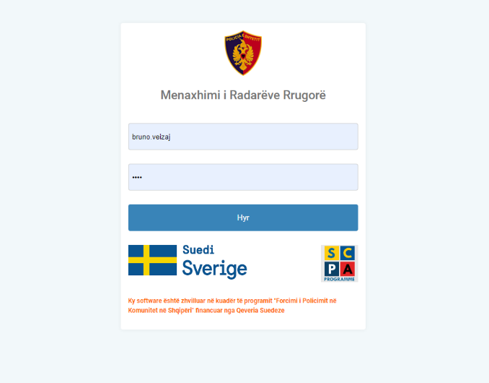
Based on these findings, the SCPA program is working to develop a software that would enable the operation of radars in real time and without manual interference of patrol police officers. The software will not only allow a better information processing and real time communication with the e-gjoba system and e-Albania, but it will also reduce to a minimum the corruptive practices of police officers who tend to engage with the citizens when the latter are caught in violation of traffic rules by the Police patrols. The radars will automatically transmit the information to the system and the fines will be processed automatically.
A second feature of the system will be the “Supervisor module”. On the one hand, this module will allow the Traffic Police managers to monitor the deployment of the patrol team on the ground, their operation, the activities they perform with the electronic equipment (radars, tablets, alcohol and drug tester, etc.) in real time and take timely management decisions and on the other the module will produce reliable statistics related to traffic safety in the country.
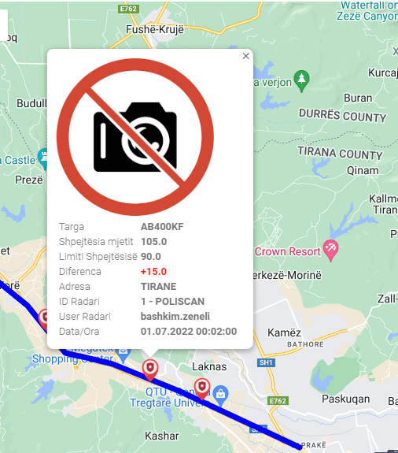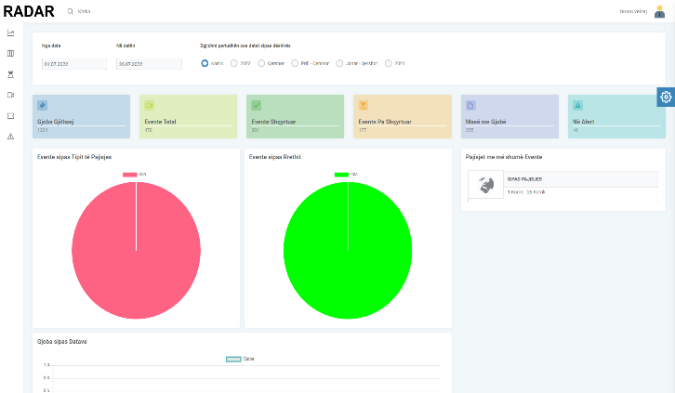
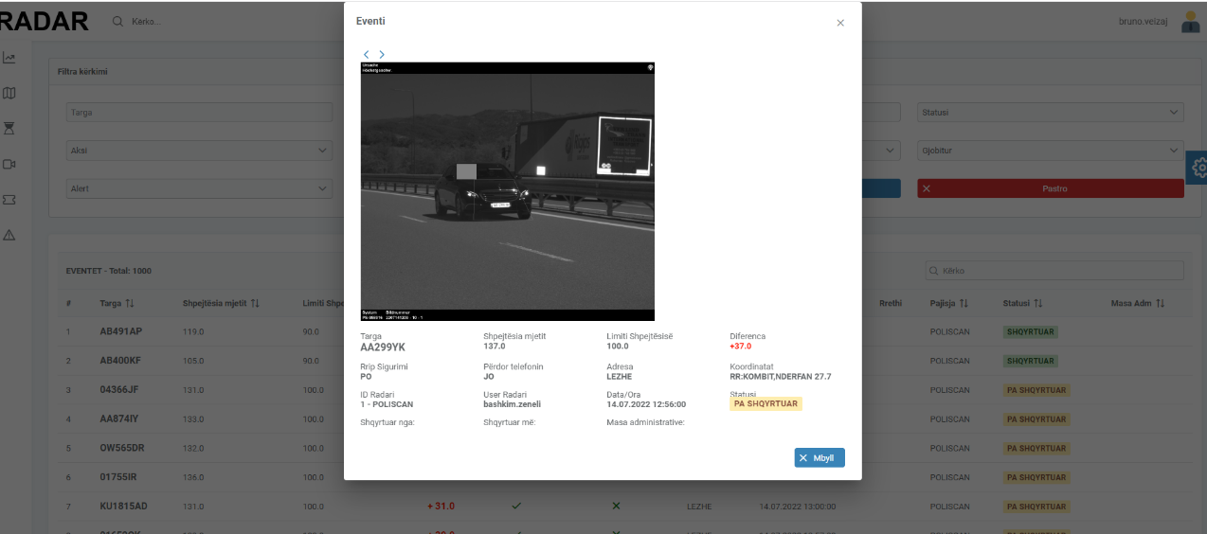
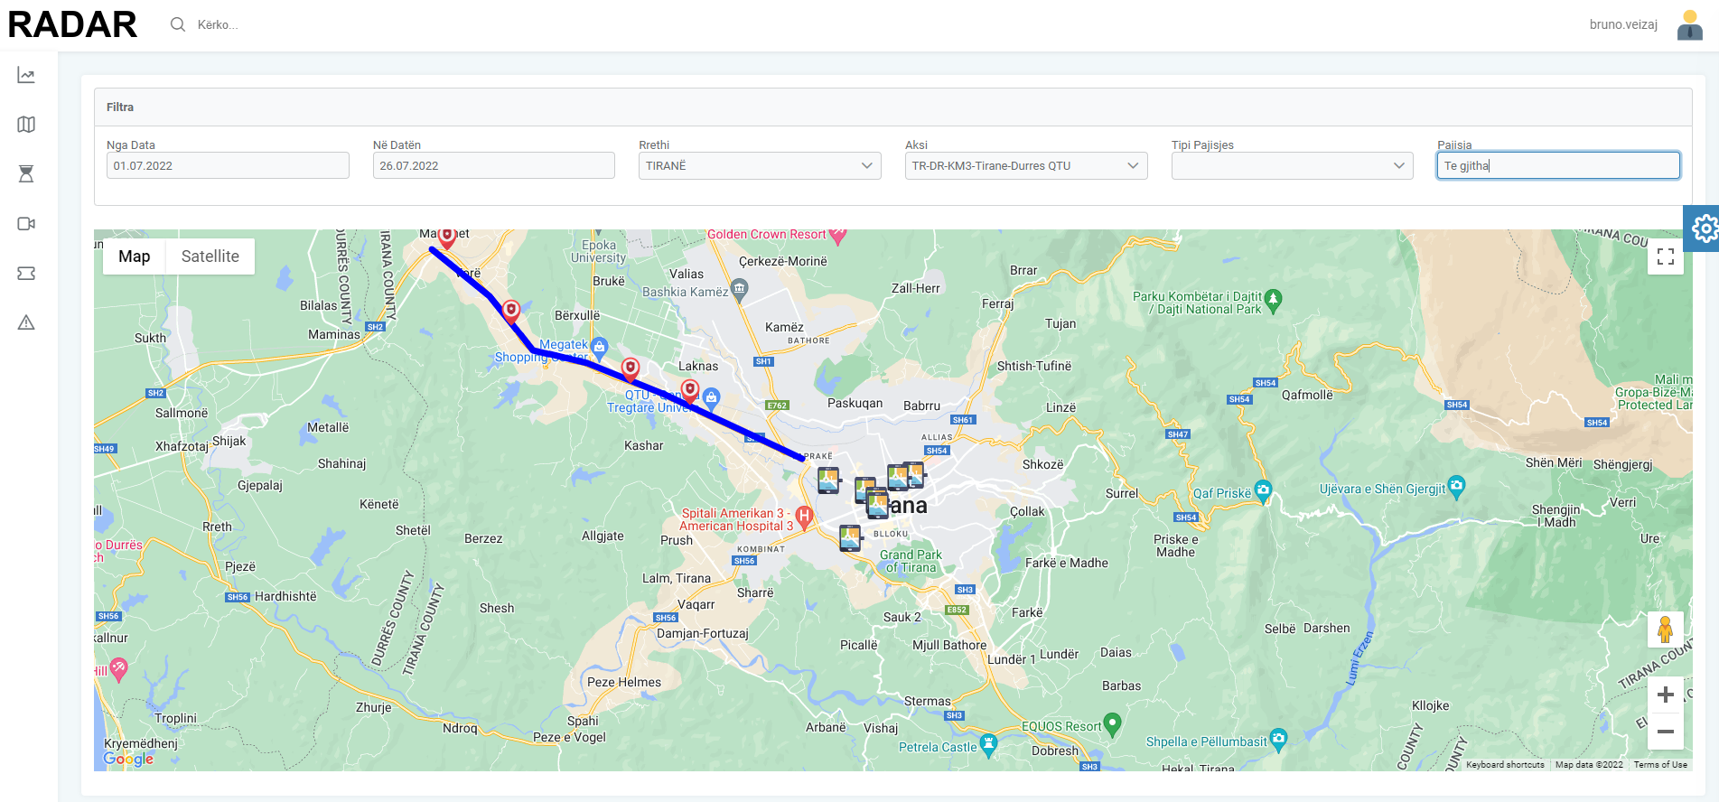
The program set up a technical working group with representatives from the Traffic Police Directorate, experts from the Technology and Information Sector in the ASP HQ, as well as programming experts in the field of IT, who have worked intensively for developing the software. After several months of work and continuous consultation with the beneficiary, the concrete presentation of the software took place in the ASP HQ in May 2022. The experts demonstrated the full functionalities of the software and different operations that could be performed by the staff. Following comments and suggestions from the Traffic Police staff, the experts did the adjustments and finetuning in the system. In June 2022, a first training session for the operators who will work with the system and process the data was organized. The system is currently in a test phase and the experts are closely following the procedure.
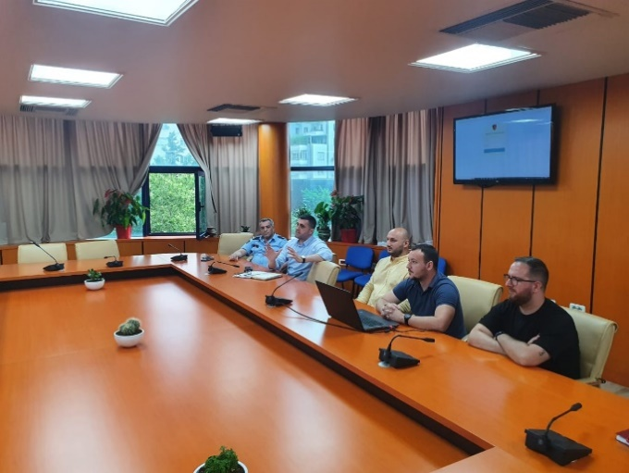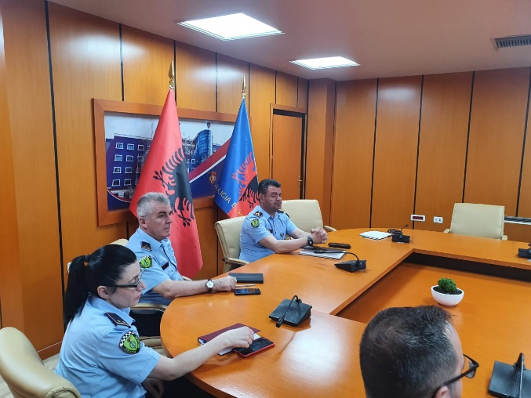

Activity 1.f Support implementation of national awareness campaign
Also, during this reporting period, the SCPA program pursued a systematic intervention for improving the quality of national awareness campaigns to enable ASP getting closer to the public and increase cooperation.
On February 18, 2022, the Memorandum of Cooperation between the Ministry of Interior and the Ministry of Education, Sports and Youth on the implementation of the program “Youth Safety” was signed. This agreement aims at ensuring cooperation between the ministries, supported by the State Police and the Local Education Offices. The memorandum provides needed tools for enhancing the safety parameters in the community. The aim is to extend the awareness raising campaigns currently implemented in primary schools by the CPOs into the high schools and to use the Security Officers (SO), employed in each high school, for this purpose. The program trained the security officers on these programs and from September the campaigns can be implemented also in high schools.
Once the MoC was approved, the SCPA in cooperation with the CP Sector at ASP HQ, informed all the CPOs serving as youth educators and made a copy of the MoC available. This MoC will mitigate some of the previous difficulties and lack of coordination with the local educational departments and school headmasters.
The PMT has contacted an official at the Ministry of Education and Sports who is responsible for coordinating the activities of high school security officers (150 SOs) and discussions are in progress on to how activate the SOs for the awareness campaigns. The project has already displayed its readiness to provide not only the experience but also awareness materials, work plans, reporting structure and formats. The Project intends to make the SOs active and start the awareness campaigns by the new academic year in September. The majority of the SOs are already trained by the project experts on the three awareness security modules and on communication skills. Recent pandemic situation hampered a regular start of the activities during the last academic year.
Within this reporting period the CPO youth educators conducted regular awareness lectures on topics such as abuse of drugs, alcohol, and tobacco, road safety, bullying, cyber bullying and personal safety in almost all LPDs. The program, in cooperation with the CP sections at LPD level and ASP HQ, monitored, advised and - when necessary - coached the activity.
The online forum of CPOs – Youth Educators and the forum for Security Officers in schools, continues to be an efficient tool to engage not only the assigned CPOs for education and work with youth but also the ASP HQ and the Academy of Security experts in exchanging experience and creating a network of CPOs and Security officers. By means of the online forum both ASP and the program were precisely informed of the various activities that were organized in the LPDs. By end of June 2022, more than 71 % out of 60 CPOs youth educators were present in the online forum. According to our daily monitoring of the forum, 157 awareness activities took place in various schools. This forum has also served to develop a peer-to-peer learning approach. It is worth mentioning that the CPOs working as Youth Educators in commissariats of Durres, Fier, Kukes, Saranda, Lezha, and Cerrik, have been very active. The PMT has observed a slight decrease of activity of the CPO youth educators in the commissariats of LPD Tirana, Elbasan, Vlora, Korca, Shkodra and almost no activity in the commissariats of Permet, Gjirokastra, Tepelena, Dibra, Bulqiza, Kurbin and Kruja.
In some cases, the heads of commissariats were reluctant to allow CPOs to continue with their assigned duties in schools, or they were tasked with other obligations in parallel. It is worth noting that the situation with LPD Tirana counterparts remain unclear. Although Tirana LPD covers a considerable number of schools and students, there have not yet assigned any CPOs as youth educators. SCPA has taken all the necessary steps to push the case forward and ASP HQ has informed that the issue will be settled in due time.

Pillar II – Strategic Management Support

The activities under this pillar are few in numbers compared to the other two pillars. They focus on the implementation of the objectives and activities included in the Public Safety Strategy 2021 – 2026 and its action plan.
In the strategy document, most of the interventions mentioned under Pillar I are part of the activities to be implemented by the ASP. Therefore, the project indirectly contributes to the ASP implementation of the activities foreseen in the strategy. The project has periodically reported to the ASP on the implementation of the activities and provided inputs for the preparation of different progress reports related to the strategy.
Activity 2.b.2 Implementation of Local Safety Measurement System in pilot LPD
One of the new practices introduced by the project was the use of public perception on different aspects of public safety in the community and adjustment of policies of the police based on this perception. After a two years suspension due to Covid 19 pandemic, the new round of the Local Safety Measurement System (LSMS), in six police areas of the Elbasan Police Commissariat of Elbasan LPD, was conducted during the months of April - May 2022.
The questionnaire followed the same survey questions and methodology used for LSMS of 2019 and 2018 to ensure that the results were comparable. This year, for the first time, the information from questionnaires was entered through a real-time google online application. The SPSS application was used to analyze the data. In total, 1 200 valid interviews pertaining to 1 200 families in the Municipality of Elbasan and 200 valid interviews for each police area made up the survey. The tables generated were calculated with a reliability index of less than 5%, so statistically we can say that the data have a high reliability, and the indicators and conclusions drawn are representative of the target group of the survey.
The results of the study show some improvements compared to 2019 at the Commissariat level as well as improvement at some police areas during 2022.
At the commissariat level, "Problems and disruption of order in residential areas", has improved overall in all addressed issues compared to 2019 and 2018. Two problems that have the greatest improvement are the noise caused by bars or other entertainment places, and drug distribution or use in public places such as streets, squares, schools, bars, etc. estimated for 2022 with 36.4% compared to 64.25% in 2019. Regarding exposure to crime at commissariat level, there is an overall decrease in respondents who claim to have been victims of physical violence and victims of robbery/theft. Regarding abstract concerns about safety in their community and residential areas, there is a decrease regarding concerns that someone could forcefully enter the apartment to steal. The concern that respondents may fall victim to crime in common living areas, is the lowest rated concern among all areas at the county level in 2022. About the concrete feelings of insecurity in 2022 there is a significant improvement among respondents of the feeling of safety when going out in the dark near their residence. Regarding the abstract perceptions on the Police care for public order problems in the residential area, there is a decrease in the satisfaction of the surveyed population (see the section Issues that continue to be problematic). However, respondents who have had contact with the Police are more satisfied in 2022.
Regarding issues that continue to be problematic, police area 4 followed by area 3 continue to present some problems regarding public safety and security. At commissariat level, environmental pollution as well as the problem related to the activity of youth gangs, although there is a small improvement compared to 2019, remain equally worrying. There is a small increase of respondents who declared that they were victims of property violence compared to 2019. Another problem remains the safety of children in residential areas. Almost the same results in 2022 regarding the declaration "Police take care of public order problems in my residential area", are shown compared to 2019 with a downward trend.
The State Police, both at the national and local levels, as well as the municipality's Local Council of Public Safety (LCPS), require systematic information about community-perceived safety in residential areas so that all responsible actors can gather, analyze, evaluate, and take institutional measures proactively to prevent public safety problems that affect communities. In this regard, the information gathered through the LSMS Survey was presented on June 30, in a special conference organized for the LCPS. About 20 representatives attended the meeting representing the Head of LCPS, Deputy Mayor of Elbasan, Head of Elbasan Police commissariat, members of the LCPS, municipal council, representatives of the media, police, religious communities, civil society and heads of municipal sectors. The members of the LCPS considered the findings of the LSMS important and will address them in their annual work plan to take concrete measures regarding community safety in defined areas, with shared responsibility of all responsible actors in this field as well as will use LSMS data for monitoring purposes over the years.

Activity 2.c. Increasing the capacities of LCPS to discuss and decide on issues related to public safety
The creation and especially the reinforcement of the capacities of the Local Councils of Public Safety (LCPS) in different municipalities has been a key activity of the project in framework of the partnerships with the community and local stakeholders. In cooperation with the Ministry of Interior PMT has created the basis for functioning of the councils and are actively supporting the Councils in different municipalities. This activity is channeled through the Grant Scheme in order to increase participation of local NGOs in the councils and their community involvement.
Five NGOs from the 5th round and two NGOs from the 6th round have put their efforts to increase the capacities and the empowerment of the LCPSs in the municipalities of Kukes, Elbasan, Korçe, Pogradec, Fier, Roskovec, Permet, Kelcyre and Libohove. Several focus group meetings with interest groups and community-based assemblies have been organized, and different meetings of LCPSs have been facilitated. The common objective of the activities was the mobilization of all local stakeholders to jointly address issues linked to local safety issues.
It should be noted LCPS have better potential in bigger municipalities. In small municipalities there is a limited number of issues and stakeholder meet often. In some cases, central institutions are not always represented in the municipality and delegated officials take the responsibility of the institution. Also, the limited budgetary means influence the activity of the Council and their possibility to actually take decisions.
In mid-size and bigger municipalities, there is more space for maneuver for the institutions and they are usually represented there. Here there is bigger potential for coordination and achievement of common goals. We recommend to the institutions to focus to the mid-size and bigger municipalities in the future.

Activity 2.d. Increasing partnerships with the citizens and other local stakeholders
In order to increase partnership at local level and awareness of the youth on road traffic safety, the Program joined the Swedish Embassy on the 30th of March 2022 to carry out a series of activities in the city of Berat to present the Swedish involvement in different projects.
The representative of the program attended a meeting with the representatives of the local government, women organisations, environment protection activists, roma community representatives, and police officers from Berat LPD. There was discussed the commitment of the municipality and local partners to increase local safety. Furthermore, in cooperation with the Road Traffic Police Directorate of the ASP HQ and the NGO GBi – Health & Safety Academy, grantee of the 5th round of the grants’ scheme, the youngsters present were informed on the road traffic rules to abide by as drivers and pedestrians. Thereafter they could try the car simulator installed at the square to experience consequence in case of speeding or not using seat-belts. The Director of Road Traffic Police, specialists of the community policing sector of the ASP HQ, police officers of the LPD Berat etc were present.

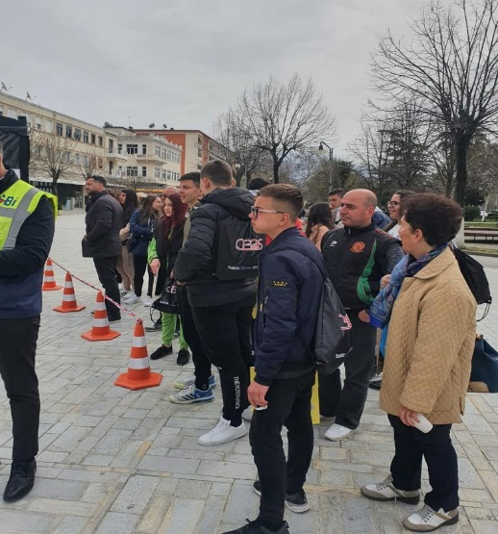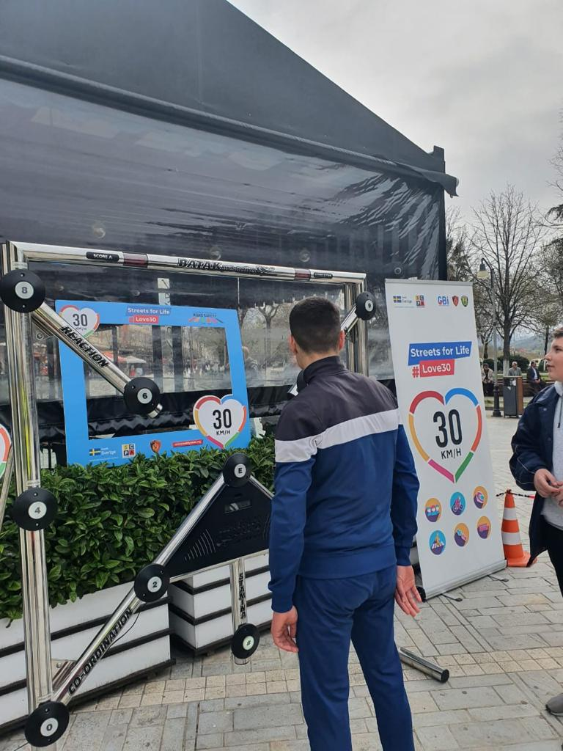

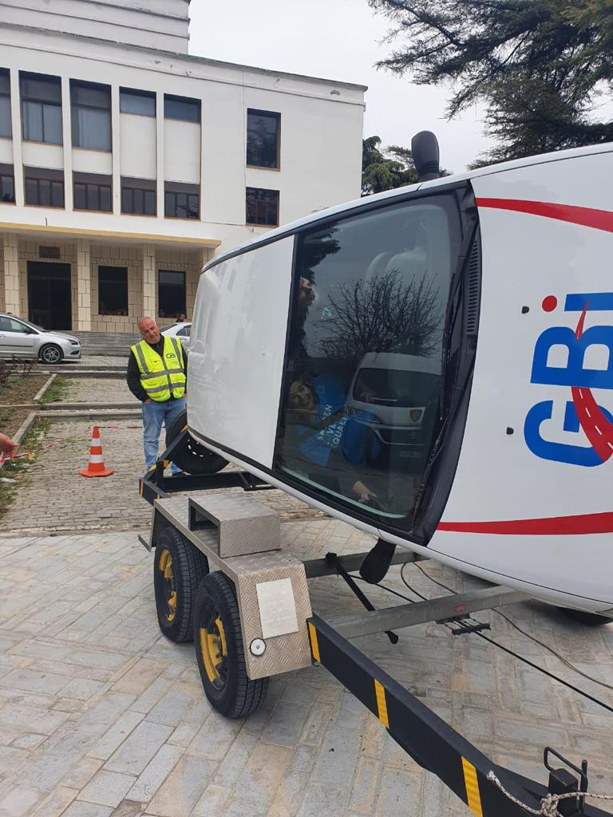
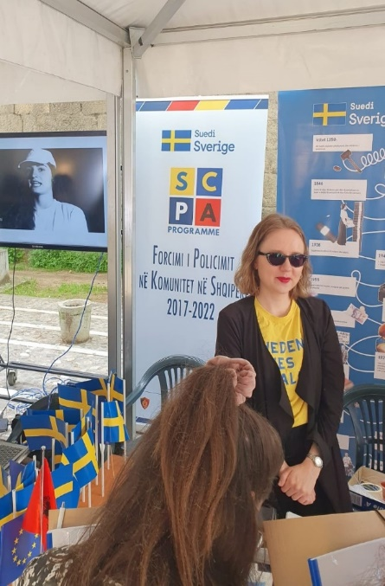
On the 9th of May 2022, the SCPA Program participated in the celebration of the EU Day at the pedestrian area of Tirana along with many other donors financed projects.
The Program presented the project activities and there were a lot of youngsters who wanted to be informed on the program. The event served very well for the program’s visibility and outreach.

Pillar III – Domestic Violence Support

In what concerns Pillar II activities, the project continued the path designed during the previous reporting periods and completed the cycle of intervention regarding the training for the risk assessment of DV cases. With our local partners, we were also involved in reinforcing the mechanisms dealing with DV in small communities.
Activity 3.a. Reinforcing referral mechanisms in the TLPDs
As of the previous reporting period, the efforts related to this activity during January – June 2022 were focused on the consolidation of the established Referral Mechanisms in the Municipalities of Belsh, Librazhd, Gramsh, Peqin, Vlore, Himare and Selenica.
The ratification of new Memoranda of Understanding between local institutions, members of the Coordinated Referral Mechanism (CRM) in each municipality, was the main output of this activity during this period. In this regard, several preliminary meetings were organized with local institutions in the municipalities and 4 constitutional meetings held with the Steering Committees of Referral Mechanisms in the Municipalities of Belsh, Librazhd, Gramsh and Peqin.
This development was based on the Council of Ministers Decision (DCoM) n. 327 dated 02.06.2021 “On the mechanism of coordination of work between the responsible authorities, for the referral of cases of domestic violence, and its functioning, for supporting and rehabilitating victims of violence”. Among other obligations, this decision emphasizes the need to identify and report other cases of violence against women as specified in the Istanbul Convention and address them through the CRM.
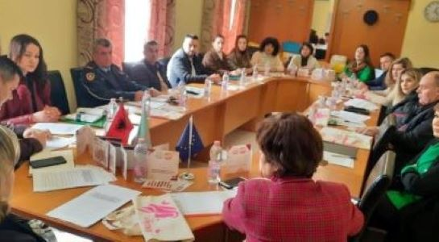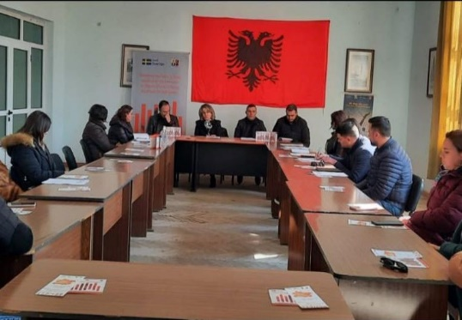

During the reporting period, 11 meetings of the Multidisciplinary Technical Team members (two in each municipality of Belsh, Librazhd, Gramsh and Peqin and one in each municipality of Vlora, Himara and Selenica) were held, where local GB–DV cases were discussed.

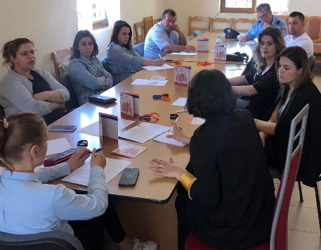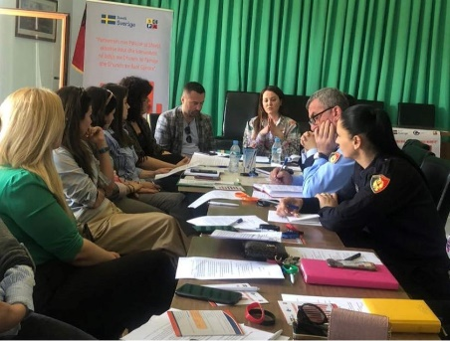

In the framework of the Grant Scheme, initiatives of local NGOs were oriented to support Referral Mechanisms establishment locally, aiming at increased synergy of interventions and efficiency of resources usage. Thus, through funds and projects of the Round V and Round VI of GS, the referral mechanisms and the Multidisciplinary Technical Team in the designated municipalities were provided with technical assistance and on the job training. The PMT supported the implementing teams of “Women Forum” in Elbasan and the center “Vatra” in Vlore with technical assistance, facilitating the process as per approved procedure. In addition, over the reporting period seven training sessions were conducted with Multidisciplinary Technical Team members to improve the availability and quality of services on site and maximize the contribution to social and economic reintegration of the DV victims.
In addition, technical assistance through coaching and on the job training were offered by the PMT, “Women Forum” NGO and the Center “Vatra” to the local coordinators of the designated municipalities increasing capacity building for first line responders on coordination techniques, DV victims’ identification, interviewing and screening methods, victim’s needs identification, case management and preparation of awareness raising materials addressing issues of gender roles.
Activity 3.b. Capacity building for police officers on DV area
Activity 3.b.1 Deliver trainings for 8 LPDs on DV, psychological and sexual violence
In coordination with the ASP HQ and the Academy of Security, the SCPA delivered a training for the four LPDs of Fier, Lezhe, Korce and Diber on the implementation of the latest changes and amendments regarding the preliminary immediate protection order and the conduct of risk assessment for domestic violence cases.

The target group of the training sessions was the community policing officers and the crime specialists. The training was conducted in two days in each TLPD and the total number of participants was 175 officers (Fier 50, Lezhe 49, Korce 51 and Diber 25).

The aim of the training was to provide the police officers with sufficient skills to carry out structured risk assessments and contribute to the uniform implementation of the specific legal provisions introduced by the recent amendments in DV law. The risk assessment procedures are intended to assist professionals in analyzing concrete situations, introducing a greater objectivity, identifying the level of the present risk and thus guide police action better in order to increase the safety of victims. A full package with supporting documents was delivered to participants.

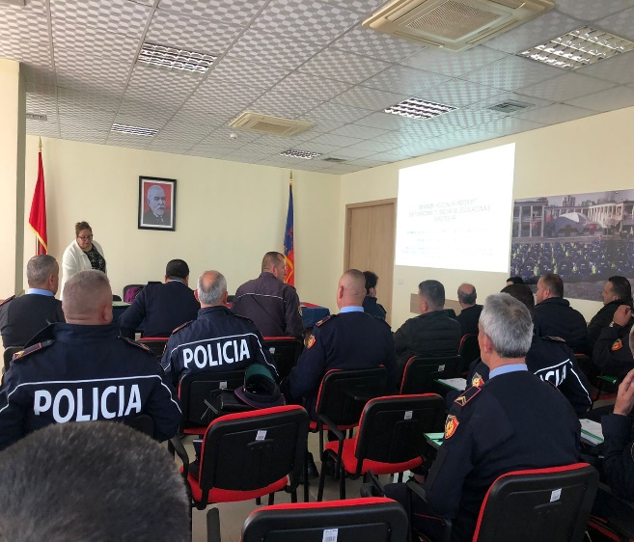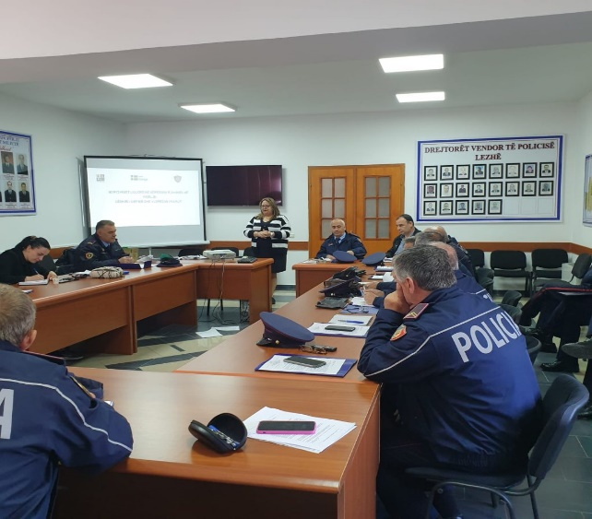

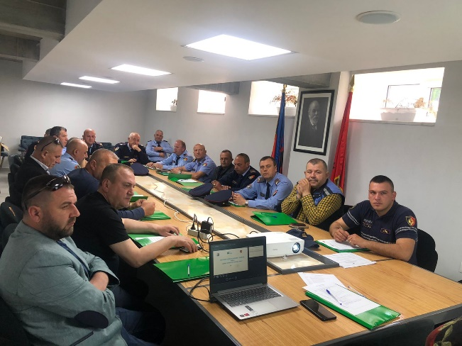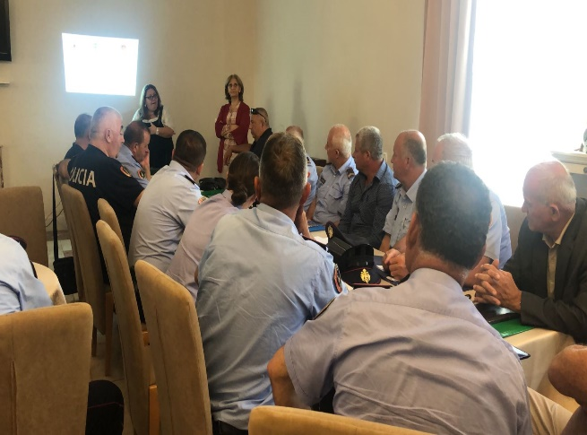

Activity 3.b.2 Monitor the implementation of the new legal provisions in LPDs
In parallel with the training sessions, the PMT has started to evaluate the quality of the risk assessment reports produced by CPOs in LPDs and dependent commissariats for the period January – June 2022 (6 months after the completion of the training conducted during September -December 2021).
The risk assessment reports in Gjirokastra LPD were collected and analyzed. The formulation and language of the reports was reviewed, as well the evidence used to support the risk assessment. The first draft report on the findings will be issued soon and will be shared with the ASP HQ and the respective LPDs. The risk assessment reports of other LPDs are still getting collected.
The further steps on the capacity strengthening of the CPOs through refreshment courses in the designated LPDs will be directed by the findings.

Horizontal Activity - Grants Scheme

In accordance with the Work Plan the sixth call for applications was launched at end of November 2021 in four regions: Vlora, Fier, Durres and Shkodra. Following the awareness campaign, 20 civil society organizations submitted their proposals. During the period mid December 2021-January 2022, the project proposals went through the selection process carried out by the Local Selection Committees co-chaired by the respective LPD heads and the PMT representative in a transparent process.

After the conclusion of the negotiation process between PMT and the implementing organizations, there were 7 projects contracted. The sixth-round grants are distributed as follows:

District | Grant size
 | Small | Medium | Large | Budget
 | (up to 5,000 €) | (up to 10,000 €) | (up to 15,000 €)
Vlora | 1 | 1 |  | 14,184
Fier | 1 | 1 |  | 13,858
Durres |  | 1 |  | 6,075
Shkoder | 1 | 1 |  | 14,035
 | Total |  |  | 48,152

With the contracts for Round 6, the overall value of the Grant Scheme grows up to 588.500 euro, with 73 contracts covering most of Albania.
The thematic distribution of funds is as follows:
- 3 projects aiming at supporting efforts for DV awareness and establishing and consolidation the local referral mechanisms;
- 2 projects aiming at supporting the establishment and capacity building of four Local Councils of Public Safety;
- 2 projects aiming at consolidating partnerships between the ASP and local communities and schools.

All the projects started the implementation in February. The PMT monitors the implementation of the projects and their progress through review of documents, programmatic and financial performance and site visits in designated districts.
Meantime, the implementation of the projects of Round 5 was completed by June. Five grantee organizations are still on the process of preparing the reports, the rest have already submitted them.
Some highlights from activities and outputs from these grants were:
- The organization “Vatra” was operating in Vlora district and its suburb and rural areas to enhance capacities of the police officers and other member institutions of the local Coordinated Mechanisms of Referral to better respond to domestic violence and to better assist the violence victims, including practical implementation of community policing. The capacity building activities were followed by awareness raising with local communities and schools to help community members to recognize violence against women, speak out against it and support victims.

- The organisation “In the Family, for the Family” successfully completed the project "Sustainable development starts with public safety", putting efforts to increase the functionalization and the empowerment of the Local Councils of Public Safety in the municipalities of Elbasan, Prrenjas and Peqin. Several focus group meetings with interest groups and community-based assemblies were conducted, as well as different meetings of LCPSs are facilitated. In addition, training sessions were conducted with the participation of technical secretariat members and community structures in the designated municipalities. Local Action Plans on Public Safety in Prrenjas and Peqin were drafted and validated.

- In the framework of the project "Public Security Team, Partner for a safe community", the NGO “New Epoch” conducted 9 focus groups in the municipalities of Fier, Patos and Mallakastër. Youth representatives of each municipality, citizens, community representatives, civil society activists and representatives of various public and private sectors were active part of the focus groups where individual and community perspectives on issues related to public safety were discussed and collected. In this context, 3 meetings of Local Councils of Public Safety were held in each designated Municipality where the mayors were present and chaired the meetings. The meetings aimed at increasing a sustainable co-operation between all local actors, including civil society, police, social services and religious communities in addressing local safety issues.

- The organization “Institute for Policy & Legal Studies” (IPLS) supported the rivitalization and the functionalization of the Local Council of Public Safety in the municipalities of Permet, Kelcyre and Libohove. In June IPLS organized a meeting/workshop on the topic “Increase local safety through community engagement and interaction” in Kelcyre where the mayor of the of Kelcyra, representatives of the Local Commissariat, social service administration, education, health service, forestry and environment, religious communities, volunteers’ groups, civil society etc. participated. The participants raised the concern of the full functionality of the LCPS as there was need to enhance the legal framework and increase the capacities of the human resources. Modalities such as schools being a center of community education, involvement of religious communities to support and cooperate with local structures to enhance public safety and the cooperation with local NGOs to support the families in need were also discussed.

- The Center “LEX FERENDA” was implementing the project “Mentoring the Municipality Council and Strengthening Public Safety in Roskovec” aimed at strengthening public safety through awareness raising of the community. Over the reporting period, 2 meetings of the Local Council of Public Safety in cooperation with Roskovec Municipality were organized where representatives of the local government participated. Both meetings were attended by the Deputy Minister of Interior Ms. Romina Kuko, the mayor of Roskovec Ms. Majlinda Bufi, representatives of Fier LPD, civil society etc. Among others, as output of the meetings the adoption of the LCPS regulation and the adaptation of the local safety plan of action in accordance with the issues identified by the community, harmonizing the recommendations for standard operating procedures can be mentioned.

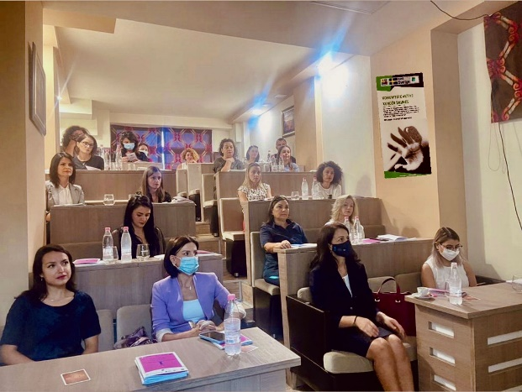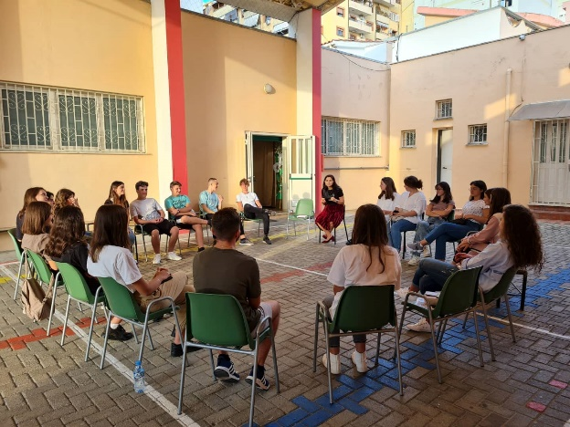
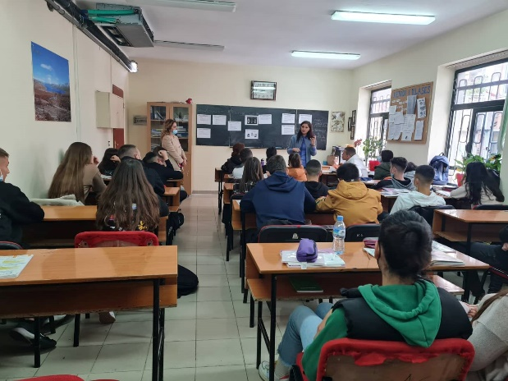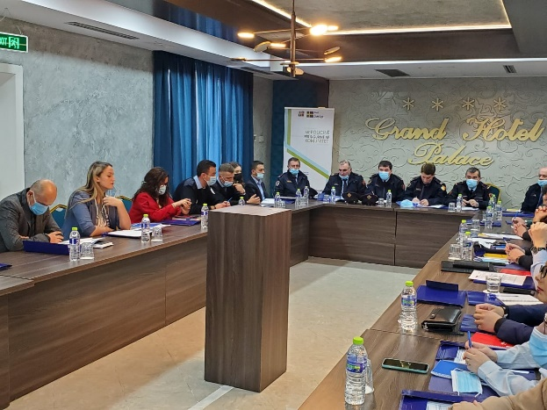
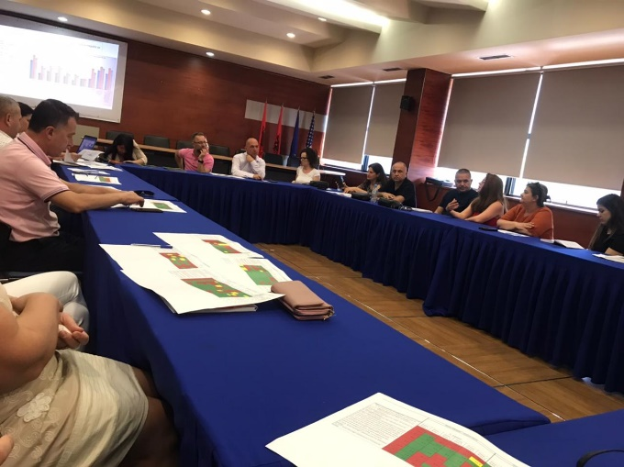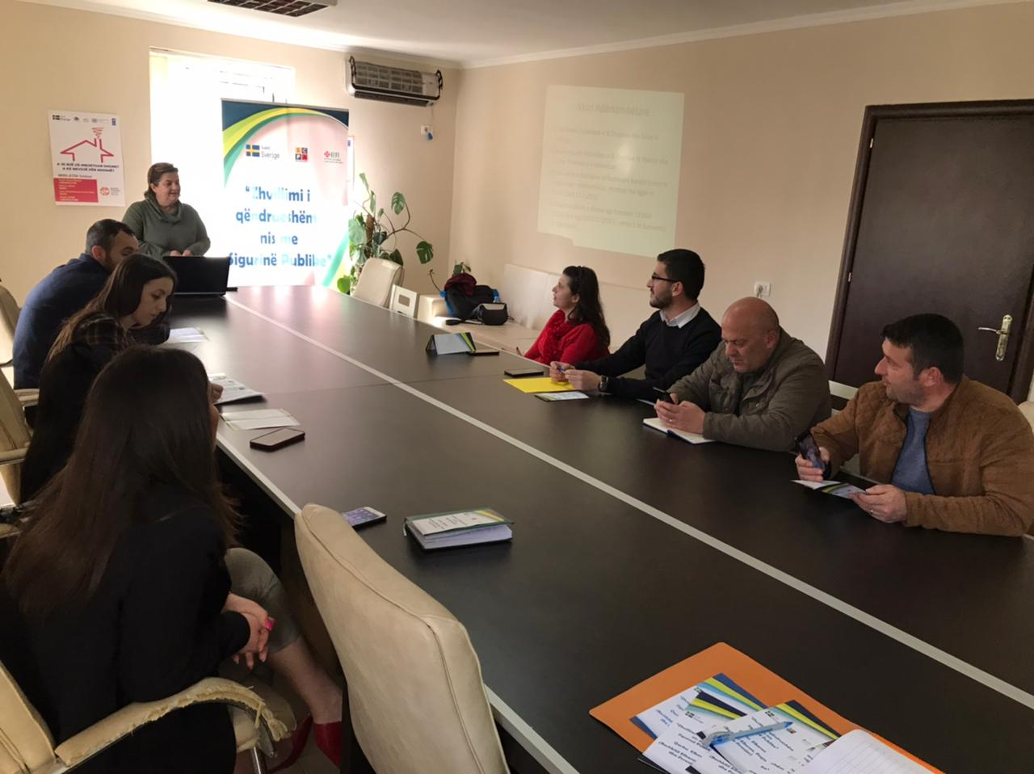
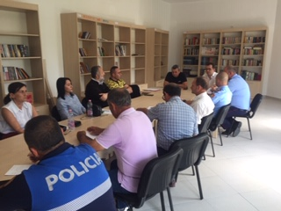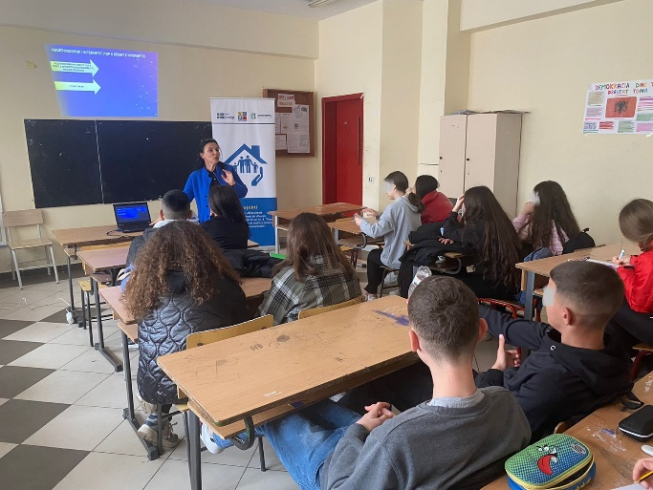

- In the framework of the project "Active Communities against Domestic Violence”, implemented by the Center “Focus”, a manual on Community Policing addressing domestic violence was produced and distributed to health care centers practitioners. In cooperation with the Police Directorate of Tirana and the Regional Directorate of Health several training sessions were organized with professional medical staff of health centers and polyclinic specialties in Petrela, Bathore, Kashar, Kamza, Peza and Dajt. The participants were trained on addressing domestic violence cases and on the newly developed protocols for the management of DV cases. In addition, real life situations were discussed to increase the awareness of the medical communities on such sensitive issue. The training was accredited by the National Center for Continuing Education (NCEC) with letter no. 543/1, dated 15.07.2021.

- The locally based organization “Assists Albania” was implementing the project “Community Policing with the participation of youth, against Domestic Violence” in Tirana, which aims at strengthening the cooperation model between the school community, police structures and local actors in preventing domestic violence and creating a safe community. The project consists of capacity building activities and networking among police officers, psycho-social staff in schools, teachers, student governments and social workers in administrative units. Several informative sessions and awareness participatory activities such as art competitions and role plays were conducted by the peer-to-peer youth group, facilitated by the community policing officers, employing a variety of interactive methodologies which aims to enhance participants’ learning through interesting and fun ways.

- “Albanian Water Sports & Tourism” was implementing the project "Strengthening community policing in Velipoja", organizing awareness sessions with students of the Department of Physical Education and Sports of Luigj Gurakuqi University (Shkodra) and students of three high schools on water sports safety and injury prevention. A key part of the discussion of awareness sessions was the role of the police in sports events at the seaside, the importance of their presence during these events, as well as the effectiveness of police cooperation and intervention in water activities. Safe use of water sports accessories and equipment and the basic principles of assistance for beach emergencies were being introduced to the target groups in open water activities, aiming at the increase of safety on the beach of Velipoja.

Budget expenses

By end of June 2022 the aggregated spending of the extension period summarizes to 11.045.924 SEK. This equals 79% of the total extension period budget. The reasons for this proportionally high figure are that the budget lines for infrastructure and equipment have been fully utilized, as well as a high turnover of local short-term experts.

The PMT budget are on par with plans, albeit for a low than budget usage of International and National M&E experts.

Overall, the budget execution accords with the work plan. There might however be a need for reallocations between some of the budget lines to allow for an optimal use of the remaining budget resources.

Annex I – Updated Logical Framework

 | Intervention logic | Objectively verifiable indicators | Sources of information | Comments
Overall objective | Contribute in building mutual trust and partnership between police and communities in order to create safer neighborhoods. | Safety situation in Albania positively assessed | - Ministry of Interior reports  - ASP reports  - Statistics  - European Commission Progress Reports  - Project reports | Based on PSS of May 2018 cc. 66% of Albanian citizens consider the ASP is doing a “good” or “very good” job.  80% of Albanian citizens declare they feel “safe” or “very safe” walking in their neighborhoods at night.  Only 60% of citizens are willing to call the police when they see a crime committed on the streets.
Specific Objectives | - Accountable, capable and responsive institutions providing community safety & security  - Citizens play an active and positive role towards their personal & CSS | - Albanian agencies skills to address community safety issues enhanced  - Increased citizens personal engagement and through CSO in safety and security issues | - Ministry of Interior reports  - ASP reports  - Statistics  - Program reports | 655 CPOs trained by the program  40 Analysts  Workshop for 60 CPO-Youth Educators  Workshop for 171 School Security Officers and Psychologist  9 workshops for the managing staff and analysts  18 LCPS activated or established.  56 CSOs contracted to support safety initiatives in local communities.  Cross-Sector Strategy on Community Safety 2021-2025 and Work Plan approved

Mandatory outputs
 | Areas of Intervention | Objectively verifiable indicators | Sources of information | Outputs January 2022- June 2022 | Overall outputs
Pillar 1 | - Support the ASP in enhancing the efficiency of CP structure  - Strengthening local partnership  - Capacity building | - Thorough analysis of the TLPDs conducted.  - Identification of the elements best fitting to Albanian context done.  - Revised job description/job profile of the CPOs  - Revised SOP presented  - CPO work in two TLPDs is coached, monitored and assessed  - Elbasan LPD pilot related to CP replicated in other LPDs  - Material support provided to the selected CPOs of the TLPDs  - Virtual Police established in the TLPDs  - RH business processes enhanced and material support provided to RH of the TLPDs  - Traffic Police capacities strengthened and material support provided  - LCPSs in the two TLPDs revitalized and established.  - The police representatives in the LCPSs coached and sensitized on the police role in the forum  - Trainings and open lectures provided at the Academy on the role of LCPS  - Training curricula for all police officers on the CP principle developed and modernized. Staff trained  - CPOs curricula revised and enhanced; ToT training  - RH staff trained; ToT training  - CPOs Educators capacities reinforced and awareness raising campaigns implemented successfully in schools  - Summer camps for the pupils organized  - Study Visits carried out | - Programme reports  - ASP reports  - Surveys  - Statistics  - Meetings  - Minutes of Meetings  - No. of staff trained | Replication of changed completed in in LPDs Tirana, Durres and Fier, Vlora, Berat, Gjirokaster and Korca.  Two days training of 58 police patrol officers of the commissariats of LPD Elbasan on changes  Two days of TOT for 36 potential trainers of police patrol officers of the remaining 11 LPDs  Two days training of a total of 206 public safety experts and command and control staff of LPDs Tirane, Durres, Fier, Berat, Vlore, Gjirokaster, Korce.  The software for radars for real time operation and link with e-gjoba and e-Albania to process data is developed and being tested | The TWG started working on the assessment report recommendations  New CPO job description drafted Elements for CP fitting Albania case recommended.  15 job descriptions recommended for LPDs and Commissariat, including CPO position. New CPO and GP job descriptions approved by the DG.  60 bikes and other firefighter equipment provided. Command and Control Room in Elbasan & Reception Hall and other premises in Has Commissariat and Librazhd commissariat renovated.  Command and Control Room of Kukes LPD co-financed with the local businesses.  Prevention Room for Kukes LPD reconstructed and refurbished  Reception Hall and detention premises of Tropoja reconstructed  LCPS in Elbasan is active, while LCPSs in Has, Tropoja, Librazhd, Perrenjas and Gramsh, were established and supported.  Training curricula for CPOs drafted, ToT delivered and training provided to 55 officers. Coaching provided for Elbasan and Kukes LPDs. 650 CPOs trained in all LPDs in 5 days training for each group.  Study visit in Slovenia and Croatia focused on CP practice organized in June 2018 and study visit to Germany organized in May 2019.  Regulation on the Technical Working Group in charge of piloting the changes in Elbasan LPD established.  Changes implemented in Elbasan LPD. Online coaching on the changes in LPD Elbasan. Continuous coaching on the consolidation of the changes in Elbasan LPD and preparation of the report Monitoring visits and online coaching of the TLPD Elbasan on change management  Reconstruction of 7 rural offices of CPOs in LPD Elbasan.  70 laptops and 40 video projectors distributed in all LPDs for the CPO educators and rural CPOs (Elbasan LPD)  The development of the RH software for business processes concluded and started the piloting and testing phase. Continuous coaching and monitoring on the use of the RH software  A review of the CP and Patrol Police curricula at the Academy of Safety carried out. Updated curricula prepared.  Donation of the minivan for the CP sector of ASP HQ. It will be used for awareness raising events  Online zoom meetings with the CPO educators and SSOs on updates  The shift leaders of Elbasan TLPD trained on new changes  Meetings in the LPD Elbasan and its commissariat to evaluate the sustainability of changes.  Replication of changes in the LPDs of Dibra, Lezha, Kukes and Shkodra (14 visits) and kick off in Tirana, Durres and Fier  Training of Public Safety Experts of Shkoder, Lezhe, Diber and Kukes. A total of 47 participants.  Workshop with Heads of the Community Policing and Public Safety Sections of the Commissariats from all 12 LPDs (48 in total)  Awareness raising activity “Apply the traffic rules, for a safe destination’ in Vlora  Awareness raising activities on road traffic behavior in 5 high schools in Tirana  Purchase of 110 sets of printers and smartphones and 6 Radars for Road Traffic Police  52 CPO educators had refreshing workshop  48.000 leaflets (12.000 per each topic) re-printed and distributed to ASP HQ and CPO educators  The Belsh Police Station fully reconstructed and made functional

Pillar 2 | - Strategic Planning and performance evaluation  - Coordination between stakeholders  - Communication | - Progress report and lessons learned on the Policy Document 2015-2017 conducted; New Policy Document 2018-2021 drafted  - New Strategy of Public Safety 2021-2026 drafted; Action plans and progress reports periodically prepared;  - Capacities of the organization at all levels to effectively monitor and assess implementation of policy documents and action plans increased  - An efficient monitoring system put in place  - The two TLPDs supported to draft periodic progress reports and identification of bottlenecks  - Capacities to externally monitor and evaluate the work of the police increased; national and local surveys conducted  - LCPS used an efficient mechanism to address local issues  - Partnerships with citizens and other local contributors increased  - Integrated Communication Strategy of ASP implemented  - National Awareness Campaigns of different topics carried out  - LPD spokespersons trained and their job description/profile reviewed.  - The PR/Communication curricula of the Academy of Security for initial and continuous training reviewed | - Documents, reports, interviews  - Notes from TGPM  - Assessment of Community Policing practice  - Monitoring and Evaluation  - Surveys  - Statistics  - ASP reports  - Visibility materials | Local Safety Measurement conducted in Elbasan City, covering 6 police zones of Elbasan Commissariat.  Results of the LSMS shared with the LCPS of Elbasan and all the members  9 LCPS of cities Kukës, Elbasan, Korçë, Pogradec, Fier, Roskovec, Përmet, Këlcyre and Libohovë established and revitalized.  2 events to enhance local partnership and project visibility  One in Berat involving local meeting to tackle local safety issues and awareness on road traffic rules  One in Tirana on EU day to promote the Swedish support to enhance democracy in Albania. | CP Document 2018-2020 approved. Monitoring plan drafted. A report of key actions and measures taken during the old strategy 2015-2020 has been produced  A Draft Policies /Priorities and strategic objectives for the new Public Safety strategy 2021-2026 was produced.  The Intersectoral Strategy for Safety in the Community 2021-2026 and the Action Plan 2021-2023 approved by the Government.  Analysts and managers in 2 TLPDs trained (25 participants in 10 training days). Coaching delivered (20 coaching days).  A workshop for all the LPD directors related to role and functions of Sector for Analysis and Monitoring organized. 16 analysts in other LPDs trained in 8 days modules. SOP for the new sector proposed by the program and approved by the ASP  Police Satisfaction Survey 2018 completed and results shared with stakeholders. PSS 2020 completed and results shared with stakeholders. Information used to feed the Strategy for Safety in the Community.  LSMS I & II for Elbasan and Kukes completed and results shared and discussed with stakeholders. Results of PSS presented in Elbasan LCPS and members invited to take measures.  LCPSs established and supported in Laç, Lezha, Patos, Kavaja, Selenica, Vlora, Korça, Berat.  12 LPDs spokespersons trained in 3 days training and coaching provided as follow up.  Newsletter for Elbasan and Kukes LPD produced and web constable launched.  Manual for the CPOs Educators prepared; 5 days training for 60 participants delivered. 3 awareness campaigns developed. Web Forum for Educators developed. Leaflets and booklets printed and distributed.  152 School Security Officers and Psychologists trained on the awareness raising topics to be held at schools. 18 days of training in total.  36 candidates for High School Security Officers Trained on the awareness campaigns. (6 days)  Monitoring of the Educators Online Forum and advising them.  Three rounds of training of the spokespersons of TLPDs regarding newsletter preparation and web constable.  Assistance to establish or strengthen the LCPS in Kukes, Elbasan, Korçe, Pogradec, Gjirokaster, Kelcyre, Permet and Libohove  Assistance to the newly established MoI working group on the drafting of the legal rules on the functioning of the LCPS

Pillar 3 | - Strategic Level Interventions  - Capacity Building and Strengthening  - Infrastructure and Logistics support | - Report on Prevention Approach completed  - Legal and by-legal framework on DV revised  - SOPs on DV cases enhanced  - Data collection system for the ASP, Prosecution Office and Courts established  - Referral Mechanisms established and functional in TLPDs  - Awareness campaigns in TLPDS against DV and gender based violence  - Capacity Building Plan on DV elaborated  - Training curricula and modules on GBV and DV upgraded  - Training for CPOs and CIDs delivered in 8 LPDs, including sexual and psychological violence  - Monitoring in practice the implementation of new legal provisions in 8 LPDs  - The DV interviewing areas in the TLPDs commissariats restructured and reconstructed  - Material support for the CPOs and CIDs in agreed commissariats provided. | - Project Reports and documentation;  - UNDP, UN Women, OSCE reports ;  - Ministry of Health reports;  - MoJ and Prosecution Office Statistics.  - Police reports/statistics;  - Project Reports;  - Assessment reports & Surveys;  - Monitoring & Evaluation Plan;  - UNDP & UN Women databases, maps and reports  - The Ombudsman /Internal Control Service /M. of Health /M. Education and Sciences / Local Government reports | Consolidation of the established Referral Mechanisms in the Municipalities of Belsh, Librazhd, Gramsh, Peqin, Vlore, Himare and Selenica  Training of 175 police officers of LPDs (Fier 50, Lezhe 49, Korce 51 and Diber 25) on the recent legal amendments to the DV law and the risk assessment.  The risk assessment reports in Gjirokastra LPD are collected and analyzed. | Referral Mechanism established in Gramsh, Belsh and Kukes and continuous support provided. Referral mechanism established in Librazhd and reactivated in Peqin.  DV Awareness Campaign implemented in November-Dec. 2017, 2018 and 2019. Awareness raising campaign during 16 days of activism against violence against women in 6 districts Vlore, Elbasan, Kukes, Lezhe and Pogradec during November 2020.  300 logged masks were donated to LPDs to be used during the awareness raising days on DV and GBD.  The report on Prevention Approach finished and submitted. Capacity development plan drafted  72 CPOs and CIDs in Kukes and Elbasan LPDs trained on the legal amendments of the DV law and the risk assessment  Friendly interview room in Librazhd and Comm. 4 in Tirana completed. Interview room created in Has.  Interview Unit for minors and DV victims in LPD Elbasan created (works + equipment) and staff trained  DV awareness event in Elbasan city center involving local NGOs, Police and institutions.  Production of 200 copies of printed posters to be put on commissariats which include the obligations of the police and the rights of the victims  Consolidation of the established Referral Mechanisms in the Municipalities of Belsh, Librazhd, Gramsh and Peqin in Elbasan region.  Training of 219 officers (Durres 45, Gjirokaster 44, Berat 45, Shkoder 42 and Vlore 43) on the recent legal amendments to the DV law and the risk assessment.  Awareness raising events within 16 days of Activism against GBV in 5 districts Tiranë, Elbasan, Kukës, Korçë, and Pogradec, which were attended by students of 16 high schools.  Design and printing of promotional materials on DV such as posters, flyers, pens, ribbons and bracelets  The report on the evaluation of the risk assessments prepared by TLPDs issued and shared. Recommendations provided.
Grants | Empower civil society organizations to embrace and implement the CP philosophy and support to combat DV. | - Grants Scheme implemented as planned and scheduled | Grantees reports  Program Reports  Surveys  ASP reports | Winners of the 6th round of grants selected | 73 grants’ contracts signed, covering 11 regions in Albania  588.500 euro contracted.

Annex 2 Risk Matrix
 | Risk Factor  (security, political, operational , financial, reputational) | Impact | Likelihood | Mitigation Strategy and Responsibilities
 | High-level buy in
1 | Overburdened national partners / lack of resilience  - Political unrest especially during the pre-election period  - Excessive demands of national partners results in them losing interest or willingness to participate in program  - Other demands results in low priority of community policing  - National counterparts may not be able to operate at the speed desired of the PMT to design and set up specific activities within the program streams  - Pressure by senior leadership to produce results within unreasonable timeframes (including pressure focusing on outputs, rather than outcomes) | Medium | High | - Pay attention to specific local deadlines or other demands  - Use existing local systems and procedures (i.e. monitoring systems, rather than setting up parallel structures)  - Sida/PMT to ensure that international community is communicating and cooperating with each other and ensure common interest and objectives in community policing  - Capitalize on the demonstrated interest from senior MoI and ASP leadership in the program  - PMT to ensure sensitization across senior MoI and ASP leadership of the program work plan and estimated timelines
2 | Lack of, or unwillingness of, stakeholders to participate and cooperate  - Resistance or mistrust from communities and local government / decentralized institutions to cooperate with police  - Partners within the regions do not feel they are part of a process | Low | High | - Ensure transparent processes and encourage local partners to actively participate  - Support for partnership approaches can be developed with the relevant line ministries (advocacy and liaison)  - Risk management matrix and development of mitigating strategies is carried out collectively by the SC  - Capitalize on the excellent partnerships developed during the first phase of the program
3 | Major reshuffle of key police personnel  - Key personnel are moved to other positions before progress can be institutionalized within the ASP or LPDs  - Long term vacancies in key positions – The Chief of Sector for the CP Sector at the Headquarters is vacant since 8 months and staff is overburdened with tasks | Medium | High | - PMT to monitor personnel shifts and timely reporting to SC  - Explicit approach by the SCPA to strengthen institutional capacity not just focus on individuals
4 | Lessons and progress made as a result of the program are not recognized by decision-makers and do not inform future policy development  - The SCPA seeks to develop institutionalized behavioral change. The gains of the program will not be sustainable if the changes remain solely at the individual level and do not influence policy changes that support cultural shifts in the way of working | High | High | - Sensitization activities on key lessons to be incorporated into the PMT program monitoring process  - M&E program stream to include creating or developing mechanisms to ensure that the lessons are fed into MoI/ASP policy making bodies  - The SMS Coordination stream will encourage cross-departmental cooperation and cohesion  - PMT to be prepared to provide summaries of key lessons and changes to the MoI if/when a process to develop an MoI policy on safety and security commences
5 | Program loses coherence  - Pressure by the MoI/ASP to provide support to ad hoc activities outside the planned design  - Program impact becomes diluted / program loses focus as a result of reacting to new/additional requests for individual activities from the MoI/ASP | Medium | Medium | - SC consent to be required, in addition to Sida’s, for any substantial deviations or requests for new assistance  - Requests should be accompanied by clear analysis of how the new request contributes to achieving the program’s direct outcomes  - PMT to ensure that requests for new activities are included in the preparatory documents for the SC
 | Program processes
6 | Corruption or allegations of corruption in program (particularly relevant for the Grants Scheme)  - Misuse of funds and poor accounting  - Favoritism of particular groups for projects | High | Low | - The SCPA shall continue the excellent transparent practices for their GS  - Emphasis on transparency throughout program  - Clear and transparent selection procedure for all projects  - Allegations of corruption to be followed up immediately by the PMT and the Embassy/ the SC informed
7 | Experts are not of a sufficiently high quality  - PMT staff members do not have the capacities to deliver the required quality of work  - Short-term experts do not provide work of a sufficient quality / relevance to the Albanian context | High | Medium | - FCG / the Embassy / ASP / MoI quality control of program’s outputs  - Use of the monitoring mechanism to track performance and follow up with feedback from the beneficiaries on expert performance  - Clear terms of reference and expected deliverables to be developed for short-term experts etc.
 | Sustainability
8 | ASP and MoI do not follow the recommendations regarding budget allocations and staff reshuffle after TLPDs piloting  - Diversion of ASP funds to the TLPDs in order to ensure their short-term success  - Diversion of ASP funds away from the TRPDs because they are covered by the program  - ASP/ MoI do not systematically provide support to TLPDs | Medium | Medium | - Relative allocation of funding to ASP LPDs (including the TLPDs) to be monitored as part of the PMT monitoring mechanism  - Concerns to be raised to the SC  - Clear and transparent selection criteria for the TRPDs  - Sensitization process across the ASP on the program – especially regarding progress being made, lessons learned, and dissemination and replication activities
9 | Lack of responsiveness to adapt proposed models to Albanian specific situation  - Models provided by PMT for Pillar I do not fit with specific conditions | Medium | Low | - PMT will not design a “model” for the community policing in Albania, but will provide different elements of a model  - The elements will be illustrated by international examples and provided with their “pros” and “cons”, aiming to develop an Albanian model.
10 | Shift in international engagement  - International development programs fail to achieve stated aims and objectives in areas linked to the SCPA  - Sida project overlaps or competes with other international project/demands and overburdens local partners | Medium | Medium | - Key international community (IC) actors have been informed/consulted throughout the design process  - PMT to map out what key deliverables from other programs will influence their activities  - Program proposal and future program activity documents to be shared widely with DDPFFA and the IC
11 | Albanian authorities do not start to take on elements of budgetary responsibility  - Whilst the SCPA will absorb the costs for monitoring activities in the early stages of the program (e.g. citizen perception surveys) these will need to be taken on by the MoI/ASP progressively as the program unfolds  - Any budgetary impacts for new procedures for the LPDs will also need to be incorporated into MoI/ASP budget planning | Medium | High | - Exit strategy contains clear mechanisms for the GoA to adopt gradually increasing funding responsibilities throughout the program – framework to be developed during the inception phase and built up over years 1 and 2  - Constant monitoring
12 | Transfer of procedures, skills and expertise to other LPDs is not done in a sustainable way  - Pressure to replicate TLPD processes and approaches to other LPDs before they have been monitored, evaluated and proven  - Lessons and new/updated ways of working are never transferred | Low | Medium | - Role of the IPA in advising on time lines  - SC consensus on large scale replication activities  - Continuous monitoring on progress and development of when aspects will be disseminated  - Selection for LPDs based on international good practice  - Individual risk analysis / mitigating strategies to be developed for specific dissemination/replication activities
 | Force majeure
13 | Covid 19 pandemic conditions implementation of activities | High | high | - Continuous monitoring of the situation  - Adopting a flexible approach in adapting the activities to the new conditions

Annex 3 - Participants/beneficiaries in SCPA activities
During this reporting period, the PMT organized the work in a manner that the beneficiaries were given the opportunity to actively participate in activities. The involvement of beneficiaries and other related stakeholders in project activities provided a positive relationship between participants and increased the effectiveness of project’s activities. PMT noted that this approach helped build a sense of ownership and sustained the outcomes of the project.
For SCPA, high and quality participation is seen to potentially release and bring in additional resources to the project. Participation of stakeholders and beneficiaries in all the groups of activities, was used as a tool in which they were empowered to have their voices heard and to strengthen relationships between the project and the stakeholders. All participation approaches were designed to generate an active participation with the intention to make stakeholders feel that they were collaborators in the project, not just simple recipients or contributors, but active partners in the activities at every phase. During this reporting period, activities within the 3 pillars and especially the activities supported by the Grants Scheme, involved a considerable number of participants/beneficiaries who operate in many public and state organisations and institutions and are located all over the country.
SCPA program has closely monitored participation and number of beneficiaries in program’s activities as a whole. Below is a brief description of activities managed by PMT:
During this reporting period PMT achieved organizing in total 168 activities; Out of this total it is worth mentioning that 75 were regular meetings with the MOI, ASP HQ, LPDs, Local Police commissariats, Academy of Security, Local government and other stakeholder representatives and 13 were capacity building training sessions of Police officers in 8 LPDs.
PMT managed to organize 1 PSC meeting, 4 trainings with the Patrol Police Shift leaders/experts of public safety and Command and Control staff of LPD, Tirana, Fier, Durres, Vlora, Berat, Gjirokaster and Korca. This group of trainings involved a total of 206 police officers out of which 140 police officers were from LPD Tirana, Fier and Durres, and 66 ones were police officers from the Southern LPDs. 1 training delivered in 3 groups for all Patrol Police Officers of LPD Elbasan (commissariats of Elbasan, Peqin, Cerrik, Gramsh and Librazhd), 58 was the total number of PPOs who took part in the event; 2 training sessions at the Academy of Security involving 36 potential ToTs selected from 12 LPDs of ASP.
SCPA also attended 3 ceremonies: the first one being the 50-th anniversary of the founding of the Academy of Security and the ceremony on the occasion of the 103-rd anniversary of the creation of the Albanian State Police. SCPA also took part in the activity organized on May 9, on the occasion of the Day of Europe activities.
6 LCPS meeting were organized in Elbasan, Prrenjas, Pogradec, Kelcyre, Roskovec and Delvine.
During this reporting period, PMT also organized 47 field visits which included 4 southern LPDs (Vlora, Berat, Gjirokastra and Korca) and LPDs of Tirana, Durres and Fier, Shkodra and Lezha 38 visits out of the total were dedicated monitoring visits to LPDs to monitor the progress and sustainability of implemented changes in each Commissariats, 5 were evaluation meetings and 4 ones were launching meetings in southern LPDs to start the implementation of the project of change (introduce, set up the project change management working groups and later to start implementing the changes in accordance with the GD’s order). One meeting was organized at the conference room of ASP HQ for introducing the software for radars donated by the SCPA.
Regarding the DV Pillar of the program, in coordination with the ASP HQ and the Academy of Security, the SCPA program during the reporting period January-June 2022 has delivered the training for the four TLPDs of Fier, Lezhe, Korce and Diber on the implementation of the latest changes and amendments regarding the preliminary immediate protection order and the conduct of risk assessment for domestic violence cases. The target group of the training sessions were the Community Policing Officers and the Crime Investigation Police officers. The training was conducted in two days in each TLPD and the total number of participants was 175 officers (Fier 50, Lezhe 49, Korce 51 and Diber 25).
In the frame of awareness activities, DBV and gender-based Violence activities were organized in, Tiranë, Gramsh, Elbasan, Pogradec, Librazhd, Peqin, Delvine and Puke.
Within the grant scheme component the PMT has also been active. During this reporting period, 5 meetings of the Coordinated Referral Mechanisms in the four municipalities were organized; four meetings of the Multidisciplinary Technical Team members (one in each municipality of Belsh, Librazhd, Gramsh and Peqin) and one meeting of the Steering Committee in Librazhd, where local GB–DV cases were discussed.
Conveyed in figures, activities involved a total of 1674 persons out of which 453 were ASP personnel, 37 were senior ASP police officers, 78 midlevel police officers and 338 grass root police officers who took active part in the activities. 768 persons were direct community beneficiaries. The Grant scheme activities were kept a high level both in terms of number of activities and participants.
The PMT has emphasized the importance of a good gender balance in all three component areas. Gender indicators were assessed in all of the activities, meetings, workshops, seminars and trainings.
Overall, the PMT assessed that: 44.7 % or 671 out of 1674 persons were girls and young women; 42.3 % of the members in the implementing/core working groups of projects are women; 21.19 % or 96 police officers out of the total that have benefited from the activities were women police officers.
Program’s visibility and outreach with the public
During this reporting period the PMT succeeded in increasing the visibility of each component. PMT applied several ways and means to expose the program. Some of the effective ways to increase the program’s visibility were the following:
- Workshops and training sessions were used successfully as an already proven networking facility.
- Meetings with community-based organizations and other stakeholders in the framework of LCPS, and Grant scheme activities. These meetings were considered as an important way to expose the program’s objectives and philosophy but also as a base for establishing networks in order to cultivate long-term relationships.
- The online forum of CPOs – Youth Educators and the forum for Security Officers in schools, continues to be a proven efficient tool to engage not only the assigned CPOs for education and work with youth, but also ASP HQ and Academy of Security experts in exchanging experience with each other and creating a network of CPOs and Security officers. It is worth mentioning that the CPOs working as Youth Educators in commissariats of Durres, Fier, Kukes, Saranda, Lezha, and Cerrik, have been very active. Their activities are displayed both at the SCPA website and in the ASP one. We observe a slight decrease of activity of the CPOs/Youth educators in the commissariats of LPD Tirana, Elbasan, Vlora, Korca, Shkodra and almost no activity in the commissariats of Permet, Gjirokastra, Tepelena, Dibra, Bulqiza, Kurbin, and Kruja. Also, it is worth mentioning that due to the lack of dedicated CPOs to work with the awareness campaigns in Tirana Commissariats, the activities are not at the desired level.
- The program’s web page, which is user-friendly, accessible and provides open, consistent and searchable information about all project activities. The activity on the program’s web page has increased substantially. During the past six months the web page was visited by 5496 viewers. The Program’s social media accounts in Facebook, Google LinkedIn, and Twitter remain quite active. The web page has been very helpful, especially in relation to the GS.
PMT has continued the appreciated practice of producing and distributing a short excerpt of activities, summarized in the Monthly Newsletter of the Program. The Newsletter is distributed to almost 285 receivers, including ASP counterparts, international partner organizations, NGOs and other Program’s stakeholders.

E-gjoba (e-fines) is the ASP system of fines management
E-Albania is the government online portal for services provided to the citizens and inter-operability of government institutions

