***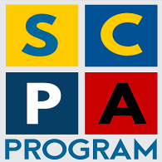***

**STRENGTHENING COMMUNITY POLICING IN ALBANIA**

**FORCIMI I POLICIMIT NË KOMUNITET NË SHQIPËRI**

**Implemented by:**

**C:\Users\HP\Desktop\templates\Templates & Logos\se_logo-FCG.png**

**BI-ANNUAL PROGRESS REPORT**

**(July 2020)**

|  |  |
| --- | --- |
| **Project title** | **Strengthening Community Policing in Albania, 2nd phase, Program implementation 2017-2020** |
| **Project No.** | UF2014/52825/TIRA |
| **Country** | Albania |
| **Funding Agency** | Sida |
| **Implemented by** | FCG Swedish Development AB |
| **Address** | Dalagatan 7, 111 23 Stockholm, Sweden  Web: [www.fcgsweden.se](http://www.fcgsweden.se)  ++46 8 406 76 20 |
| **Contact person** | Mr. Pontus Förberg, Project Director FCG  Cell: +46 70 214 21 81, Office: +46 8 406 76 20 [pontus.forberg@fcgsweden.se](mailto:pontus.forberg@fcgsweden.se) |
| **Date of report** | 30 July 2020 |
| **Reporting period** | 1st January 2020 – 30 June 2020 |
| **Chair of Project Steering Committee** | General Director of Albanian State Police |
| **FCG Project Team Members** | Mr. Ansi Shundi, Team Leader  Mr. Ulrich Dugas, International Police Advisor  Mr. Enri Hide, Long Term Advisor  Mrs. Eldisa Zhebo, Long Term Advisor  Mrs. Miranda Fishka, GS Manager, DV Expert  Mr. Arian Braha, Program Coordinator  Mrs. Jolanda Gugaj, Program Officer |
| **SCPA Contacts** | Address: Blv “Zhan D’Arc”, Nd. 61, H.5, K. 5, Ap. 6, Tirana, Albania. Tel + 355 44 511 340  Mail: [info@cp-project.al](mailto:info@cp-project.al)  Web: [www.cp-project.al](http://www.cp-project.al) |

Table of Contents

[ACRONYMS AND ABBREVIATION 4](#_Toc266359)

[1. Executive Summary 5](#_Toc266360)

[2. Progress achieved based on Program Pillars 8](#_Toc266361)

[2.1 Pillar I – Local Police Directorate Community Policing Support 8](#_Toc266362)

[2.2 Pillar II – Strategic Management Support 15](#_Toc266363)

[2.3 Pillar III – Domestic Violence Support 20](#_Toc266364)

[2.4 Horizontal Activity - Grants Scheme 22](#_Toc266365)

[3. Budget expenses 22](#_Toc266366)

[4. Focus for the next phase 25](#_Toc266367)

[Annex I – Updated Logical Framework 27](#_Toc266368)

[Annex 2 Risk Matrix 34](#_Toc266369)

[Annex 3 - Participants/beneficiaries in SCPA activities 38](#_Toc266370)

# ACRONYMS AND ABBREVIATION

ASP - Albanian State Police

CP - Community Policing

CPO - Community Policing Officer

CSS - Community Safety and Security

DV - Domestic Violence

DVS - Domestic Violence Support

ESS - European Social Survey

EU - European Union

EUR - Euros

GD - General Director [of the ASP]

GoA - Government of Albania

GS - Grants Scheme

HQ - Headquarters

ICITAP - International Criminal Investigative Training Assistance Program

IOM - International Organization for Migration

IPA - International Police Advisor

ISSAT - International Security Sector Advisory Team

SC - Steering Committee

JWG - Joint Working Group

LCPS Local Council on Public Safety

LPD - Local Police Directorate

M&E - Monitoring and Evaluation

MoI - Ministry of Interior

MoJ - Ministry of Justice

NGO - Non-Governmental Organization

NSDI - National Strategy for Development and Integration

OSCE - Organization for Security and Cooperation in Europe

PAMECA - Police Assistance Mission of the European Community to Albania

PMS - Performance Management System

PMT - Project Management Team

SACP - Swedish Support to the MoI / ASP on Community Policing

SAPEMR - Sector of Strategic Analysis, Planning, Evaluation, Monitoring and Reporting

SCPA - Strengthening Community Policing in Albania

Sida - Swedish International Development Cooperation Agency

SMS - Strategic Management Support

SSR - Security Sector Reform

SOP Standard Operating Procedure

TLPD - Target Local Police Directorate

TWGs - Technical Working Groups

UNDP - United Nations Development Program

UNHCR - United Nations High Commission for Refugee

UNICEF - United Nations Children’s Fund

USAID - United States Agency for International Development

# Executive Summary

The activities of the SCPA project, as all the activities in Albania and around the world, were severely influenced by the spread of the Covid19 pandemic. While 2020 started with the hope and wish to recover from the effects of November 2019 earthquake, the rapid spread of the pandemic erased this and created a whole new situation.

The PMT, in close cooperation with the beneficiary and the Swedish Embassy, tried as much as possible to live with the situation and adapt to the new reality. Despite the efforts, the exceptional situation left an important mark in the list of activities and the implementation pace. Efforts were made to postpone activities with large number of participants and to anticipate activities that could be implemented online. From mid-March to May the PMT switched to distance working and limited interactions in person with the beneficiary.

At the beginning of 2020, in cooperation with the Ministry of Education, Science and Youth and the ASP, the project started a training of almost 171 Security Officers and Social Workers from high schools around Albania. The aim was to extend all the three awareness raising campaigns, currently implemented by the CPOs in secondary education schools, in the high schools. Based on the positive example of the trainings organized for the CPOs related to communication/presentation skills and knowledge about the three awareness campaigns, a special training module was designed for the security officers. The objective was to complete the training in March and immediately start the Traffic Safety campaign in all schools, given that 2020 was declared as the year of traffic safety. Unfortunately, only half of the target group got the training as planned, while the rest was trained by the end of June, when restrictions were eased. All awareness raising campaigns were suspended and there is uncertainty if they will be retaken with the new school year start. Meanwhile, the PMT completed the procurement procedure for laptops and projectors for the CPOs educators. 40 sets will be purchased and delivery is expected in September. In September the delivery and entry into function of the mobile office to be used for CP activities is also expected. The SCPA project has procured a minivan that will be adapted as mobile office and will be used by the ASP in different awareness raising activities. This is based on the models from various countries visited during the study visits.

The activities to streamline the work of the CPOs in Elbasan LPD started at a good pace at the beginning of the year and several meetings of the working group and with the LPD Elbasan were organized. Procedures were defined and the General Director approved the new job descriptions for the CPOs and general patrol officers in February 2020. Activities on the ground were suspended in March and the PMT and the working group focused on reviewing the SOPs related to CPOs and general patrol work. Some drafts are prepared and shared/ discussed with the ASP. Only at the end of June activities on the ground were possible to restart, although with limited participation of police officers.

A joint ASP - SCPA team inspected the working premises of the CPOs in rural areas and the project decided to support the renovation of 7 such premises. The work will start in September. At the same time, the project will provide LPD Elbasan with 30 laptops to facilitate the work of the CPOs in these rural offices. LPD Elbasan has committed to verify the computer skills of the recipients and support the capacity building, if needed.

To complete the circle of intervention after the conclusion of CPOs training last year, the PMT, in cooperation with the Academy of Security, revised the curricula used at the Faculty and the College pertinent to community policing. Suggestions were provided to managers and workshops were organized with them and lecturers. The activities will continue during the next semester and open lectures will be provided by the SCPA. The Academy staff has shown commitment and interest in completing this activity as they also felt the need for this intervention.

A major activity completed during this semester was the elaboration of a new software to manage business processes in Reception Halls. The new software has been presented to and endorsed by the beneficiary. The main objectives of the software are:

a) Delivery of services to citizens in an efficient and modern way;

b) Increasing the performance of daily users of IT systems;

c) Increasing the performance of operators in Reception Halls;

d) Timely and transparent approval of services provided by the Albanian State Police;

e) Reduction of corruption phenomenon within the Police;

f) Unification of data and approval and reporting processes;

g) Increased transparency; and

h) Interaction withother government platforms.

This software will be easy and user-friendly. It will allow for electronic management of most work processes, registration of different decision-making steps and the possibility to check the performance of work by not only the RH staff, but also the staff involved in service delivery to the public. The “Reports” section of the software was developed to provide numerical and graphical representation of the work completed. During next semester piloting will start in Elbasan LPD and training will be provided to the users.

Following a request from the Ministry of Interior the SCPA started to provide support in preparing the next Public Safety Strategy 2021 - 2026. This was supposed to be a consultative process, albeit after the pandemic, it was transformed into desk work, combined with ZOOM meetings and consultations. The SCPA team has been tasked to facilitate this process and provide expertise to MoI and ASP in formulating the new Strategy and respective initial 2-year action plan.

During March – April 2020 several strategic meetings with MoI and ASP, and supported by SCPA experts, took place to discuss three options to pursue regarding the formulation of the new strategy. Furthermore, a desk review of several EU countries’ similar strategies has been prepared by SCPA experts and provided to MoI and ASP.

The option to develop a new strategy, based on the concept of community policing, interaction and coordination with local actors and other law enforcement agencies to effectively address public safety issues in the territory, was chosen by the working group. A draft report on the progress of the implementation of the current strategy was prepared and shared with the counterparts. In September consultation and work on the actual draft of the strategy and action plan is expected to restart. By the end of the year the document is anticipated be ready and approved.

In January 2020, three one-day training sessions on “Legal Amendments in Addressing Domestic Violence” were held at the Elbasan Local Police Directorate. The training sessions were attended by a total of 72 community policing officers and Crime Investigation Experts (CIDs) from Elbasan LPD. The aim of the training was to provide the police officers with enough skills to carry out structured risk assessments and contribute to the uniform implementation of the specific legal provisions introduced by the recent amendments in DV law. Risk assessment procedures are intended to assist professionals in analyzing concrete situations, introducing a greater objectivity, identifying the level of the present risk and thus guide police action better, in order to increase the safety of victims. The training was jointly conducted by the national DV expert of the SCPA program and the head of the Juvenile Protection and DV Sector in the ASP HQ.

The Covid-19 pandemic affected specifically the grant scheme. Starting from mid-March, given the quarantine situation and limitations, most of the grantees of round 3 remodeled and rescheduled their project activities into remote activities and online training, adapting the project design in accordance to the pandemic restrictions. SCPA provided training for the NGOs on how to work online and the use of distance working tools. Despite the situation, it was possible to establish four Councils of Public Safety in four municipalities during this period, while in three municipalities this was postponed.

During February and March 2020, the process of selecting the winning applicants for the fourth round of the Grant Scheme was completed. The fourth round includes the districts of Kukes, Berat and Tirana. Contracts were signed and activities started, with the restrictions mentioned above. With the 4th round awards, the overall contracted amount is 467,447 Euro, meaning 94.4% of the total fund dedicated to the Grant Scheme.

Unfortunately, beside postponed activities mentioned in the report, there were activities that could not be implemented at all. The National Police Satisfaction Survey and the last LSMS were postponed for September, hoping for better conditions. The same was for the study visit planned for Portugal. In September, given the developments and new state of affairs, the SCPA might review the budget and the activities and propose reallocation of funds, if needed.

As a response to the November 2019 earthquake, the SCPA project, following an approval from the Swedish Embassy, decided to support the reconstruction of the house of a martyr police officer damaged by the earthquake. A family was identified in Bushnesh village and following the procurement procedures, reconstruction work will start soon, allowing the family to benefit from normal living conditions.

To support the ASP and especially the CPOs, who are at the front line of the organization during this difficult period, the SCPA project supported the organization with 2000 multiuse face masks (produced by companies employing women in difficulties) and 200 liters of hand sanitizers. We express our gratitude to all police officers working at the front line and serving the community.

During this semester, a team of evaluators contracted by the Swedish Embassy, evaluated the project. Although implemented in a difficult situation when interviews in person were not possible and the team of evaluators could not travel to Albania, the SCPA project would like to express sympathy for the work done and gratitude for their findings and recommendations that praise the work done by the PMT and the other stakeholders in the project. We agree with the findings and the recommendations that appraise the effectiveness of the SCPA program and consider the possibility to extend the support as a mean to enhance the sustainability of the intervention.

# Progress achieved based on Program Pillars

The activities of the Program were implemented in line with the Inception Report and the Action Plan approved by the JWG and the SC. The activities of Pillar 1 were severely affected by the Covid-19 pandemic. During this semester the project planned to kick off the enforcement of the new job descriptions for the CPOs and Patrol Officers and pilot the implementation of the Police Zones concept in the LPD Elbasan. These activities would have involved intensive coaching and working with the CPOs in Elbasan area, which unfortunately was not possible due to this extraordinary situation.

## Pillar I – Local Police Directorate Community Policing Support

Pillar I constitutes the core of the project and many of the activities implemented during the reporting period are part of this pillar. The activities under this pillar are grouped in three sub-components:

**1.1.[[1]](#footnote-1) Support the ASP to enhance the efficiency of the CP structure**

Based on the results achieved during the previous phase, the activities under this subcomponent focused on creating the ground for the implementation of the new job descriptions for the CPOs and patrol officers and the implementation of the Police Zone concept for LPD Elbasan.

**Activity 1.1.b. Assist to identify those community policing elements which fit best for Albania**

In the previous reporting period a Technical Working Group (TWG) was established. The group is responsible for support and supervision of planned changes in the TLPD Elbasan during a test phase. The TWG establishment was the result of recommendations of the project submitted to the ASP Department for Public Security.

The project developed a proposal of a work plan for the TWG, which includes changes related to

* regulations (job descriptions and Standard Operating Procedures/SOPs)
* human resources
* equipment and premises.

Furthermore, the project together with the TWG organised an information meeting with the managerial staff of the TLPD, with the view to kick off the process. The meeting took place on March 10th and was chaired by the Director of the ASP Department for Public Security. The aim was to launch the program in Elbasan and proceed quickly with the implementation in practice of all the proposed changes. Despite the personal involvement of the high-level managers from the Headquarter and the commitment from the LPD’s Elbasan managers, the practical implementation of activities was suspended due to Covid 19 outbreak.

Instead the program drafted an instruction of the TLPD Elbasan Director to establish a project group responsible for change management. The instruction contains the intended changes, amongst others:

* the establishment of a new “CPO model” based on the job description
* to shift tasks from the CPOs to the Patrol Police and other police structures
* reducing of stand-by shifts of CPOs
* reducing waste of time of CPOs especially in rural areas and equipping zone offices
* to reinforce the CPOs involvement in territory control and search of cannabis
* to increase the cooperation between different police sectors in the police zones.

In addition, the instruction regulates the members of the project group, tasks and reporting as well as the project duration. The main tasks of the project group are the development of an implementation plan and support and supervision of the changes.

The implementation has restarted again in July. For this purpose, a series of Zoom Meetings are organized with the Elbasan colleagues, after the meetings organized in June with the management and the visits in rural areas to inspect the CPOs’ offices.

On another topic, and as an extracurricular activity, the project supported the ASP Department for Public Security with proposals for organization and establishment of a volunteer Police Service. A draft SOP was discussed and commented by the project in the light of Community Policing (CP) and the fact that the Volunteer Police Service shall not be a substitute for the ASP and take over primary tasks of police.

**Activity 1.1.c. Design job descriptions and job profile for the function of Community Policing Officer (CPO).**

The project developed proposals for a new job description for CPOs and Patrol Police Officers. The aim was first and foremost to shift the responsibility for urgent police operations from the CPOs to the General Patrol and to reduce the tasks of CPOs. Additionally, this was included in the first progress report of the TWG submitted to the ASP Department of Public Security.

The interventions were extended to the job descriptions for the CPO Educators who work with the youth. The General Director of the ASP approved all three model job descriptions by the Order no. 197 of 17.02.2020, just before the pandemic exploded. This order is the ground for the changes foreseen by the TWG and the coaching activities will be based on the provisions foreseen in the job descriptions.

**Activity 1.1.d. Check and revise the SOP for CPO function, if deemed necessary.**

A proper Standard Operating Procedure for CPOs does not exist till now, even though provisions related to the activities implemented by the public order sectors in each LPD are foreseen in various documents. In consultations with the TWG, the project examined the possibility to draft such SOP for the CPOs, or to compile a manual in the form of a handbook for all CPOs.

The experts have developed a format and main provisions of an SOP, but it seems more appropriate for the members of the TWG to shape the document in a Manual format, as many provisions are descriptions and behavior suggestions, and not proper for the language normally used in SOPs. In addition to the enumeration of the main tasks the document describes in detail topics like:

* Visible presence in the zone
* Information gathering on safety and security problems
* Knowledge about the area where the CPO serves
* Establishment of trust
* Internal cooperation
* External cooperation with the heads of public institutions and their staff, with education institutions, etc.
* Complaint and petition management
* Proactive policing of CPOs and territory control
* Fight against narcotics, etc.

Moreover, the project assessed the existing handbook of CPOs (2014) and came to the conclusion to rework it. The draft of the new handbook is structured in a preface, a mission statement and 12 main tasks of a CPO. The description of a task are described in a very short but concise way and is divided in “Why” (relevance of the task) and “How” to implement the task.

***Example regarding building of trust from the CPOs Handbook:***

***Establishment of trust***

*Establishing and maintaining mutual trust is the central goal of community partnership realised by CPOs. He/she is the most important connector between the citizens and police.*

***You shall***

* *take sufficient time to become acquainted with the community and the fucntioning of it*
* *have intensive contact to the citizens living in the zone as the key for building trust*
* *Stay close to the citizens and behave in a trustworthy way, so people say “this is our police officer”*
* *be a good listener; listen and take care about the problems and hardships of the citizens and try to find solutions*
* *find the balance between being a partner and helper of the people but not just a ”nice guy” they disrespect*
* *act with integrity, professionalism, fairness, impartiality and courage (see above)*
* *pay attention that the service delivered responds to the needs of the citizen.*

The new CPO and General Patrol job descriptions also affect the existing SOP for Patrol Police Officers. After discussion with the TWG the project drafted a new such SOP. It now includes explicitly the responsibility for “managing of urgent police actions and emergency cases” for general patrol officers. Amongst others the SOP describes detailed procedures for:

* Planning and information
* Patrolling
* Information gathering
* Responding to all calls of the Command and Control room and reporting
* Maintenance of public order and security via territorial control
* Internal and external cooperation and support
* Responding to citizens’ demand/complaints
* Cooperation with media and
* Self-defense.

Currently the drafts of SOP for Patrol Police Officers as well as the CPOs manual and the handbook are under scrutiny of the ASP. In addition, the project sent the drafts to the Academy of Security for eventual comments.

**Activity 1.1.g. Provide the CPOs with material support and communication means**

In the previous reporting period the project initiated stock taking of CPO zone offices in Elbasan commissariat area. The aim was to create proper working conditions for the CPOs in rural areas to ensure a frequent presence of the CPOs in their areas of responsibility. The project team, together with Elbasan commissariat colleagues, visited eight rural areas and the offices allocated for the CPOs in each of them. In general, these offices were in relatively good shape, except for Gainer office, that is in an old and damaged building. The other seven offices require only normal maintenance (painting and refining) and some need small electric maintenance and possibly heaters for winter season. The project discussed with Elbasan LPD and agreed to support the reconstruction and with some equipment (chairs, tables and shelves and heaters) for seven offices. With the laptops foreseen to be procured for the CPOs, there will be decent premises in place to allow for efficient work to meet community needs. This activity will be completed in September 2020.

The further objective is to provide the CPOs in rural areas with templates for the reports or applications that they use in their daily operations. The CPOs should have access to the Case Management System (CMS) and to the Total Information Management System (TIMS) to make checks of individuals. The laptops can also be used to share information via special forms SK 1 and SK 2 that are generally used by the CPOs for communicating internal/sensitive information. In the future CPOs should compile intelligence and send SK 1 and SK 2 as email attachment to the commissariat to be saved into MEMEX. Currently the CPOs need to hand deliver these forms to the commissariat within 24 hours, which is very time and resource consuming. It is much more time-efficient to deal with all these issues electronically from the zone offices and this will enable the CPOs to carry out their main task, which is to be present in the zone and serve public there.

**Activity 1.1.i. Support to enhance the services provided by the Reception Halls**

One of the core activities completed during this semester was the elaboration of a new software to manage all the requests submitted by the citizens at the reception halls of the police, as well as the management of the workflow within the police structures. Despite the pandemic and given the nature of the programming work, the activity was completed without major disruptions.

The TWG established to supervise the work of the experts held several meetings where the solutions for certain services were analyzed and the necessary adjustments were made. The development of such complex and multi-dimensional software was based on existing platforms, and the creation of the new program aims to integrate with all platforms and systems already used by ASP, as well as other state institutions.

The main goals of this program are:

a) Delivery of service to citizens in an efficient and modern way;

b) Increasing the performance of daily users of IT systems;

c) Increasing the performance of operators in Reception Halls;

d) Timely and transparent approval of services provided by the Albanian State Police;

e) Reduction of corruption phenomenon within the Police;

f) Unification of data and approval and reporting processes;

g) Increased transparency; and

h) Interaction withother government platforms.

Below follows the block scheme of the operations with the new software:

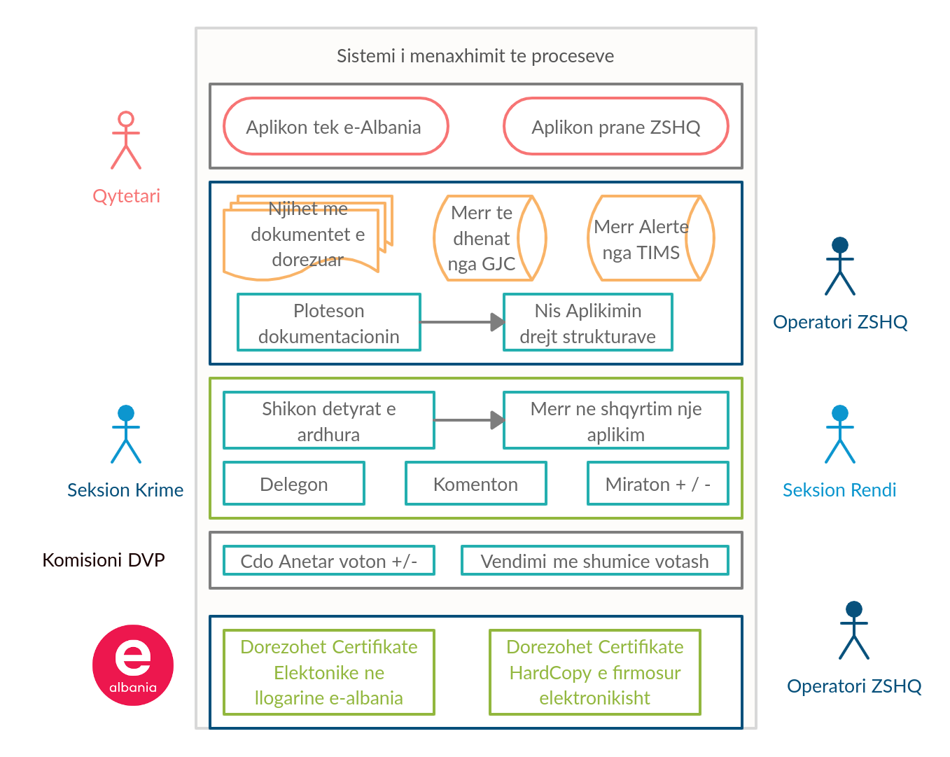

In summary this software will be an easy and user-friendly tool. It will allow for electronic management of most work processes, registration of different decision making steps and the possibility to check the work performance of not only the RH staff, but all the staff involved in public service delivery. The “Reports” section of the software was developed to provide numerical and graphical representation of the work completed.

On July 29, 2020, the system, which is considered ready for use, was presented to ASP HQ and entered the pilot phase. The presentation was attended by representatives of the Directorate of Public Order, Road Traffic and the CP Sector. Attendees decided to start piloting and testing the software at the RH of Elbasan Commissariat. After the presentation, the participants, who will be also the main users of the software, confirmed the ease and simplicity to use it and expressed their satisfaction with this software**.**

**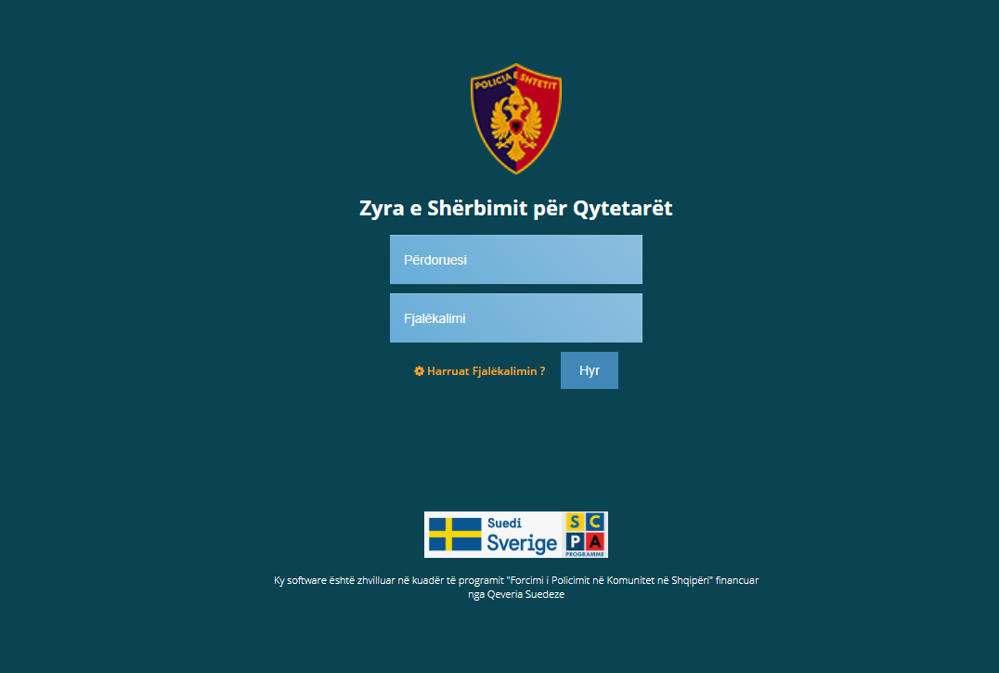**

**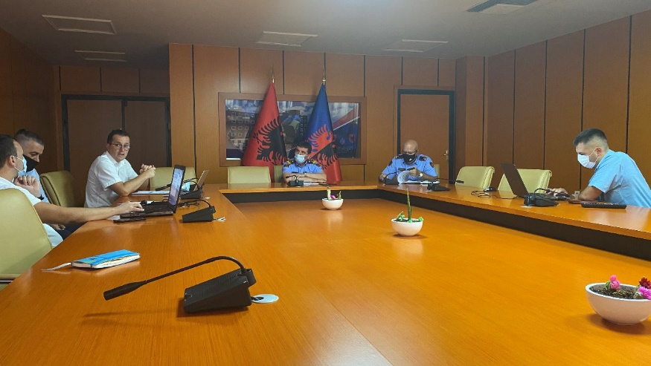**

**1.2. Strengthening local partnerships**

***Activity 1.2.j. Initiate and support the establishment and working of regional/local safety and security* councils in the municipalities included in the two TLPDs. In the municipalities where they exist, support proper functioning and discussion of common concerns related to security and safety in the neighborhoods.**

During the reporting period, the Covid19 spread affected this activity. In the first semester of 2020 the establishment of LCPS in Kukes, Lezha and Laç was planned. All preparatory activities were completed and initial meetings were organized with the municipalities and other representatives from the ASP local offices. Unfortunately, due to restrictions for public gatherings, it was not possible to officially set up these bodies, expect for Laç, where the constitutive meeting took place in July 2020.

**1.3. Capacity building to transform ASP into a modern citizen and service oriented organization**

**Activity 1.3.l. Initiate the development of curricula for training of all police officers to transform ASP into a modern citizen and service oriented organization. Deliver and evaluate the training.**

At the end of the extensive series of trainings organized and implemented by the project, where almost 650 CPOs were trained in four training days each, the project, in cooperation with the Academy of Security and the ASP started a process of incorporating the training in the permanent curricula of the Academy, be that at the Faculty, or at the College. In this way, the full content of the trainings, will be delivered in a systemized and structured way to all new students.

The project assessed the curricula of the Faculty and College of the Academy of Security, with the aim to find out how the students of bachelor studies (Faculty) and the police cadets (College) are educated and trained in CP, and in managing urgent police operations. The assessment showed that the Faculty delivers CP in two specific teaching hours and in two seminar hours. Some CP topics are included in other related modules. The CP subject delivered at the College is more comprehensive but seems not well regulated in the curriculum.

Comparing with a German police training curriculum any specific module for CP is not included. Instead, due to the long tradition of CP in Germany, CP is an integral part of all relevant modules. In Albania however, it seems quite meaningful to provide the police students, especially at the College, with a specific module for basic understanding of CP. This is in line with the CP strategy of the government.

The Faculty of the Academy agreed to incorporate more hours for CP in the bachelor studies in the so-called “open lectures”. Based on a proposal of the project, they will deliver themes like “Surveys and CP” and “Cooperation with the local government and Local Councils of Public Safety”. Thereby any modification of the curriculum is unnecessary. Furthermore, it was decided that the project should deliver a workshop for the lecturers of the Faculty, mainly on teaching techniques and the development a short training manuals on various topics.

The CP modules of the College curriculum will be enhanced. The project has developed a series of modules on several themes. This was discussed with the Head of the College and he agreed to conduct a workshop with the College lecturers responsible for education and training of CP. In this workshop the introduction of additional CP themes will be discussed and decided.

With regard to education and training to manage urgent police operations, the curricula of the Academy and the German institution are not essentially different. The project proposes to include only a few additional topics to enhance the current College modules.

Furthermore, the project has developed concise “trainer manuals” on selected CP themes. These serve like a road map for the lecturer on how to structure a lesson. Due to the frequent replacement of lecturers the College is highly interested in this. The before mentioned workshop will be used to develop some examples.

**Activity 1.3.o. Organize study visits to other European countries**

The project planned to organize a study visit for the police representatives on topics centered around community policing and domestic violence in Portugal. Contacts were established and the program detailed and the visit was planned for May 2020. The trip, however, was cancelled at the end of March due to restrictions related to the Covid 19 pandemic.

The initial plan was to have the study visit to Portugal in May and the following one to Sweden in autumn 2020. But in view of the current situation with travel restrictions, as well as the prohibition to organize activities with many participants, this will have to be postponed.

## Pillar II – Strategic Management Support

The activities under this pillar are divided in three subcomponents:

**2.1. Strategic planning and performance evaluation**

The activities under this sub-component are focused on **improving the system of strategic planning and performance evaluation** within the ASP and MoI by increasing capacities to collect, analyze and use data to inform management, identify and better communicate results achieved by the ASP. The activities of the program are centered around the newly created Sector of Strategic Analysis, Planning, Monitoring and Evaluation in all LPDs.

**Activity 2.1.b. Support drafting the new Public Safety Strategy 2021-2026**

The experts supported the ASP to prepare the Community Policing Document 2018-2020 and also analyze the progress related to the Public Order Strategy 2015 – 2020. Recently, the Ministry of Interior requested the SCPA support in preparing the next Public Safety Strategy 2021- 2026. This was supposed to be a consultative process, albeit after the pandemic, it was transformed into desk work, combined with ZOOM meetings and consultations.

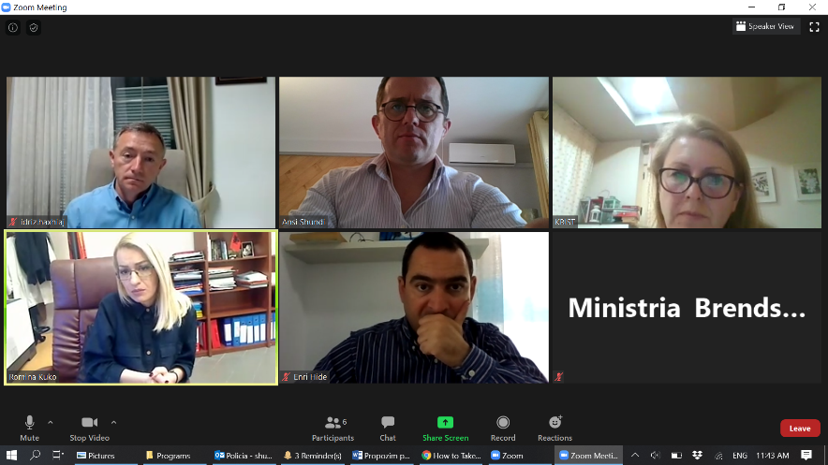

The Public Safety Strategy 2021 - 2026 comes as a need to renew the Public Order and Safety Strategy 2015-2020. With the launch and implementation of the decentralization process as well as the concept of community policing, public safety has already undergone a re-dimensioning in the way services are provided to the citizens. This new approach will be materialized in the new Public Safety Strategy, through which public safety will be applied more democratically and in accordance with the best Western standards and practices. The SCPA team has been tasked to facilitate this process and provide expertise to MoI and ASP in formulating the new Strategy and a respective initial 2-year Action Plan.

**During March – April 2020 several strategic meetings** with MoI and ASP and supported by SCPA experts took place to discuss three options to pursue regarding the formulation of the new strategy. Furthermore, **a desk review of several EU countries’ similar strategies** has been prepared by SCPA experts and provided to MoI and ASP.

**Option 1 – Utilizing the current Public Order and Safety Strategy** as a basis for the next six years. This strategy, as it extends to all areas of public order, can serve to address the classic security issues. This strategy beyond public security issues also addresses the phenomenon of organized crime and corruption, integrated border management and migration, alignment with EU standards and strengthening inter-institutional and international cooperation. Given the large scope and the general formulation, this strategic document meets the requirements for strengthening the level of security, as the issues that are addressed remain valid.

**Option 2- Extension of the current the Action Plan** of the Public Order and Security Strategy 2015-2020 by three years and thereafter start the work of drafting a new comprehensive strategy. This option will enable MoI and ASP to achieve all remaining or pending objectives in the Action Plan of the strategy, as well as their reinforcement with more measurable interventions and indicators, so that the vision and mission of this strategy is completed. This will then pave the way for the design of a new strategy with another dimension. Given the fact that the National Strategy for Development and Integration (NSDI), the National Plan for EU Integration (NPEI) and National Security Strategy (NSS) remain unapproved, this option could serve as the most optimal option.

**Option 3- Develop a new strategy, which will be based on the concept of community policing**, interaction and coordination with local actors and other law enforcement agencies to effectively address public safety issues in the territory. This strategy comes as a necessity considering the decentralization process and the need to empower local actors in this regard. As the strategic umbrella documents (NSDI, PKIE, NSS) are still being drafted/waiting for approval, it would be possible for the strategy to be drafted in parallel with them, in order to enable coordination of strategic policies and objectives.

The MoI and ASP are considering the Option 3 as the best approach for formulating the new strategy. Therefore, the SCPA experts have **produced the Draft Policies /Priorities and strategic objectives** for the new Public Safety strategy with contribution of ASP and MoI. During May 2020 **a road map** for the development of the strategy was drafted and approved.

Discussions on the most pertinent issues regarding the new emerging role of the Police and with a focus on community policing and a more proactive approach have been strategically held on several meetings during May – June 2020. **The SCPA experts have prepared a policy note for facilitating a strategic analysis process with MoI and ASP.** The processhas not been finalized as it will consider inputs by MoI, ASP, draft priorities discussed in various meetings and outcomes of the consultative process of August 2020.

**A draft report of key actions and measures taken during the old strategy 2015-2020** has been produced and will be shared with the MoI and ASP for final inputs in August 2020. **A list of key areas to be addressed by ASP** have been taken from the report and are to be consulted with ASP and MoI for further consideration in the new strategy action plan.

The new procedures for development of national strategies issued by Council of Ministers (CoM) on April 2020 require a formal process to be initiated with **a draft concept note proposing the three options and a rationale for selection of Option 3**. The draft was prepared for MoI and forwarded for consultation to CoM, before being discussed in the Sectoral Steering Committee. It is expected to have the concept approved in September and to start the preparations for the new strategy during fall –winter 2020.

**2.3. Support communication processes and capacity building**

Communication with the external stakeholders as well as within the organization is vital for the Police to increase the support and cooperation. In this regard the program supported the TLPDs and the HQ to carry out several activities.

**Activity 2.3.h Support the ASP to implement the Integrated Communication Strategy and Activity 2.3.i. Support implementation of national awareness campaign**

These activities were severely hit by the Covid 19 pandemic. Unfortunately, all activities in schools were interrupted in March 2020 and it was not possible to present the Traffic Safety topics as part of the second awareness raising campaigns. As the developments stand currently, it will be difficult to plan similar awareness raising activities when the new school year will start in September. However, the project stands ready to immediately step in, as soon as the situation will improve and larger events will be allowed.

Since the very start, SCPA is aware that interacting with youth and especially with school children presents special challenges, but these interactions can also bring opportunities to intervene with youth in ways to reduce delinquency, victimization, improve education and above all strengthen community relationships. In SCPA’s vision, cooperation with schools is crucial when trying to engage youth. Undoubtedly this was reflected in the careful tailoring of our activities, particularly those activities related to the youth educators.

Facing the growing demand for these activities, SCPA commenced discussions and consultations with ASP, MoI and the Ministry of Education, Sports and Youth (MESY) in order to extend the awareness classes to high schools. The Community Policing Document 2018-2020 provides a useful platform for launching such activities. It was agreed to involve security officers, social workers, or psychologists to carry out these trainings.

With the direct contribution of the Ministry of Education, a group of security officers and school psychologists to be trained was selected. The group consists of 171 participants, at country wide level, to be trained in 9 groups. The grouping took geographical proximity into consideration and the training had the following themes:

* Day 1 - Increase presentation skills, public communication, audience management, and
* Day 2 - Introduction to the content of awareness topics.

The SCPA program developed the training curricula and prepared production of leaflets and other materials (to be distributed in future presentations by security officers (SOs) in their respective schools), covered costs for trainers, participants’ transports and accommodation for long-distance travelers as well as logistic cost for development of the training. ASP guaranteed the participation of CPOs who were involved in previous youth education. By inviting them, SCPA could convey the same message delivered so far in 9-year schools and to enable networking between SOs and CPOs. MESY took responsibility for providing training facilities, preparing lists of participants and send out invitations. MESY also committed to start implementing the awareness campaigns in the designated classes, according to an approved schedule. Also, MESY appointed representatives who would serve as liaison officers and monitor the training and entire process. Under the initial agreement, a group of SOs would immediately start awareness classes in schools (March-June) with the road safety-related campaign. Due to the Covid 19 pandemic, this was not possible.

Chronologically, the training started at the Academy of Security in Tirana with two training groups, followed by two other groups of trainees in Elbasan and Durres with a total of 77 security officers. During the first week of March, 31 SOs and psychologists from Shkodra, Lezha, Kukes and Dibra were trained in Lezha, divided in 2 groups. After a break due to Covid-19, on June 22, the training resumed with 55 SOs and psychologists in the regions of Fier, Vlora, Gjirokastra and Korca. As a whole, a total of **18 training days** were conducted throughout Albania.

 

All participants were provided with literature and supporting materials as well as presentations and videos that were produced for this purpose. The materials are intended for the school year 2020-2021 and onwards.

During the 2-days multidisciplinary training, the following topics were addressed: presentation skills, communication with the public, audience management, interviewing and debating skills, planning and preparing presentations of the three modules (traffic safety, security at schools including bulling and cybercrime and use of light drugs). Of particular importance was the sessions where the CPOs shared their experience with the SOs, with a view to stimulate cooperation on joint presentations on specific topics.

Trainees also embraced the idea of creating an online forum, similar to the CPO forum for Youth Educators, in order to use this virtual tool for exchanging experiences. SCPA monitors this recently created forum, and notes with pleasure that the SOs are very active in exchanging learning experiences and presentations.

SCPA takes the opportunity to extend special thanks to the MESY officials, who have unreservedly supported this initiative since it was launched and have made all necessary efforts to assist in organizing the trainings. All participants have been active in the training activities and have expressed enthusiasm for this initiative. It is satisfying to note that SOs in some schools already have begun to conduct awareness-raising activities.

The Directorate of Public Order and Security and the Community Policing Sector in ASP have been an active part in the discussions and have participated in several activities. Such cooperation, involving all stakeholders, is a great example of raising awareness among young people, which will contribute to increased public safety in the community.

## Pillar III – Domestic Violence Support

The activities have proceeded as planned for this pillar, although it was not possible to visit and monitor on the ground the work of the CPOs and CIDs following the training provided in Elbasan and Kukes LPDs.

**Activity 2.j. Specific training for CPOs and crime inspectors on DV cases**

In coordination with the UNDP, the ASP HQ and the Academy of Security, it was agreed that the SCPA program should deliver training on the implementation of the latest changes and amendments regarding the preliminary immediate protection order and the conduct of risk assessment for domestic violence cases for the two TLPDs of Kukes and Elbasan.

On 14, 15 and 21 January 2020, three one-day training sessions on “Legal Amendments in Addressing Domestic Violence” were held at the Elbasan Local Police Directorate. The training sessions were attended by a total of 72 community policing officers and Crime Investigation Experts (CIDs) from Elbasan LPD staff and its subordinate commissariats. These training sessions followed the ones in LPD of Kukes and the commissariat of Tropoja that were conducted in December 2019. The aim of the training was to provide the police officers with sufficient skills to carry out structured risk assessments and contribute to a uniform implementation of the specific legal provisions introduced by the recent amendments in DV law. Risk assessment procedures are intended to assist professionals in analyzing concrete situations, introducing a greater objectivity, identifying the level of the present risk and thus guide police action better, in order to increase the safety of victims.

The training was jointly conducted by the national DV expert of the SCPA program and the head of the Juvenile Protection and DV Sector of the ASP HQ. In addition to addressing changes in the legal framework, the training also focused on the practical aspects of issuing an order for the preliminary immediate protection order of the DV victim and risk assessment for domestic violence cases.

With the completion of these training sessions the objective that all the staff involved in the DV cases investigation in the pilot LPDs of Kukes and Elbasan should go through the training cycle is achieved.

**Activity 3.2.k. – Restructuring and reorganizing internal premises in pilot commissariats**

On the 19th of February, the inauguration ceremony of the Minor’s Interview Unit in LPD Elbasan was held. In the ceremony participated the Minister of Interior, the General Director of Albanian State Police, the Program Manager from the Swedish Embassy and the representative of PMT.

The Interview Unit for Minors and Victims of Domestic Violence underwent a complete reconstruction and refurnishing. In order to use the equipment efficiently audio and video recording equipment were installed and a one-day training with the DV and crime investigation experts was held.

By supplying this unit with equipment and expertise the latest international interviewing standards and norms, set by the Criminal Justicefor Children Code (Juvenile Code), are met for the first time in Albania. This is intended to limit the number of interviews, statements and hearings involving a minor and a victim of violence as well as to enhance the quality of the investigation.

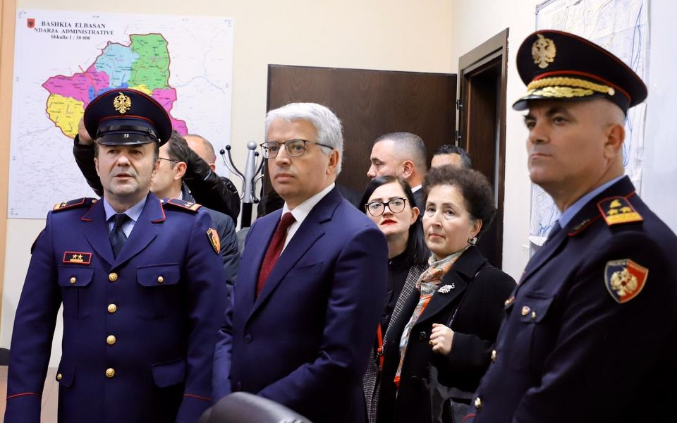 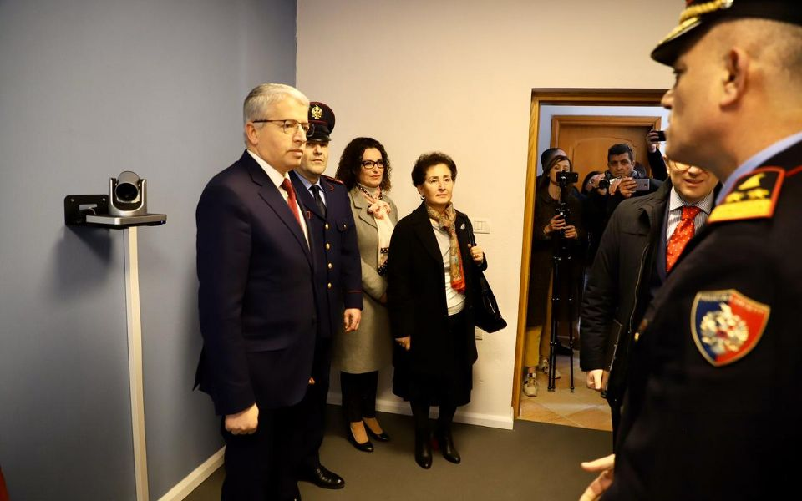

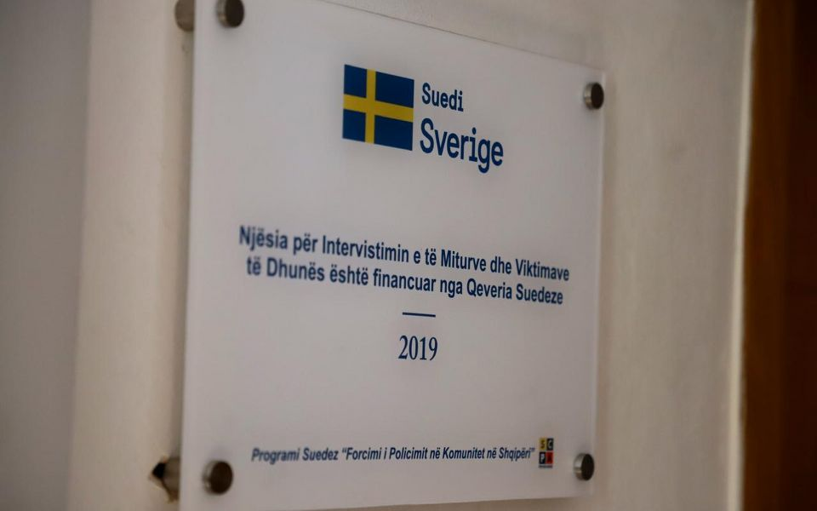 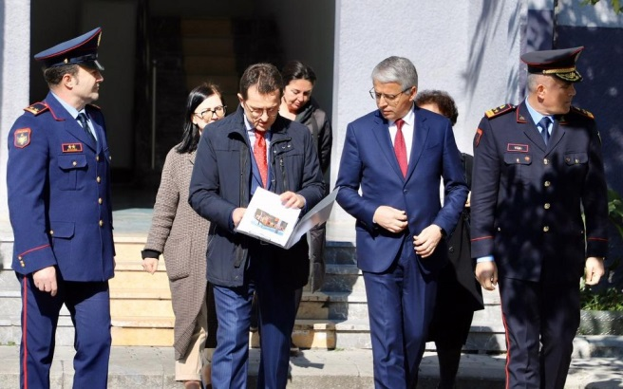

## Horizontal Activity - Grants Scheme

The Covid-19 pandemic specifically affected the grant scheme. Starting from mid-March, given the quarantine situation and restrictions, most of the grantees of the round 3 remodeled and rescheduled their project activities into remote activities and online training, adapting the project design in accordance to the pandemic restrictions . For some NGOs, which had regularly used teleworking and online meeting tools prior to the pandemic, the transition was fairly seamless. For others, whose work mainly consisted of public events, partner facility visits, workshops the pandemic turned out to be a serious challenge.

For that reason, during April the PMT organized three webinar trainings with representatives of about 20 NGOs implementing the third and fourth round projects of the Grant Scheme. Virtual meetings took place 27, 28 and 30 April 2020, on the Zoom platform. The training sessions focused mainly on general knowledge of online or distance work, managing and using tools to implement online work, as well as practical aspects related to remote work. The training sessions aimed at assisting the organizations facing physical/social distance to solve their problems through technological means. The webinars were offered as an effective alternative to facilitate a considerable part of their work processes such as communications, reporting, project development in online environments and other elements according to the respective agendas. It also aimed at increasing the efficiency and flexibility, especially in managing people remotely, managing documents, and gaining knowledge in using some of the technologies that enable this process.

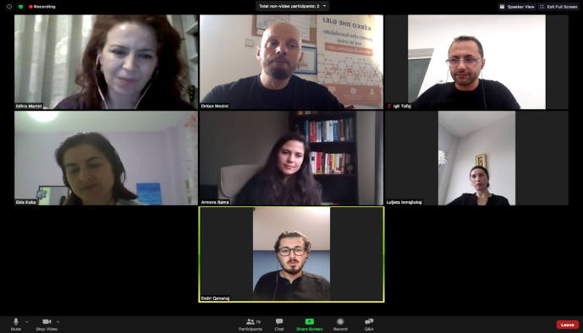 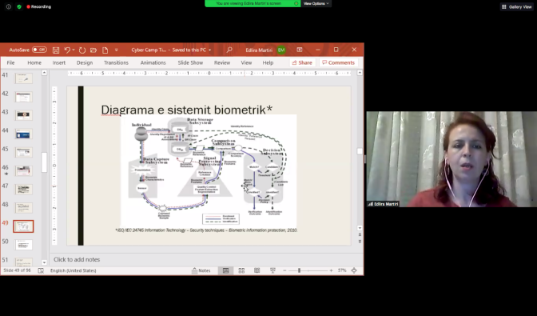

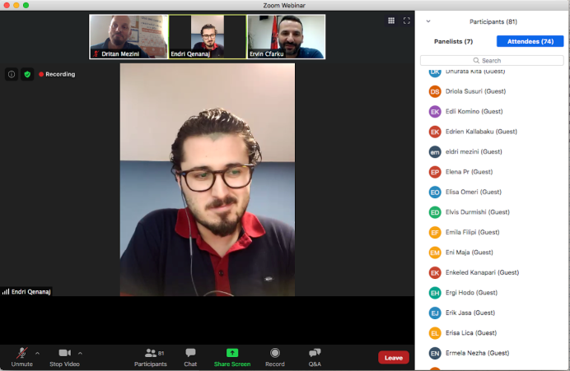 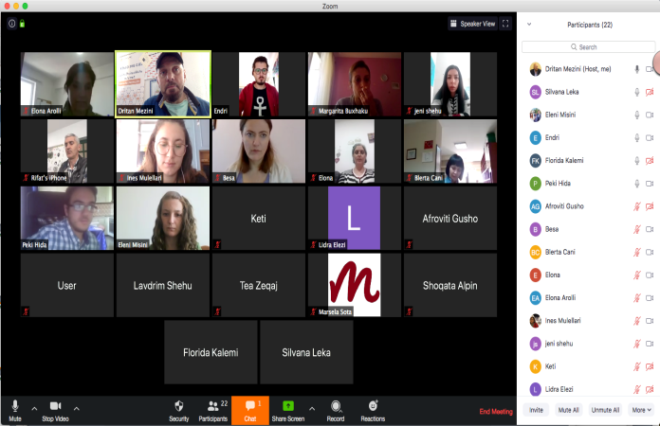

The webinar training continued with the individual coaching of the grantees, and they were mentored via email, WhatsApp and Zoom on issues related to organization of online work and use of specific tools.

The training proved to be beneficial for the grantees. Meanwhile, by end of June, 15 out of 17 projects of the 3rd round succeeded to complete the activities, while two projects are still ongoing on a no-cost extension basis.

Some of the highlights of the 3rd round projects were:

* Local Councils of Public Safety (LCPS) have been established and validated in four municipalities with efforts and contribution of three NGOs, grantee of the 3rd round of the Grant Scheme (Other Vision Organization in Peqin, TED Center in Korca, Vlora Youth Center in Selenica an Himara) and an Action Plan is drafted in each established LCPS. Another NGO, the Institute for Policy and Legal Studies is facilitating the establishment of the LCPSs in Kurbin and Lezhe, where formalization meetings are expected to be held soon. In addition, Vlora Youth Center facilitated the whole process of the establishment of the LCPS in Vlora municipality. In all seven LCPSs have been established with the help of the 3rd round grantees.
* The Coordinated Referral Mechanism (CRM) on DV cases has been established in the municipality of Librazhd and it has been reactivated in Peqin municipality. A two days training was conducted with members of the multidisciplinary technical team of each CRM.
* Partial reconstruction and complete furbishing of the community policing office in the Administrative Unit No. 3, Elbasan LPD.
* There have been 270 educational and preventive joint activities that NGOs have organized jointly with the police at the local level;
  + There were 182 information and awareness sessions on community policing organized with students of 59 high and 9- years schools;
  + There were 25 training sessions and 19 round tables conducted with community policing officers, local stakeholders and peer educators;
  + There were 4 community meetings and public forums organized in the designated districts;

During February and March 2020, the process of selecting the winning applicants for the fourth round of the Grant Scheme was completed. The fourth round includes the districts of Kukes, Berat and Tirana. Following an intense awareness campaign, a significant number of civil society organizations submitted their proposals, 27 in total (Berat 4, Kukes 7, Tirana 16). They went through the selection process carried out by the Local Selection Committees co-chaired by the respective LPD heads and the PMT representative in a transparent process.

A novelty for the fourth round is the project’s use the FCG Grant Management Application, which recently has been developed. It is a web-based tool, which facilitate the overview, document management, monitoring and risk management of grant scheme.

In May, after the conclusion of the negotiation process between PMT and the implementing organizations, there were 10 projects contracted. The fourth round grants are distributed as follows:

|  |  |  |  |  |
| --- | --- | --- | --- | --- |
| **Region** | **Grant size** | | | **Budget** |
| **Small**  (up to 5,000 €) | **Medium**  (up to 10,000 €) | **Large**  (up to 15,000 €) |
| **Berat** |  | 1 |  | 9,550 |
| **Kukës** | 2 |  |  | 9,438 |
| **Tiranë** | 4 | 3 |  | 49,078 |
|  | **Total** € |  |  | **68,066** |

With the 4th round awards, the overall contracted amount is 467,447 Euro, meaning 94.4% of the total fund dedicated to the Grant Scheme.

The thematic distribution of funds is as follows:

* Two projects aiming at supporting efforts for DV awareness and establishing and consolidation the local referral mechanisms;
* Two projects aiming at supporting the establishment and capacity building of four Local Councils of Public Safety;
* 8 projects aiming at consolidating partnerships between the ASP and local communities and schools.

All the winners have started project implementation by May 2020 under the Covid-19 situation . As mentioned above, most of them benefited by the webinar training organized by the PMT and remodeled their activities in accordance to the restrictions, adjustments which were sustained even after the quarantine was lifted.

On the 30th of June 2020, pupils of schools in Tropoja, under the auspices and supervision of the road traffic police, patrolled all the most important roads of Tropoja, like the ones to the Valbona Valley, Fierzë (the ferry) and the streets in town. This activity was held in the frame of the project of the 4th round “Child road safety and community policing in Tropoja” implemented by the NGO “Alpin”. This activity was a call to all the Tropoja’s citizens to enhance road safety and increase awareness about road safety rules. The activity was attended by the Deputy mayor of Tropoja, the head of Police Commissariat, the Programme Manager from the Swedish Embassy, other local government institution representatives and the PMT.

# Budget expenses

The total invoiced amount up until end of July 2020 amounts to 24 373 356 SEK, which corresponds to 81% of the total contract budget of 30.000.000 SEK. The last invoice from FCG included both June and July, and it is difficult to give an account for June separately. Therefore, the budget follow-up here includes also July.

In relation to the project time that has passed (90% by end of July) the spending is proportionally a bit low. However, some major budget items come at the end of the project, such as investments and the Grant Scheme. These alone sums up to almost 2 million SEK and are already committed.

Regarding the spending of fees, these are well on track and in line with the budget.

There are a few budget items, which utilization might be impacted by the Corona epidemic. That concerns study tours and awareness raising campaigns, see more information below. The project will follow the spending pace and regularly provide Sida/The Embassy with updated forecasts during the remainder of the project.

# Focus for the next phase

The project is entering its last semester of implementation and activities are very intensive, especially taking into consideration the situation caused by Covid19. There is no doubt that the project’s activities will be affected compared to the original design and some might not be possible to implement. The project’s team stands ready to adapt to this exceptional and rapidly changing situation, with the main aim to implement as much as possible from planned activities. We regret that some of the activities might not be possible to implement till the official end date of the project. In case of an extension, these activities might be reconsidered. The study visits might not be possible, given the travel restrictions for Albanian nationals and restrictions in gatherings with many persons. Another big activity related to awareness raising campaigns in schools, risks to be postponed, although we will monitor the situation closely and will try to retake these activities in schools as soon as it will be possible.

In this phase the aim is to complete as many activities as possible and to consolidate what was achieved so far. As there might be chances for an extension of the program, we are confident we can recuperate the lost time and retake the activities restricted by the situation.

Activities under the first pillar will focus on fostering the changes in Elbasan LPD in view of the new approach to community policing, based on the “police zone” concept.

**Proposals for the next phase:**

* Supporting the TWG and the LPD Elbasan with
* preparation of the staff of the LPD Elbasan for the changes (e. g. information campaign, on the job training, training of computer skills);
* provide laptops to CPOs in Elbasan, especially the ones in rural areas;
* renovate police offices in rural areas in Elbasan region (7 offices);
* guidance for the changes for the managerial staff in Elbasan LPD and staff on the ground;
* monitoring of the implementation of the changes in the LPD Elbasan and evaluation of the results achieved;
* consolidation of the intended changes (sustainability).
* Supporting the Faculty and College of the Academy of Security in improvement of the training modules/themes for Community Policing.
* Deploy the mobile office dedicated to CP (minivan for the CP Sector).
* Provide laptops and projectors (40 sets) for the CPOs Educators and work with the youth.
* Support the ASP and Ministry of Education in implementing awareness raising campaigns in schools.
* Finalize the construction of the martyr police officer’s house in Bushnesh village, Kruja district.
* Support the MoI and ASP in drafting the new Public Safety Strategy 2021-2026.
* Run the national Police Satisfaction Survey, elaborate the data and use the information for elaboration of strategic documents.
* Run the last LSMS in Elbasan and Kukes regions, elaborate the data and inform the local councils of public safety.
* Monitor the activities and supervise the conclusion of all grants from rounds 3 and 4. Elaborate a final monitoring report.
* In coordination with the Public Order Directorate and IT Directorate support the roll-out of the Reception Halls’ software. Support training of the users and implementation of the program.
* Support the activities of Referral Mechanisms in the targeted municipalities.

# Annex I – Updated Logical Framework

|  | ***Intervention logic*** | ***Objectively verifiable indicators*** | ***Sources of information*** | ***Comments*** |
| --- | --- | --- | --- | --- |
| **Overall objective** | Contribute in building mutual trust and partnership between police and communities in order to create safer neighborhoods. | Safety situation in Albania positively assessed | * Ministry of Interior reports * ASP reports * Statistics * European Commission Progress Reports * Project reports | Based on PSS of May 2018 cc. 63% of Albanian citizens consider the ASP is doing a “good” or “very good” job.  75% of Albanian citizens declare they feel “safe” or “very safe” walking in their neighborhoods at night.  Only 62% of citizens are willing to call the police when they see a crime committed on the streets. |
| **Specific Objectives** | 1. Accountable, capable and responsive institutions providing community safety & security 2. Citizens play an active and positive role towards their personal & CSS | * Albanian agencies skills to address community safety issues enhanced * Increased citizens personal engagement and through CSO in safety and security issues | * Ministry of Interior reports * ASP reports * Statistics * Program reports | 655 CPOs trained by the program  40 Analysts  Workshop for 60 CPO-Youth Educators  Workshop for 171 School Security Officers and Psychologist  9 workshops for the managing staff and analysts  13 LCPS activated or established.  45 CSOs contracted to support safety initiatives in local communities. |

| **Mandatory outputs** | | | | | |
| --- | --- | --- | --- | --- | --- |
|  | ***Areas of Intervention*** | ***Objectively verifiable indicators*** | ***Sources of information*** | ***Outputs Jan- July 2020*** | ***Overall outputs*** |
| **Pillar 1** | 1. Support the ASP in enhancing the efficiency of CP structure 2. Strengthening local partnership 3. Capacity building | * Thorough analysis of the TLPDs conducted. * Identification of the elements best fitting to Albanian context done. * Revised job description/job profile of the CPOs * Revised SOP presented * ASP HRM assisted to assess current CPOs against new job profile * CPO work in two TLPDs is coached, monitored and assessed * Material support provided to the selected CPOs of the TLPDs * Virtual Police established in the TLPDs * RH business processes enhanced and material support provided to RH of the TLPDs * LCPSs in the two TLPDs revitalised and established. * The police representatives in the LCPSs coached and sensitised on the police role in the forum * Training curricula for all police officers on the CP principle developed and modernised. Staff trained * CPOs curricula revised and enhanced; ToT training * RH staff trained; ToT training * Study Visits carried out | * Programme reports * ASP reports * Surveys * Statistics * Meetings * Minutes of Meetings * No. of staff trained | New job descriptions for CPOs and Patrol Officers compiled  Regulation on the Technical Working Group in charge of piloting the changes in Elbasan LPD established.  Kick off meeting with managerial staff on the changes held.  Online coaching on the changes in LPD Elbasan  Logistics need assessment for CPO rural offices in LDP EL conducted, Procurement of the laptops finalized.  The development of the RH software for business processes concluded and started the piloting and testing phase.  The Laç LCPS kick off meeting held.  A review of the CP curricula at the Academy of Safety carried out. Future actions defined. | The TWG started working on the assessment report recommendations  New CPO job description drafted Elements for CP fitting Albania case recommended.  15 job descriptions recommended for LPDs and Commissariat, including CPO position.  60 bikes and other firefighter equipment provided. Command and Control Room in Elbasan & Reception Hall and other premises in Has Commissariat and Librazh commissariat renovated.  Command and Control Room of Kukes LPD co-financed with the local businesses.  Prevention Room for Kukes LPD reconstructed and refurbished  Reception Hall and detention premises of Tropoja reconstructed  Web constable established in TLPDs.  LCPS in Elbasan is active, while LCPSs in Has, Tropoja, Librazhd, Perrenjas, Gramsh, Patos, Kavaja, Peqin, Selenica and Vlora established.  Training curricula for CPOs drafted, ToT delivered and training provided to 55 officers. Coaching provided for Elbasan and Kukes LPDs.  Study visit in Slovenia and Croatia focused on CP practice organized in June 2018 and study visit to Germany organized in May 2019. |

|  |  |  |  |  |  |
| --- | --- | --- | --- | --- | --- |
| **Pillar 2** | 1. Strategic Planning and performance evaluation 2. Coordination between stakeholders 3. Communication | * Progress report and lessons learned on the Policy Document 2015-2017 conducted; New Policy Document 2018-2021 drafted * Capacities of the organization at all levels to effectively monitor and assess implementation of policy documents and action plans increased * An efficient monitoring system put in place * The two TLPDs supported to draft periodic progress reports and identification of bottlenecks * Capacities to externally monitor and evaluate the work of the police increased; national and local surveys conducted * LCPS used an efficient mechanism to address local issues * Partnerships with citizens and other local contributors increased * Integrated Communication Strategy of ASP implemented * National Awareness Campaigns of different topics carried out * LPD spokespersons trained and their job description/profile reviewed. * The PR/Communication curricula of the Academy of Security for initial and continuous training reviewed | * Documents, reports, interviews * Notes from TGPM * Assessment of Community Policing practice * Monitoring and Evaluation * Surveys * Statistics * ASP reports * Visibility materials | A Draft Policies /Priorities and strategic objectives for the new Public Safety strategy 2021-2026 was produced  A draft report of key actions and measures taken during the old strategy 2015-2020 has been produced  Newsletter for Elbasan and Kukes LPD monthly produced  152 School Security Officers and Psychologists trained on the awareness raising topics to be held at schools. 18 days of training in total | CP Document 2018-2020 approved. Monitoring plan drafted.  Analysts and managers in 2 TLPDs trained (25 participants in 10 training days). Coaching delivered (20 coaching days). 16 analysts in other LPDs trained in 8 days modules.  Police Satisfaction Survey 2018 completed and results shared with stakeholders.  LSMS I & II for Elbasan and Kukes completed and results shared and discussed with stakeholders. Results of PSS presented in Elbasan LCPS and members invited to take measures.  12 LPDs spokespersons trained in 3 days training and coaching provided as follow up.  Newsletter for Elbasan and Kukes LPD produced and web constable launched.  Manual for the CPOs Educators prepared; 5 days training for 60 participants delivered. 3 awareness campaigns developed. Web Forum for Educators developed. Leaflets and booklets printed and distributed.  Workshop with managing directors of the LPDs  Workshops with analysts and managing staff of 8 LPDs.  A workshop for all the LPD directors organized  SOP for the new sector proposed by the program and approved by the ASP  Workshops with analysts and managing staff of Shkoder, Korca, Vlora, Fier, Elbasan, Kukes, Diber and Lezha LPDs  CPOs- Youth Educators participated in a workshop on the new themes and experience sharing  LSMS II for Elbasan and Kukes compiled and data to be shared in the upcoming period  Monitoring of the Educators Online Forum and advising them |

|  |  |  |  |  |  |
| --- | --- | --- | --- | --- | --- |
| **Pillar 3** | 1. Strategic Level Interventions 2. Capacity Building and Strengthening 3. Infrastructure and Logistics support | * Report on Prevention Approach completed * Legal and by-legal framework on DV revised * SOPs on DV cases enhanced * Data collection system for the ASP, Prosecution Office and Courts established * Referral Mechanisms established and functional in TLPDs * Awareness campaigns in TLPDS against DV and gender based violence * Capacity Building Plan on DV elaborated * Training curricula and modules on GBV and DV upgraded * Refreshing training delivered in all LPDS on GBV and DV * Training for CPOs and CIDs delivered * The DV interviewing areas in the TLPDs commissariats restructured and reconstructed * Material support for the CPOs and CIDs in agreed commissariats provided. | * Project Reports and documentation; * UNDP, UN Women, OSCE reports ; * Ministry of Health reports; * MoJ and Prosecution Office Statistics. * Police reports/statistics; * Project Reports; * Assessment reports & Surveys; * Monitoring & Evaluation Plan; * UNDP & UN Women databases, maps and reports * The Ombudsman /Internal Control Service /M. of Health /M. Education and Sciences / Local Government reports | Referral mechanism established in Librazhd and reactivated in Peqin.  72 CPOs and CIDs were trained on the legal amendments of the DV law and the risk assessment  Interview Unit for minors and DV victims in LPD Elbasan created (works + equipment) and staff trained | Referral Mechanism established in Gramsh, Belsh and Kukes and continuous support provided.  DV Awareness Campaign implemented in November-Dec. 2017, 2018 and 2019.  Friendly interview room in Librazhd and Comm. 4 in Tirana completed.  Interview room created in Has.  The report on Prevention Approach finished and submitted Capacity development plan drafted  42 police officers of Kukes LPD trained on addressing DV cases and risk assessment.  Interview Unit for minors and DV victims in LPD Elbasan created (works + equipment) and staff trained  Consolidation of the DV Referral Mechanism in Belsh, Gramsh and Kukes through support  Awareness raising campaign during 16 days of activism against violence against women in 6 districts Vlore, Elbasan, Kukes, Lezhe and Pogradec.  Capacity development plan drafted  42 police officers of Kukes LPD trained on addressing DV cases and risk assessment.  Interview Unit for minors and DV victims in LPD Elbasan created (works + equipment) and staff trained |
| **Grants** | Empower civil society organizations to embrace and implement the CP philosophy and support to combat DV. | * Grants Scheme implemented as planned and scheduled | Grantees reports  Program Reports  Surveys  ASP reports | Fourth round 10 winners selected and contracted | 55 grants’ contracts signed, covering 10 regions in Albania  467,447 Euro contracted. |

# Annex 2 Risk Matrix

|  |  |  |  |  |
| --- | --- | --- | --- | --- |
|  | Risk Factor  (security, political, operational , financial, reputational) | Impact | Likelihood | Mitigation Strategy and Responsibilities |
|  | **High-level buy in** | | | |
| 1 | Overburdened national partners / lack of resilience   * Political unrest especially during the pre-election period * Excessive demands of national partners results in them losing interest or willingness to participate in program * Other demands results in low priority of community policing * National counterparts may not be able to operate at the speed desired of the PMT to design and set up specific activities within the program streams * Pressure by senior leadership to produce results within unreasonable timeframes (including pressure focusing on outputs, rather than outcomes) | Medium | High | * Pay attention to specific local deadlines or other demands * Use existing local systems and procedures (i.e. monitoring systems, rather than setting up parallel structures) * Sida/PMT to ensure that international community is communicating and cooperating with each other and ensure common interest and objectives in community policing * Capitalize on the demonstrated interest from senior MoI and ASP leadership in the program * PMT to ensure sensitization across senior MoI and ASP leadership of the program work plan and estimated timelines |
| 2 | Lack of, or unwillingness of, stakeholders to participate and cooperate   * Resistance or mistrust from communities and local government / decentralized institutions to cooperate with police * Partners within the regions do not feel they are part of a process | Low | High | * Ensure transparent processes and encourage local partners to actively participate * Support for partnership approaches can be developed with the relevant line ministries (advocacy and liaison) * Risk management matrix and development of mitigating strategies is carried out collectively by the SC * Capitalize on the excellent partnerships developed during the first phase of the program |
| 3 | Major reshuffle of key police personnel   * Key personnel are moved to other positions before progress can be institutionalized within the ASP or LPDs * Long term vacancies in key positions – The Chief of Sector for the CP Sector at the Headquarters is vacant since 8 months and staff is overburdened with tasks | Medium | High | * PMT to monitor personnel shifts and timely reporting to SC * Explicit approach by the SCPA to strengthen institutional capacity not just focus on individuals |
| 4 | Lessons and progress made as a result of the program are not recognized by decision-makers and do not inform future policy development   * The SCPA seeks to develop institutionalized behavioral change. The gains of the program will not be sustainable if the changes remain solely at the individual level and do not influence policy changes that support cultural shifts in the way of working | High | High | * Sensitization activities on key lessons to be incorporated into the PMT program monitoring process * M&E program stream to include creating or developing mechanisms to ensure that the lessons are fed into MoI/ASP policy making bodies * The SMS Coordination stream will encourage cross-departmental cooperation and cohesion * PMT to be prepared to provide summaries of key lessons and changes to the MoI if/when a process to develop an MoI policy on safety and security commences |
| 5 | Program loses coherence   * Pressure by the MoI/ASP to provide support to ad hoc activities outside the planned design * Program impact becomes diluted / program loses focus as a result of reacting to new/additional requests for individual activities from the MoI/ASP | Medium | Medium | * SC consent to be required, in addition to Sida’s, for any substantial deviations or requests for new assistance * Requests should be accompanied by clear analysis of how the new request contributes to achieving the program’s direct outcomes * PMT to ensure that requests for new activities are included in the preparatory documents for the SC |
|  | **Program processes** | | | |
| 6 | Corruption or allegations of corruption in program (particularly relevant for the Grants Scheme)   * Misuse of funds and poor accounting * Favoritism of particular groups for projects | High | Low | * The SCPA shall continue the excellent transparent practices for their GS * Emphasis on transparency throughout program * Clear and transparent selection procedure for all projects * Allegations of corruption to be followed up immediately by the PMT and the Embassy/ the SC informed |
| 7 | Experts are not of a sufficiently high quality   * PMT staff members do not have the capacities to deliver the required quality of work * Short-term experts do not provide work of a sufficient quality / relevance to the Albanian context | High | Medium | * FCG / the Embassy / ASP / MoI quality control of program’s outputs * Use of the monitoring mechanism to track performance and follow up with feedback from the beneficiaries on expert performance * Clear terms of reference and expected deliverables to be developed for short-term experts etc. |
|  | **Sustainability** | | | |
| 8 | ASP and MoI do not follow the recommendations regarding budget allocations and staff reshuffle after TLPDs piloting   * Diversion of ASP funds to the TLPDs in order to ensure their short-term success * Diversion of ASP funds away from the TRPDs because they are covered by the program * ASP/ MoI do not systematically provide support to TLPDs | Medium | Medium | * Relative allocation of funding to ASP LPDs (including the TLPDs) to be monitored as part of the PMT monitoring mechanism * Concerns to be raised to the SC * Clear and transparent selection criteria for the TRPDs * Sensitization process across the ASP on the program – especially regarding progress being made, lessons learned, and dissemination and replication activities |
| 9 | Lack of responsiveness to adapt proposed models to Albanian specific situation   * Models provided by PMT for Pillar I do not fit with specific conditions | Medium | Low | * PMT will not design a “model” for the community policing in Albania, but will provide different elements of a model * The elements will be illustrated by international examples and provided with their “pros” and “cons”, aiming to develop an Albanian model. |
| 10 | Shift in international engagement   * International development programs fail to achieve stated aims and objectives in areas linked to the SCPA * Sida project overlaps or competes with other international project/demands and overburdens local partners | Medium | Medium | * Key international community (IC) actors have been informed/consulted throughout the design process * PMT to map out what key deliverables from other programs will influence their activities * Program proposal and future program activity documents to be shared widely with DDPFFA and the IC |
| 11 | Albanian authorities do not start to take on elements of budgetary responsibility   * Whilst the SCPA will absorb the costs for monitoring activities in the early stages of the program (e.g. citizen perception surveys) these will need to be taken on by the MoI/ASP progressively as the program unfolds * Any budgetary impacts for new procedures for the LPDs will also need to be incorporated into MoI/ASP budget planning | Medium | High | * Exit strategy contains clear mechanisms for the GoA to adopt gradually increasing funding responsibilities throughout the program – framework to be developed during the inception phase and built up over years 1 and 2 * Constant monitoring |
| 12 | Transfer of procedures, skills and expertise to other LPDs is not done in a sustainable way   * Pressure to replicate TLPD processes and approaches to other LPDs before they have been monitored, evaluated and proven * Lessons and new/updated ways of working are never transferred | Low | Medium | * Role of the IPA in advising on time lines * SC consensus on large scale replication activities * Continuous monitoring on progress and development of when aspects will be disseminated * Selection for LPDs based on international good practice * Individual risk analysis / mitigating strategies to be developed for specific dissemination/replication activities |
|  | **Force majeure** |  |  |  |
| 13 | Covid 19 pandemic conditions implementation of activities | High | high | * Continuous monitoring of the situation * Adopting a flexible approach in adapting the activities to the new conditions |

# Annex 3 - Participants/beneficiaries in SCPA activities

This biannual reporting time was characterized by a number of unexpected situations. Despite the unusual Covid-19 pandemic situation, PMT managed to maintain a good pace of implementing activities in accordance with the work plan.

Once faced with the new situation, PMT made all efforts to adopt a new strategy of implementing the planned activities and adjust its methods towards a better practical way of working.

By redesigning the work plan, where possible, SCPA encouraged beneficiaries and main stakeholders to participate in its activities when mass activities were in question. By involving participants in that approach, PMT managed to establish a base for sustained self-development efforts.

Increasing participation in program’s activities has always been considered by the SCPA as a useful tool in enhancing the effectiveness, efficiency and coverage of project benefits. SCPA has a specific objective to help create new or strengthen existing self-formed and self-run groups and organizations through which local bodies gain access to various resources, inputs and services and participate actively in the project activities.

SCPA program has closely monitored participation and number of beneficiaries in program’s activities as a whole. Below is a brief description of activities managed by PMT:

During this reporting period PMT achieved organizing in total **197** activities; **82** were regular meetings with the MOI, ASP HQ, LPDs, Academy of Security, Local government and other stakeholder representatives. Unfortunately, PMT could not organize regular PSC meeting and JWG meeting due to restrictions of COVID-19 social distancing and protection protocol.

On the other hand, PMT managed to organize **12** rounds of trainings that involved 56 CPOs from LPD of Tirana and 157 Security officers, social workers and psychologists from all over Albania, Training sessions took place in Tirana, Durres, Elbasan, Lezhe , Fier , Lushnja and Korca. During June 2020, all training sessions with Security officers were developed under strict protection measures against Covid -19. The PMT experts have taken an active part in supporting the Progress report of the Public Order Strategy and drafting the new one. For that reason, they have participated in **5** online meetings chaired by the Vice Minister of Interior. The Expert on strategic analysis has continued online support to the staff of the newly created sector of Analysis, Reporting Monitoring and Evaluation of LPDs of Kukes and Elbasan. During this period, she could organize 4 online meetings which proved to be successful.

During this reporting period, PMT also organized 4 Technical Work group meetings for drafting the SOP and revising the job description of patrol police service in the framework of the monitoring report on CPO situation. PMT experts have also organized 4 direct meetings and 3 online ones with Academy of security and Faculty of Security and Investigation in relation to analyzing and improving the Curricula on CP and urgent police operations.

PMT also organized 8 field visits in the area of TLPD Elbasan, out of which 2 were dedicated visits regarding monitoring of the situation of CPO offices and 1 field visit in TLPD Kukes (Tropoja and Kukes commissariat) in order to monitor the progress of the infrastructure support project in that area. During the last visit the monitoring team consisted of one representative from the Swedish embassy as well.

Regarding the DV Pillar of the program, 9 activities were organized. 4 activities aimed at either establishing or running existing DV referral mechanism committees in Elbasan, Vlora and Lezha area.

Within the grant scheme component PMT has also been active in organizing 8 webinars online training with almost 20 NGOs. 4 LCPS meetings have taken place, as well

Conveyed in figures, activities involved a total of **3581** persons out of which **376** were ASP personnel, **38** were senior ASP police officers, 27 midlevel police officers and **263** police officers who took active part in the activities. The Grant scheme activities were kept a high level both in terms of number of activities and participants.

PMT has emphasized the importance of a good gender balance in all three component areas. Gender indicators were assessed in all of the activities, meetings, workshops, seminars and trainings. Exclusively, the PMT guided the activities of the Grants Scheme towards the establishment of gender indicators, including an understanding of how contacts between the police and young citizens might differ (pending not only on gender but also on ethnicity and geographical extent). Also, PMT noted a rather good gender balance especially for the LPDs of Tirana, Vlora, Elbasan, Kukes and Lezha.

Over all, the PMT assessed that: 53.75 % or **1925** out of **3581** direct community beneficiaries were girls and young women; 48 % of the members in the implementing/core working groups of projects were/are women; 29 % of 376 police officers that have benefited from the activities were women police officers.

**Program’s visibility and outreach with the public**

During this reporting period the PMT succeeded in increasing the visibility of each component. PMT applied several ways and means to expose the program. Some of the effective ways to increase the program’s visibility were the following:

* The online forum of CPOs – Youth Educators and the forum for Security Officers in schools were a proven efficient tool to engage not only the assigned CPOs for education and work with youth but also ASP HQ and Academy of Security experts in exchanging experience with each other but also creating a network of CPOs and Security officers. Almost all the trainees have now joined the forum. They have been very active to display their activities (over 1523 photos uploaded) and have maintained regular communication, exchange of experience and work plans. The upcoming school year will show how this forum works and to what degree and quality the experience exchanging will develop.
* Meetings with community-based organizations and other stakeholders in the framework of LCPS, and Grant scheme activities. These meetings were considered as an important way to expose the program’s objectives and philosophy but also as a base for establishing networks in order to cultivate long-term relationships.
* Workshops and training sessions were used successfully as an already proven networking facility.
* The program’s web page, which is user-friendly, accessible and provides open, consistent and searchable information about all programs. The activity on the program’s web page has increased substantially. During the past six months the web page was visited by 27.089 viewers. The Program’s social network accounts in Facebook, Google LinkedIn, and Twitter have also been quite active. The web page has been very helpful, especially in relation to the GS. It should be noted that PMT managed to easily recover the functionality of the programme’s web page, in spite the passing away of the previous web manager in May 2020, and there was a period of 2 weeks without any web management. PMT took all the necessary measures not only to find a new web manager but also increase the web storage and resume every feature.

PMT has continued the appreciated practice of producing and distributing a short excerpt of activities, summarized in the Monthly Newsletter of the Program. The Newsletter is distributed to almost 300 receivers, including ASP counterparts, international partner organizations, NGOs and other Program’s stakeholders.

1. Please note the number of the activities is the same as in the Inception Report. In this progress report only the activities implemented in the reporting period are mentioned. [↑](#footnote-ref-1)