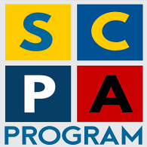
STRENGTHENING COMMUNITY POLICING IN ALBANIA
FORCIMI I POLICIMIT NË KOMUNITET NË SHQIPËRI

Implemented by:



BI-ANNUAL PROGRESS REPORT
(December 2021)

Project title | Strengthening Community Policing in Albania, 2nd phase, Program implementation 2017-2020
Project No. | UF2014/52825/TIRA
Country | Albania
Funding Agency | Sida
Implemented by | FCG Swedish Development AB
Address | Dalagatan 7, 111 23 Stockholm, Sweden  Web: www.fcgsweden.se  ++46 8 406 76 20
Contact person | Mr. Pontus Förberg, Project Director FCG  Cell: +46 70 214 21 81, Office: +46 8 406 76 20 pontus.forberg@fcgsweden.se
Date of report | 7 February 2021
Reporting period | 1st August 2021 – 31 December 2021
Chair of Project Steering Committee | General Director of Albanian State Police
FCG Project Team Members | Mr. Ansi Shundi, Team Leader  Mr. Ulrich Dugas, International Police Advisor  Mr. Enri Hide, Long Term Advisor  Mrs. Eldisa Zhebo, Long Term Advisor  Mrs. Miranda Fishka, GS Manager, DV Expert  Mr. Arian Braha, Program Coordinator  Mrs. Jolanda Gugaj, Program Officer
SCPA Contacts | Address: Blv “Zhan D’Arc”, Nd. 61, H.5, K. 5, Ap. 6, Tirana, Albania. Tel + 355 44 511 340  Mail: info@cp-project.al  Web: www.cp-project.al

Table of Contents

ACRONYMS AND ABBREVIATION 4
1. Introduction 5
2. Progress achieved based on Program Pillars 7
2.1 Pillar I – Local Police Directorate Community Policing Support 7
2.2 Pillar II – Strategic Management Support 17
2.3 Pillar III – Domestic Violence Support 18
2.4 Horizontal Activity - Grants Scheme 22
3. Budget expenses 25
Annex I – Updated Logical Framework 26
Annex 2 Risk Matrix 35
Annex 3 - Participants/beneficiaries in SCPA activities 39

ACRONYMS AND ABBREVIATION
ASP - Albanian State Police
CP - Community Policing
CPO - Community Policing Officer
CSS - Community Safety and Security
CID Crime Investigation Detective
DV - Domestic Violence
DVS - Domestic Violence Support
ESS - European Social Survey
EU - European Union
GD - General Director [of the ASP]
GoA - Government of Albania
GS - Grants Scheme
HQ - Headquarters
ICITAP - International Criminal Investigative Training Assistance Program
IPA - International Police Advisor
ISSAT - International Security Sector Advisory Team
SC - Steering Committee
JWG - Joint Working Group
LCPS Local Council on Public Safety
LPD - Local Police Directorate
M&E - Monitoring and Evaluation
MoI - Ministry of Interior
MoJ - Ministry of Justice
NGO - Non-Governmental Organization
NSDI - National Strategy for Development and Integration
OSCE - Organization for Security and Cooperation in Europe
PAMECA - Police Assistance Mission of the European Community to Albania
PPO Patrol Police Officers
PMT - Project Management Team
PGCM - Project Group for Change Management
SACP - Swedish Support to the MoI / ASP on Community Policing
SAPEMR - Sector of Strategic Analysis, Planning, Evaluation, Monitoring and Reporting
SCPA - Strengthening Community Policing in Albania
Sida - Swedish International Development Cooperation Agency
SMS - Strategic Management Support
SSR - Security Sector Reform
SOP Standard Operating Procedure
TLPD - Target Local Police Directorate
TWGs - Technical Working Groups
UNDP - United Nations Development Program
UNHCR - United Nations High Commission for Refugee
UNICEF - United Nations Children’s Fund
USAID - United States Agency for International Development

Executive summary

During the semester July - December 2021 the activities of the SCPA project focused on the implementation of the Police Zone concept entailing, inter allia, the cooperation and interaction of different police units within the zone, especially the community policing officers and the general patrol officers. The expected results from this intervention are: 1. A better alignment of CPOs with their core tasks and focus on enhancing the relationship with the community, serving the community policing paradigm; 2. Increasing the role of the General Patrol Officers within the police zone in managing and reporting cases; 3. Enhancing the cooperation with the public.
Following the piloting in Elbasan, the implementation of changes was extended to the first group of LPDs of Lezha, Shkodra, Kukes and Dibra. The monitoring activities in these LPDs were concluded during the reporting period and LPD individual reports as well as a summary report were prepared. In November the implementation activities kicked off in three other LPDs, Tirana, Durres and Fier and will be extended until spring 2022.
The results of implementation of changes, although not uniform in all LPDs and commissariats are encouraging. The LPDs are supportive of the changes and see practical benefits on the new way of implementing the daily activities. During this period, the project organized, in close cooperation with the Sector of Community Policing, several monitoring and consultation visits in the respective LPDs. In the 4 north LPDs a special training for the public order specialists and command and control staff was organized to improve their capacities in managing the cases in the light of the recently introduced changes.
A special training on cooperation and coordination in police zones was organized with the heads of community policing sections in all LPDs and commissariats, together with the Academy of Security. The feedback paper was prepared and submitted to the CP Sector. The project continued the efforts to increase the capacities of the CPOs Educators and a special refreshing training session was organized for them during the reporting period.
The implementation of the changes was accompanied with the upgrade of police infrastructure. The fully reconstructed Police Station in Belsh is now available for the police officers and the community. With this intervention, the project successfully concluded the infrastructure support in the TLPDs.
A major focus during this period was put on improving traffic safety in Albania. Therefore, 6 modern speed radars were procured and provided to the traffic police and almost 120 police officers from 6 LPDs were trained for their use. These radars can be used in automatic mode, minimizing the contacts with the public and potential corruptive practices. In addition, 110 sets of tablets and thermal printers for traffic police patrols were procured and donated. Several awareness raising activities were organized in cooperation with the Directorate of Road Traffic Police at the ASP and different grantee NGOs.
The project continued to support the partnership activities where the ASP is one of the stakeholders. A special focus was paid to the establishment and increased functionality for the Local Councils of Public Safety. The discussions regarding the legal framework continued with the MoI and the ASP and the project is directly supporting the activities of LCPSs in 7 municipalities.
Activities related to reinforcing Referral Mechanisms for DV cases were focused in 4 municipalities during this period. Capacity building activities and mentoring for the stakeholders was provided by the NGO contracted by the project.
During September-November 2021, in coordination with the ASP HQ the program delivered a training for 5 (five) LPDs, namely Durres, Gjirokastra, Berat, Shkoder and Vlore (CPOs and the crime investigation specialists – 219 officers in total). The focus areas of the training were the implementation of the latest legal amendments of the DV law regarding the urgent protection order and the risk assessment for domestic violence cases. As a follow up to the same training delivered in LPDs Elbasan and Kukes, the project assessed the quality of the risk assessment reports produced by CPOs of these LPDs during January – May 2021. The assessment found that there is still room for improvement and capacity building of the staff there, as many risk assessment reports are not yet up to the expected standard. The project is planning a refreshing training in these two LPDs. The findings from the assessment were also used to inform the training material delivered to the other LPDs.

By the end of 2021 the project was involved in implementation of awareness raising activities against gender-based violence in 5 major cities in Albania. The activities were organized as part of the 16 days of activism against violence against women, organized by the UN Secretary General.

Regarding the Grant Scheme, the activities of the grants under Round 5 continued as planned and the project issued the call for proposal for the last round, Round 6. Four regions are participating in this round and the selection will take place in early 2022.

The PMT would like to extend a sincere gratitude to all the collaborators from the ASP and other institutions, who participated in project activities and contributed to the joint efforts for increased safety in the community.

Progress achieved based on Program Pillars
The activities of the Program were implemented in line with the Action Plan 2021-2022 approved along with the extension package by the SC. The activities of Pillar 1 and the Grant Scheme were the most affected by the Covid-19 pandemic. During this semester the main project plan was to closely follow the implementation of the changes in Elbasan LPD and the expansion into the other 4 LPDs. The electoral campaign was another “distraction” factor influencing most of the activities of Pillar 2.

Pillar I – Local Police Directorate Community Policing Support

Pillar I constitutes the core of the project and many of the activities implemented during the reporting period are part of this pillar. In this regard, the program supported the implementation of a series of changes in the LPDs of Dibra, Lezha, Kukes and Shkodra, related to the functions of CPOs and PPOs, as provided by the new job descriptions approved by Order Nr. 197, 17.02.2020 of the ASP General Director. The implementation of these changes started after an initial piloting phase in TLPD Elbasan and the following discussions with local and HQ stakeholders. The discussions were based on the Final Report delivered by the TLPD Elbasan, which drafting was supported by the Program.
These changes aimed to disburden CPOs from the tasks that are not linked to community policing and increase their presence in their communities. They also affected other procedures/tasks in the police structure, e. g. the Command-and-Control Sector and the Public Order Specialists (PPO Shift Leaders). In order to proceed with the implementation of these tasks, each of the four abovementioned LPDs established “Project Group for Change Management” led by the LPDs Deputy Director for Public Order and Safety. They followed the model of TLPD Elbasan.

Activity 1.c. Support replication of changes in other LPDs

As a follow up to the activities implemented during the first semester of 2021, the project team had regular meetings across all northern LPDs and their commissariats (26 visits in total). The implementation process and the level of achieved changes were discussed with the LPD Directors, Heads of the Project Groups and the managerial staff of commissariats. Discussions included assistance to monitor the implementation plan of the changes in accordance with a set timeline, specific steps and actors involved, identification of challenges and indicators for the impact of changes, as well as ways to enhance reporting. This was enabled by means of introducing a new quality report for CPOs and their direct supervisors (see below).
Most of the commissariats have implemented the changes in a step-by-step mode in accordance with their capacities. The large commissariats have put most of the expected changes into practice, starting with the transfer of the tasks to deliver the notifications and traffic police fines from the CPOs to the PPOs of the urban areas. This activity was faced with some challenges due to the lack of an accurate address system, which in some cases were overcome through cooperation with the respective CPOs or joint patrolling of PPOs and CPOs. This process was partially achieved by the LPDs of Dibra and Kukes in urban and accessible areas, while it encountered difficulties in Shkodra and Lezha. This new task increases the engagement of PPOs into community policing, allowing them to acquire a better understanding of the police zone they cover.
Another change implemented was the establishment of a two-shift system for CPOs (08.00-16.00 and 13.00-21.00), together with the cancelation of regular stand-by night shifts for CPOs at the commissariat premises. As a result of this, the CPOs are allowed to stay on duty from home during nights on a weekly alert calendar to support their colleagues in case of emergencies. This will enable CPOs to spend more time in their communities and enhance the crime prevention capabilities. This change was achieved in all large commissariats of the four LPDs.
Another change aimed to improve the reporting process of CPOs was through the introduction of a Daily Quality Report (DQR). The DQR template was prepared by the Project Experts, presented to the LPD Director and the Head of the Project Group for Change Management (PGCM) at LPD level, and then introduced to the LPDs during meetings and workshops. This process could not be implemented in all LPDs due to CPOs lack of reporting experience, lack of logistics and poor working conditions. The process of filling out and supervising reports needs to be further consolidated, and further training is needed.
All LPDs are committed to identify tailored solutions for reducing CPO visits to Commissariats, depending on their specificities. This change aimed to increase CPOs presence in their police zone and their abilities to gather information to prevent criminal activities. This objective was achievable for most CPOs of urban commissariats, while it was more difficult to achieve for distant rural areas. This is due to the fact that CPOs covering rural areas are obliged to report and/or visit their commissariats for passport verifications and fill in other forms related to information collection (such as SK1 and SK2) and write Case Management Reports. In order to improve the situation, they need computers, internet and police intranet access from their zone offices.
The CPOs spend significant amount of time for territory control of cannabis, especially during the cultivation period. The Project suggested the establishment of a mixed team at LPD level exclusively responsible for territory control, with all adequate equipment. The CPOs would only support the mixed teams with data and information. However, due to the importance of maintaining close supervision on the territory to avoid cultivation of cannabis, it was not possible to implement the project’s proposal or identify another solution. Therefore, this task is implemented as before in all LPDs unfortunately.
One of the changes supported by the Project was shifting responsibilities of the crime scene related procedures from CPOs to PPOs. PPOs will be now responsible for these procedures, which also includes interviewing injured persons at regional hospitals.
A constant focus of the Project is to substantially increase the cooperation of police services in the police zones. Therefore, all commissariats have increased the information exchange among the services and very frequent meetings between CIDs and CPOs/PPOs are held.
Small commissariats like Has of Kukes LPD, Mirdita of Lezhe LPD or Puka and Vau-Dejës of Shkoder LPD were not able to establish all intended changes. Instead, the commissariats came up with other adequate solutions, e. g. mixed teams with PPOs and CPOs in some shifts. For the Lezhe and Shkoder commissariats it has been challenging to implement changes as they have been heavily occupied during the tourist and cannabis cultivation season. Hence, these commissariats could start implementing the above-mentioned changes only in the beginning of September 2021.
The project supported all LPDs in drafting the Final Report for the changes implemented in their territory for the ASP HQ. The structure and content of the report was discussed with the Heads of the LPD Project Group for Change Management. Based on these reports the project compiled a summary report and submitted it to the ASP HQ Sector for Community Policing. Based on the summary report the ASP HQ has ordered the four LPDs involved to submit periodic reporting on the consolidation of changes in their commissariats.
By the end of 2021, the project started to implement the changes in three new LPDs: Tirana, Durres and Fier. These are very important LPDs, covering the larger cities of the country. Tirana LPD is a special target, given its particular organization and the importance it has in the overall economy of the intervention. For this reason, the project team intensified the preliminary meetings in this LPD and its commissariats. The representatives of the CP Sector at ASP HQ have often joined the project team during these visits and brainstorming sessions. The intended changes were discussed in separate meetings with the LPD Heads and the managerial staff. The project provided a model of an internal instruction, a model of Daily Quality Report for CPOs and the Implementation Plan. The latter, additionally includes a proposal for establishing a Project Group for Change Management at LPD level, a description of the changes and the reasons for it. Thereafter, the project experts had a first round of visits to all commissariats of these LPDs (14 visits in total). The aim was to be informed about the organizational and business structures and specifics of the commissariats as well as issues concerning public order and crime situation.

1.c.3 Capacity building activities implemented in cooperation with Academy

The project delivered a two-day training for the Experts of Public Safety, who also have the role of shift leaders for the Patrol Police Officers (PPOs). A total of 47 participants from Shkoder, Lezhe, Kukes and Diber LPDs took part in this training. During the training the participants were informed on the reasons for the changes, of their new competences, responsibilities, duties and tasks and how to put them into practice. The training module also involved practical exercises on how to manage complex police operations and serious emergency cases.
The training held in Diber LPD had a wider audience including the experts of Public Safety of all relevant commissariats, heads of Police Stations and Police Posts as well as staff of the Command-and-Control rooms of the LPD and of the main commissariats. An important aspect of the discussions was the key role and position of the Command- and-Control staff regarding the cooperation between the PPOs, CPOs and CIDs. The Command-and-Control staff is not simply a dispatcher of the call, but also he/she assists the site operations by managing the communication and providing necessary technical information on operational readiness to ensure that the cooperation works as a system. This principle of cooperation was made more tangible by some practical exercises involving the participants.
Based on the above experience the PMT experts prepared an updated training material for joint training of PPOs and Command-and-Control staff. This training will be delivered in cooperation with the Academy of Security in the next reporting period.
Another important change is the “Enhancement of cooperation of police services in the police zone” (see above activity 1.c.). The General Director’s Order No 4087, dated 26.04.2018, on the establishment of the police zones does not provide an entire list of cooperation actions. This issue was brought forward in a seminar held with Heads of the Community Policing and Public Safety Sections of the Commissariats from all 12 LPDS on 18-19 October 2021. During the workshop the participants (48 in total) extensively addressed the changes that the new job descriptions for Patrol Police Officers (PPOs) and CPOs has brought. The new tasks and responsibilities that these changes have brought about, not only for these police structures, but also for the entire chain of command was debated.
Discussions were mainly focused on finding the best ways of increasing cooperation between police units operating in the police zone and fostering best practices for joint cooperation measures. The participants listed a number of proactive cooperation measures which are mainly meant for preventive work within the police zone and reactive measures that call for conflict or dispute management in zone. The outcome of the workshop reported to the ASP HQ Sector of Community Policing. The report was a synthesis of cooperation measures to be taken in a police zone and was a reflection of main suggestions provided by the workshop attendees.
Based on the gaps identified during the trainings of public order specialists, frequent discussions with the stakeholders and observations during the monitoring visits, the program experts developed a training module for PPOs. This module focuses on community policing for PPOs, increased cooperation in the police zones and a better understanding of their new tasks stemming from the new job description. The PMT is discussing the training modalities with the Academy and the Directorate of Public Order at the ASP, either through a ToT session followed by roll out by the Academy, or inclusion in the standard yearly Academy training program.

Activity 1.e. Support traffic safety reforms

Traffic Safety was designated as a clear objective of the Ministry of Interior and ASP for the year 2021. In this regard the project designed various activities to support the ASP in implementing the assigned tasks and making road safety as one of the core interventions for this extension phase of the project.

Activity 1.e.1 Develop and implement public/awareness raising campaigns on traffic safety

As there is a lot of traffic all year round between Albania and Kosovo, in addition to patrolling during summer period, joint awareness campaigns on road traffic rules have been initiated. One of these activities was supported by the SCPA: November 27-29, 2021 the National Club “Auto Moto Touring” Kosovo, in cooperation with the Road Traffic Police Directorate of ASP HQ and the SCPA program organized a sport activity. The activity consisted of a sportive competition between drivers on the accuracy of driving in normal traffic conditions respecting all norms of conduct and driving regulations. “Apply the traffic rules, for a safe destination”, was the motto of the “National Flag Rally”, departing from Prizren and arriving in Vlora, coinciding with the Albanian National Independence Day 28th of November.
The company GBi-Health & Safety Academy supported the activity by providing simulation equipment and trainers, who organized a training session on safe driving. The focus of the activity was abiding to road signs, wearing seat belts, improving driving skills, eliminating bad driving habits, and increased road safety awareness.
The activity was ended by testing of the competitors’ driving dexterity and accuracy in the special designated area near Lungomare in Vlora. Vlora citizens got the opportunity to try the seat belt simulator, raising their awareness on the importance of seat belt use. A spot was also produced by the Public Relations Sector of the ASP.

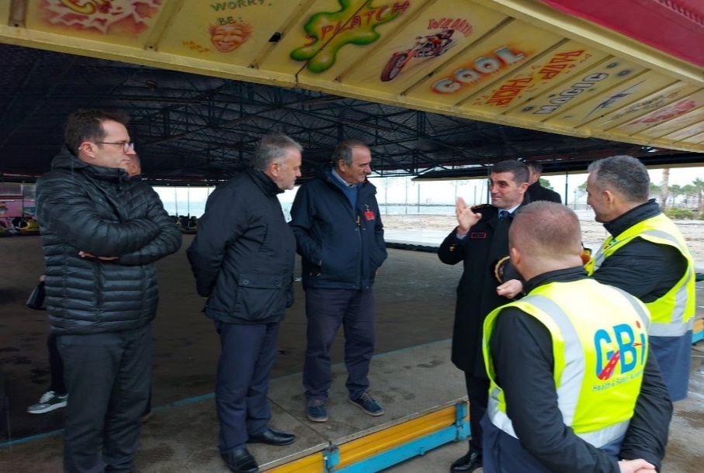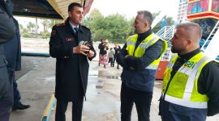

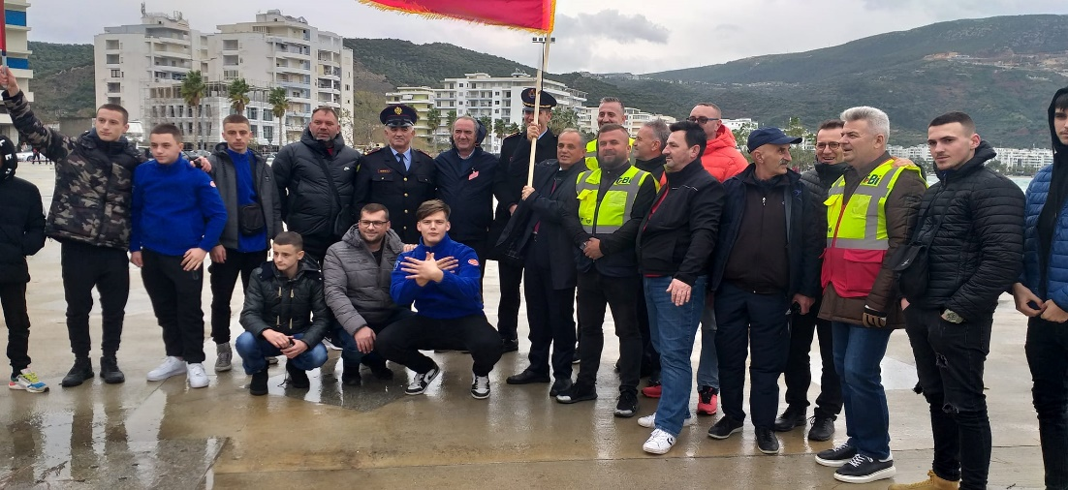

The Grant Scheme was extensively used during the reporting period to promote activities related to traffic safety, especially raising awareness on this topic among the youngsters. The ASP HQ has shown a keen interest and participated in such activities, as they are effective in preventing road traffic accidents and educating the youth. One of the grantees from Round 5 targeted students of the 12th grade in five high schools of Tirana. These soon-to-be drivers were educated on road traffic and safety rules, making them better and more careful drivers.
The methodology used for such awareness raising activities starts with theoretical presentations in the classroom, where all the students are present and are informed on the many topics related to road traffic as the current legislation, road traffic behavior and signs, notions related to road users such as drivers, pedestrians and cyclists, how to react in case of accidents, safe contra aggressive driving etc.
In the second step video clips of road accidents are shared to identify the causes of accidents, which are more interactive and engaging. As a final step practical exercises in a seat belt and ‘roll over” simulator were organized, giving the students a realistic experience of the risks of careless driving. Additionally, the students were provided with awareness raising materials including information and data on traffic rules and consequences when not respecting them.

Activity 1.e.3 Material and technology support for the Traffic Police

The SCPA Program has continuously discussed the ASP’s equipment to strengthen prevention and punish the perpetrators. The statistics on road traffic accidents and the shortage of traffic police equipment, gave clear evidence of ASP lacking proper modern equipment to prevent and manage accidents. Therefore, the SCPA decided to support the ASP with 110 sets of smartphones and mobile printers. These devices enable the traffic police to make real time checks of cars and drivers in the police system, and also fine perpetrators on the spot. The funds used for the purchase of these devices amounted to 120.000 Euro, and the procurement process strictly followed Sida’s procurement guidelines.
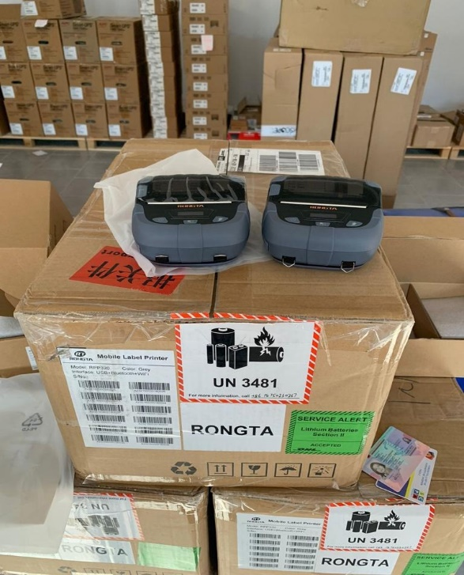
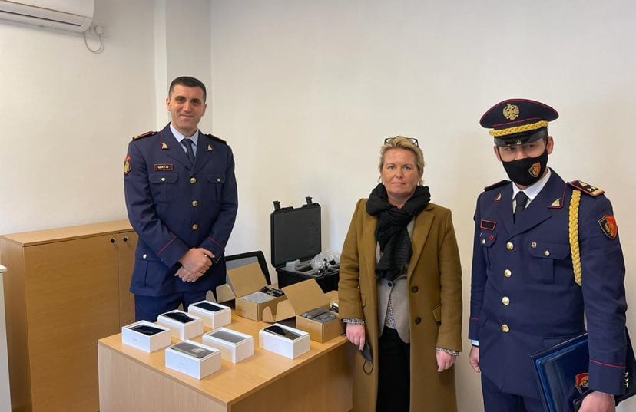

Additionally, the SCPA was informed by the ASP that only 5 radars are available to them operating in the territory of Albania. Due to the lack of such equipment, it is very difficult for the police to trace the drivers who overspeed and take the necessary preventive measures. During the reporting period 6 radars and their respective accessories were procured and donated to the ASP. These radars are designed to work in automatic mode and further reduce the contacts between the police and the citizens, reducing therefore the risks for corruption and other allegations.
The SCPA program has procured a team of IT experts who is currently designing a software that would facilitate the operation of the radars and interface with the ASP “e-gjoba” system. This software will be operational during the first semester 2022.
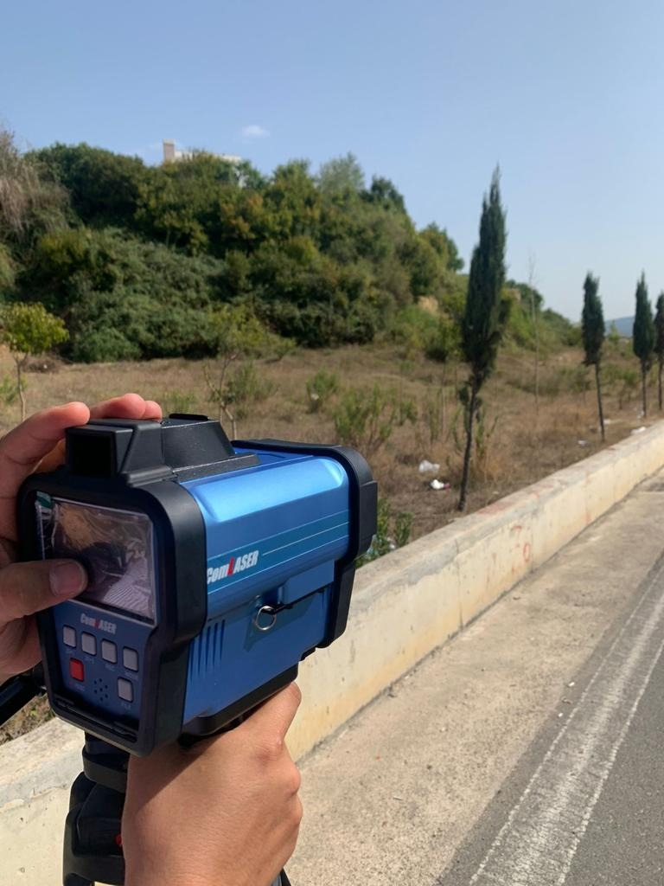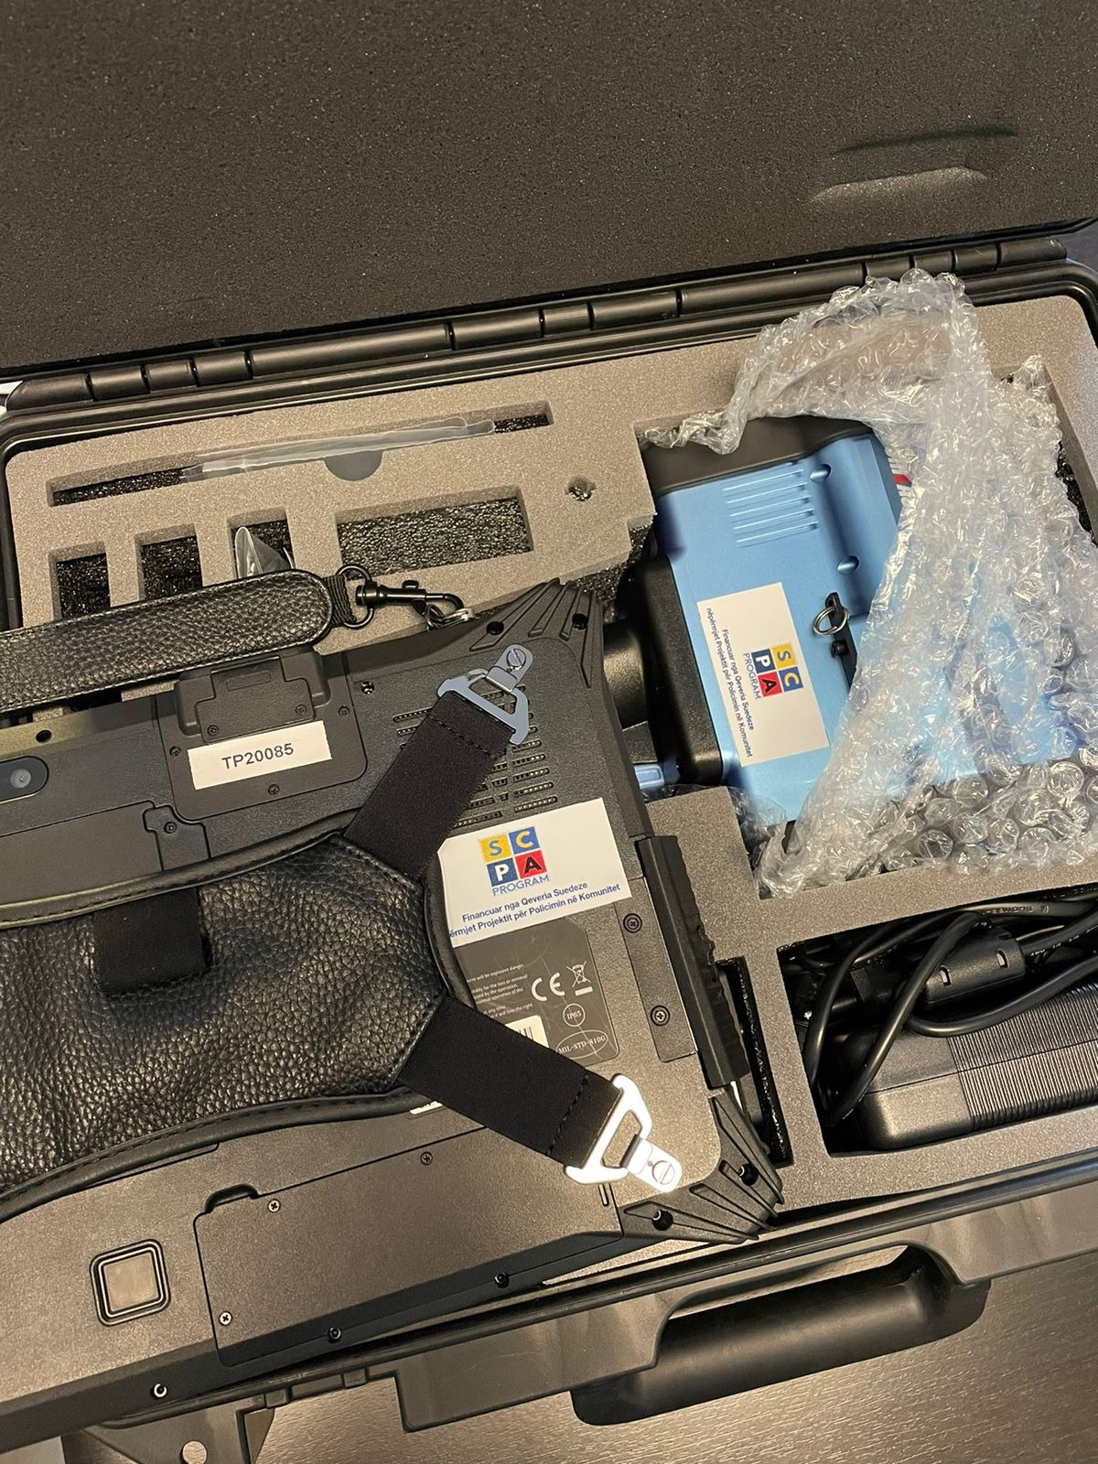
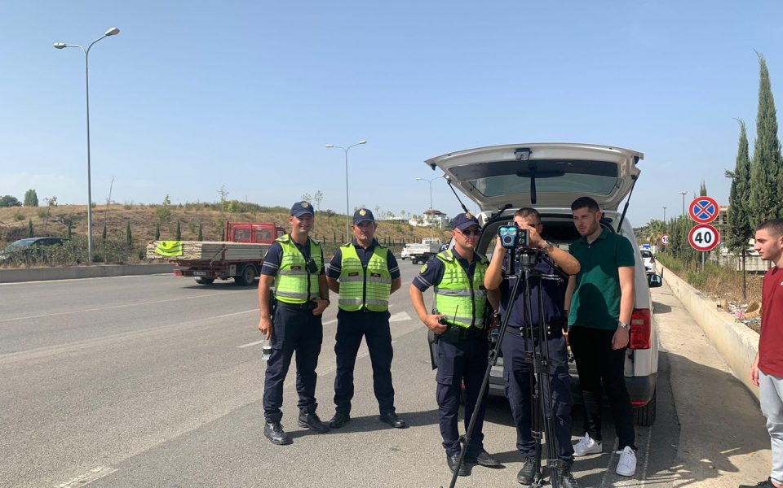

Furthermore, all the road traffic police staff officially engaged to use the radars was trained by the supply company. Almost 120 police officers attended the training in 6 different LPDs. The fund used to purchase the radars was 120.000 euro, and the procurement was also carried following Sida’s Procurement Guidelines.

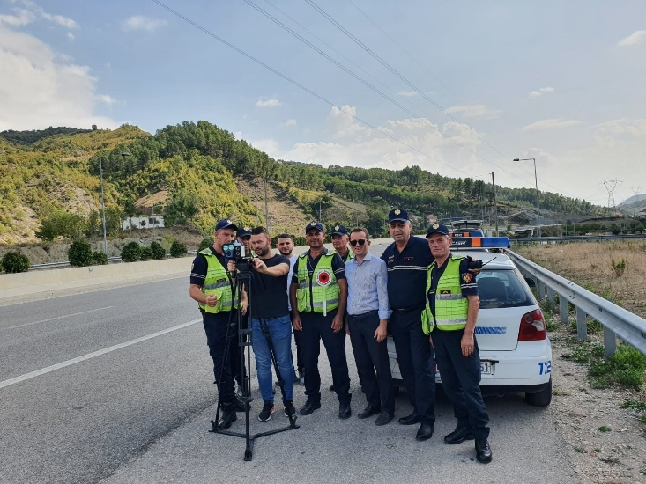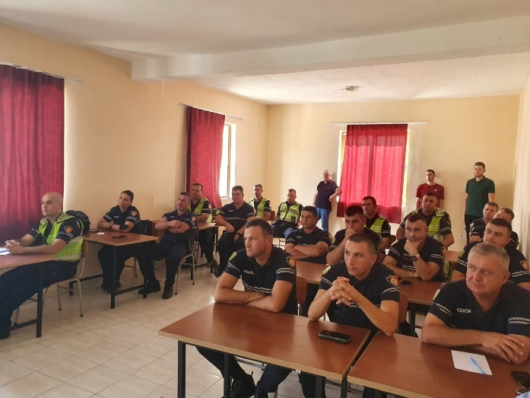

Activity 1.f Support ASP run awareness raising campaigns and increase capacities of CPOs Educators
On 6-8 October 2021 the SCPA Program, in cooperation with the experts of ASP HQ Community Policing Sector, conducted a training for 52 CPOs (from all LPDs), who are assigned for education and work with youth in schools.
The training was delivered in groups of 3 and took place in the premises of the Faculty of Investigation and Security at the Academy of Security and intended to keep the CPOs updated with the awareness raising modules. The activity was developed with the aim of strengthening their proactive and preventive role by raising awareness on safety issues among school children.
The trainees were updated on the awareness topics which mostly affect the youngsters such as internet safety, bullying and cyber-bullying; the risks of abuse of drugs, alcohol and smoking; road safety, etc.
As promotional materials are seen as a very efficient and practical way of sharing information with the children, SCPA re-printed 48.000 leaflets, 12.000 per topic, which were distributed to all LPDs and to the CP Sector at ASP HQ.

Activity 1.i. Improve infrastructure to support CP activities

During the extension period only one infrastructure intervention was planned: the Belsh Police Station, part of Elbasan LPD. Thanks to the investment of 41.000 euro, the working conditions and service level will be considerably improved. The inauguration took place on the 7th of January 2022 with the participation of high-level police officers from the ASP, the Head of the International Cooperation from the Swedish Embassy, the SCPA Program Manager and the mayor of Belsh.
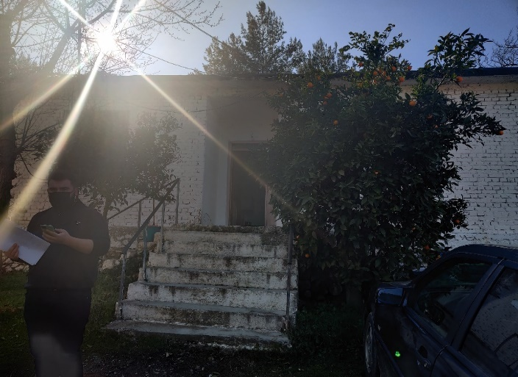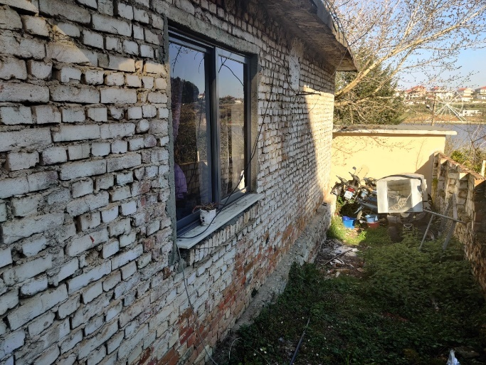
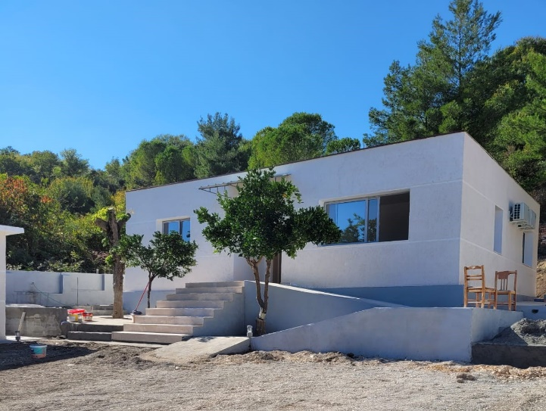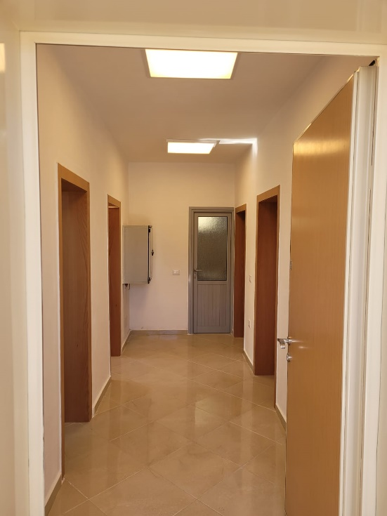
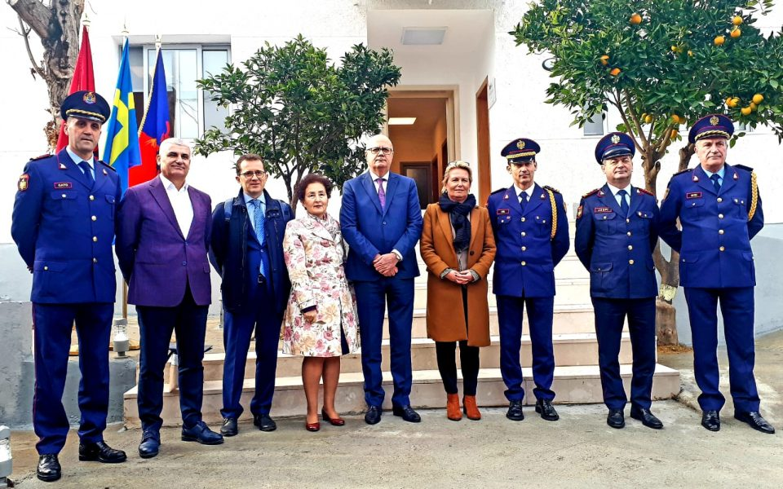

Pillar II – Strategic Management Support

The activities under this pillar are few in numbers compared to the other two pillars. They focus on the implementation of the objectives and activities included in the Public Safety Strategy 2021 – 2026 and its action plan.
In the strategy document, most of the interventions mentioned under Pillar I are part of the activities to be implemented by the ASP. Therefore, the project indirectly contributes to the ASP implementation of the activities foreseen in the strategy. The project has periodically reported to the ASP on the implementation of the activities and provided inputs for the preparation of different progress reports related to the strategy.
Currently we are discussing with the ASP the need to organize a workshop to discuss the progress made so far and the potential need to revise and adjust different activities and targets for the remaining period of the work plan. This workshop is expected to take place in spring 2022.
A second group of activities included in this pilar is related with the Local Councils of Public Safety (LCPS), which are community and stakeholders’ forums to discuss and decide on community safety. The creation and functionalization of the councils is a priority for the Ministry of Interior. This is why this objective was also included in the Strategy.
The SCPA project supported this priority by supporting several grant projects on this topic. Our approach was to create a positive pressure from the local civil society towards the local institutions participating in the Councils. The NGOs will also have a second role, which is to support the municipalities, as the main stakeholder in the Council, in organizing the meetings.
Through different grantees, the project was involved in establishment and reinforcement of LCPSs in 7 municipalities and will continue to do the same during 2022. Through the new Grant Scheme round the project will be involved in four additional municipalities (Fier, Roskovec, Vlora and Durres). In some LCPSs the activities conducted are related with the consolidation of the Councils, training of the staff and participants, support for the preparation of the annual action plans and informing main stakeholders on the role and benefits of the councils (please see the Grant Scheme Section below for more info on activities related to LCPSs).
The Ministry of Interior established an interinstitutional working group on the elaboration of the legal framework related to the LCPSs. This group held its first meeting in December 2021. The project will support the continued activities of the working group.
The grant scheme also contributed to increase partnerships of the police with other local contributors, such as youth representatives, marginalized groups or women in difficult situations. Two projects were focused on these issues during the reporting period.

Pillar III – Domestic Violence Support

Activity 3.a. Reinforcing referral mechanisms in the TLPDs
During the reporting period, the efforts related to this activity were focused on the consolidation of the established Referral Mechanism in the Municipalities of Belsh, Librazhd, Gramsh and Peqin in Elbasan region.
The aim of the intervention was to further support the local level institutions to consolidate a sustainable cross-referral system for managing the DV cases and enhance the police’s role in the CCR (Coordinated Community Response) to better assist the victims, including practical implementation of community policing.
In order to increase synergy of interventions of all project pillars, the SCPA oriented potential grantees to support Referral Mechanisms established locally. Thus, through funds of the GS Round V, the referral mechanisms and the Multidisciplinary Technical Team in the above designated municipalities have been supported with capacity building activities and provided with mentoring and on job training by “Women Forum” of Elbasan.
During September – December 2021, five meetings of the Coordinated Referral Mechanisms in the four municipalities were organized; four meetings of the Multidisciplinary Technical Team members (one in each municipality of Belsh, Librazhd, Gramsh and Peqin) and one meeting of the Steering Committee in Librazhd, where domestic violence cases were discussed.
Technical assistance through coaching was offered by the PMT and the “Women Forum” NGO to the local coordinators of the designated municipalities on coordination techniques, DV victims’ identification, interviewing and screening methods, victim’s needs identification and case management.
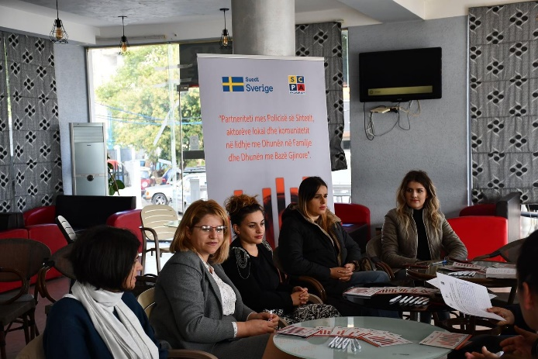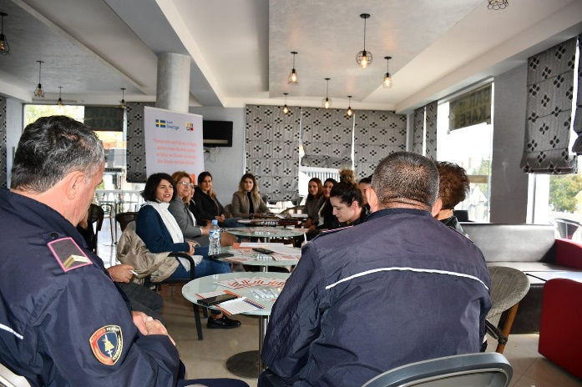
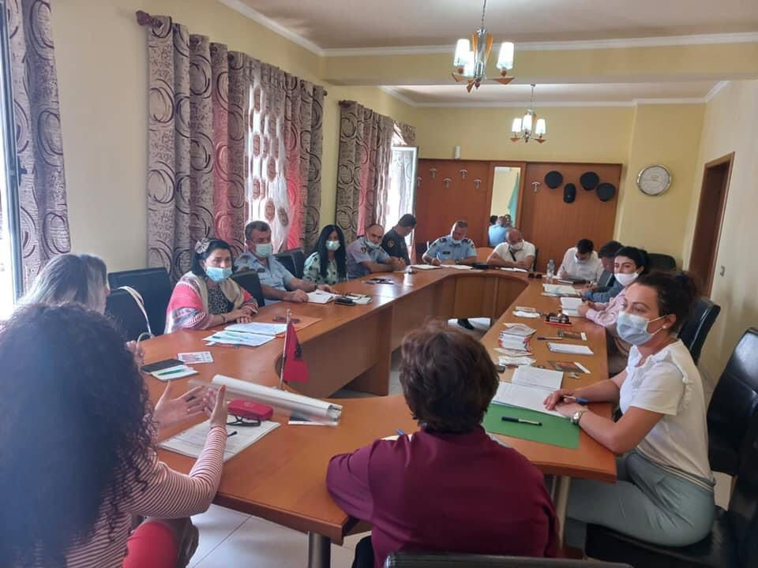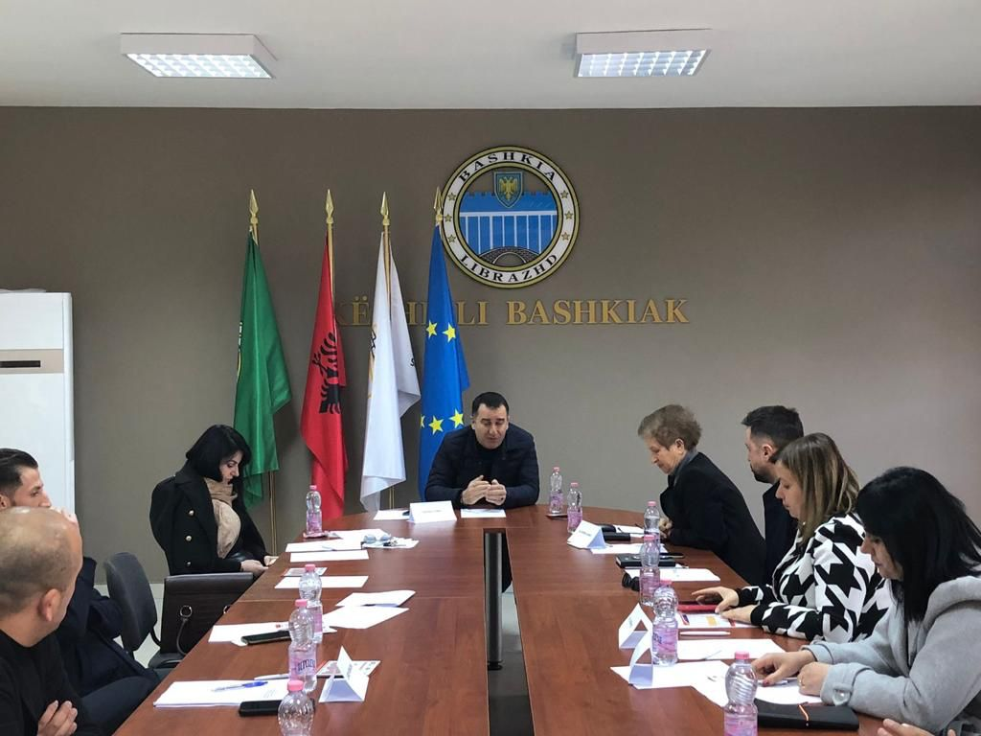

Activity 3.b Capacity building of police officers on DV area
Activity 3.b.1 Deliver trainings for 9 LPDs on DV, psychological and sexual violence
During September-November 2021, in coordination with the ASP HQ and the Academy of Security, the SCPA program delivered a training for five LPDs, namely Durres, Gjirokastra, Berat, Shkoder and Vlore. The focus areas of the training were the implementation of the latest changes and amendments regarding the preliminary immediate protection order and the risk assessment for domestic violence cases.

The target group of the training sessions was the CPOs and the crime investigation specialists. The training was conducted for two days in each LPD and the total number of participants was 219 officers (Durres 45, Gjirokaster 44, Berat 45, Shkoder 42 and Vlore 43).

The aim of the training was to provide the police officers with sufficient skills to carry out structured risk assessments and contribute to the unified implementation of the specific legal provisions introduced by the recent amendments in DV law. Risk assessment procedures are intended to assist practitioners in analyzing concrete situations, introducing a greater objectivity, identifying the level of the present and potential risk and thus guide police action to increase the safety of victims. The training in the remaining 4 LPDs will be organized in spring 2022.

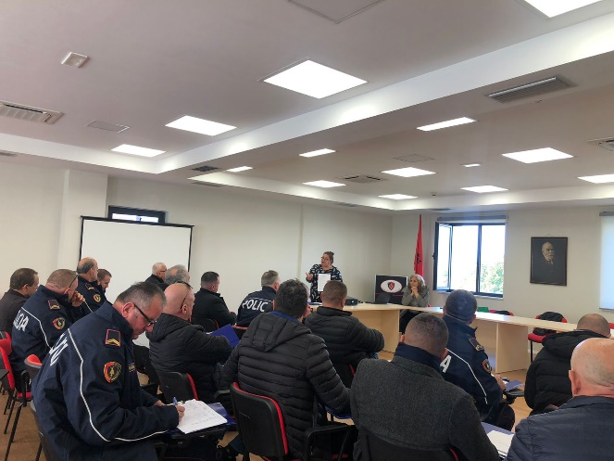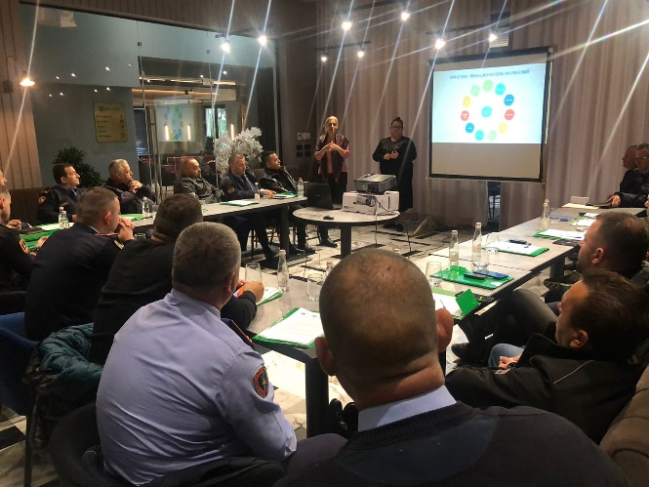

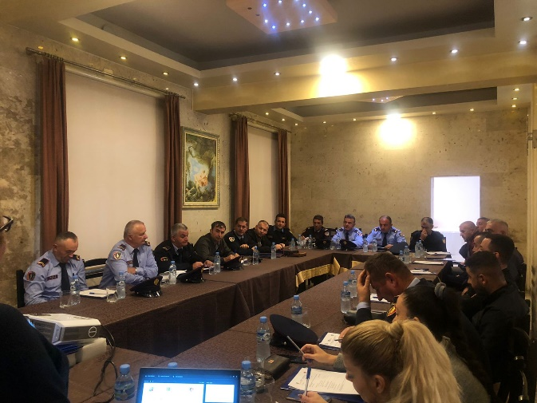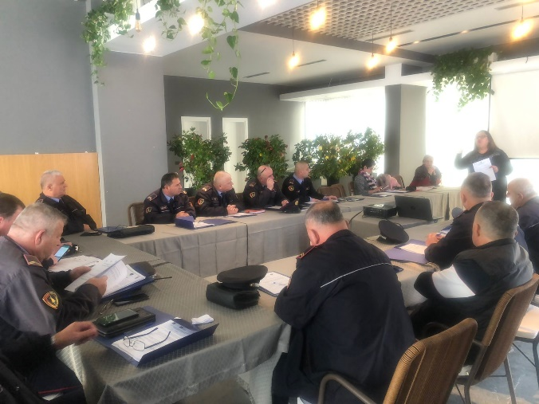

Activity 3.b.2 Monitor implementation of the new legal provisions in LPDs
During the reporting period, the PMT assessed the quality of the risk assessment reports produced by CPOs of the Elbasan and Kukes TLPDs covering the period January – May 2021.
The risk assessment reports were collected and analyzed. The formulation and language of the reports was reviewed, as well the evidence used to support the risk assessment. A report on the findings was issued and shared with the ASP HQ and the respective LPDs.
The assessment found that less than half of the reports were drafted in line with the instructions and guidelines given. There is generally a brief and shallow way of completing the risk assessment reports, and they lack details and accuracy. The identified shortcomings are more or less the same in every commissariat.

Recommendations from the assessment:
- Delivery of consistent refreshment training sessions for the CPOs and crime investigation specialists, focused more on the practical aspects and difficulties encountered during the risk assessment process and the compilation of relevant reports;

- Based on the identified needs, the review and the improvement of the existing format of the risk assessment report should be considered to make it more user-friendly;

- Develop specific written guidelines in the format of a pocket-sized manual to support CPOs and crime specialists in conducting risk assessments and delivering relevant risk management interventions for DV victims;

- In addition to training and capacity building of police officers, joint trainings with members of multidisciplinary technical teams are necessary, for everyone to develop better skills in handling DV cases. This would benefit from the creation of a robust framework that will facilitate more effective cooperation.

The further steps on the capacity strengthening of the CPOs in the designated LPDs will be guided by these findings.

Activity 3.c. Support preparation & carry-on awareness raising campaigns on DV cases
Within the frame of the annual campaign of 16 days of activism against violence against women, the SCPA Program joined the UN SG’s campaign “UNiTE to End Violence against Women”. Awareness activities were organized in 5 districts (Tiranë, Elbasan, Kukës, Korçë, and Pogradec), which were attended by students from 16 high schools.
The awareness campaign was designed in consultation and cooperation with the Ministry of Interior and the ASP, taking into account their specific needs and requests and it was coordinated and synchronized with the UNDP national campaign. For a better use of the resources and capacities, 7 local NGOs and CSOs implementer of current projects of the Grant Scheme were engaged to coordinate and organize the campaign activities.
Promotional materials such as banners, posters, leaflets, logged pens, logged wristbands, ribbons, etc. were designed, produced and distributed in the designated districts.
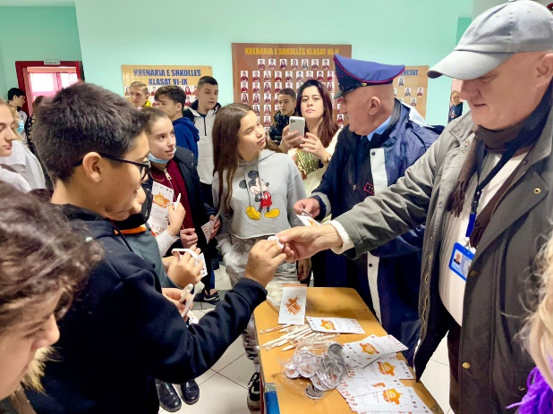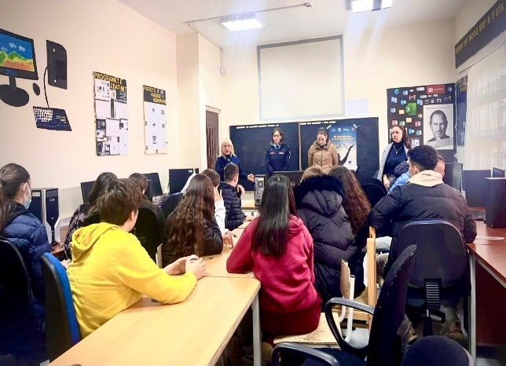
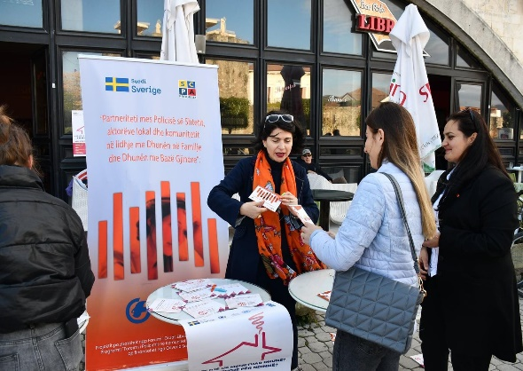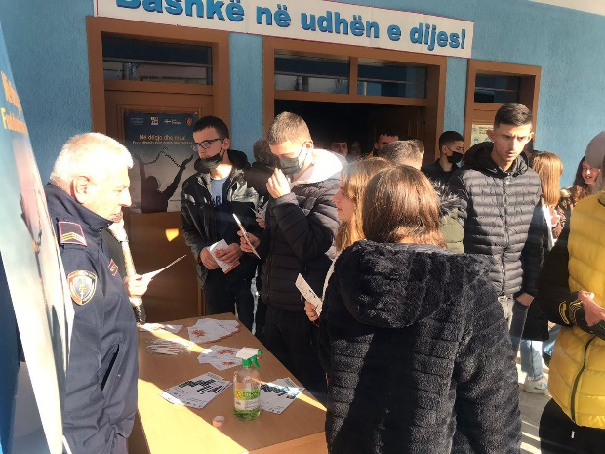

Horizontal Activity - Grants Scheme

The implementation of the projects of the round 5 continued during the reporting period. The focus of interventions of this round was the functionalization of the Local Public Safety Councils (LPSCs). 5 (five) projects out of 11 are based on activities that support the functionalization and the consolidation the LPSCs in 7 municipalities. The thematic distribution of other interventions is: 3 (three) projects aiming at supporting efforts for DV awareness and establishing and consolidation the local referral mechanisms; 2 (two) projects focused on awareness raising on road traffic rules among youngsters and 1 (one) aiming at consolidating partnerships between the ASP and local communities and schools.

Some highlights from activities of the 5th round are:
- 4 NGOs from the 5th round are joining their efforts to increase the functionalization and the strengthening of the LCPS in the respective municipalities of Kukes, Elbasan, Korçe and Pogradec. Several focus group meetings with interest groups and community-based assemblies are being conducted. Also, various meetings of LPSCs are facilitated.

- The organization “Institute for Policy & Legal Studies” is supporting the revitalization and the functionalization of the LCPSs in the municipalities of Permet, Kelcyre and Libohove. In November in Gjirokastër this NGO organized the regional meeting on the topic “Increase local safety through community engagement and interaction”, where mayors of all municipalities of the districts, representatives of the Local Police Department, social service administration, education, health service, forestry and environment, religious communities, businesses, local media, volunteers’ groups, civil society etc. participated. Representatives from the Embassy of Sweden and from the General Directorate of Police also attended the meeting. The participants raised the concern of the full functionality of the LCPS as there was a need to enhance the legal framework, establish a special fund on community safety and increase the capacities of the human resources. Through this joint meeting the mayors were able to share their issues concerning local and regional safety, and were also made more aware about their responsibilities to enhance safety and quality of life of the citizens.

- The center “Focus” is implementing the project “Active communities against domestic violence”, whose objective is to enhance the cooperation between police and health care providers related to qualitative preventive actions and support services to domestic violence victims. So far, they have organized 12 informative workshops with professional staff of four urban primary health care centers in Tirana and the rural ones in Kashar, Kamëz, Paskuqan, Dajt, Petrelë and Bathore. Legal obligations, forms to be filled out, best practices on interviewing techniques of DV victims, women and minors, were among the thematic discussions conducted in the workshops.

- “Assist Albania” NGO conducts sessions to inform and discuss with the youth on the topic of alcohol, drugs and narcotics, the dependency and the damages they cause on health and also advised on how they can live healthy. The project is implemented in Tirana and involves students of 5 high schools of the urban districts and youngsters of a daily service center in the rural area. During September-December 2021, 18 info sessions were organized with the aim to strengthen the relations and mutual trust between school community and police.

- The national “Center for Community Services” is implementing the project “Increasing efficiency of violence prevention through cooperation”, in the Administrative Unit n. 8 area in Tirana. During the reporting period 3 meetings with local stakeholders (representatives from police commissariat n. 4, municipality police, social services office, school psychologists, local businesses, primary health care and community liaisons) have been conducted. The activities aims at establishing a sustainable cooperation between local stakeholders in order to prevent any form of violence and to enhance the safety level for citizens. In addition, awareness and information sessions are organized with high school students and community groups in the designated area on prevention of violence, bullying and discrimination.

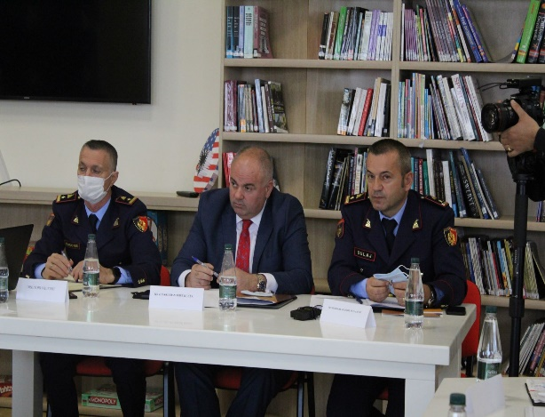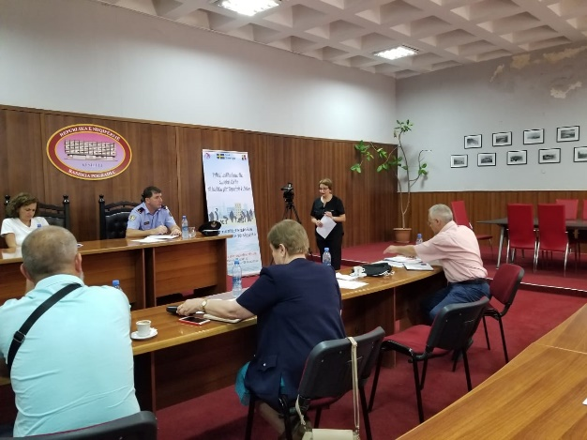

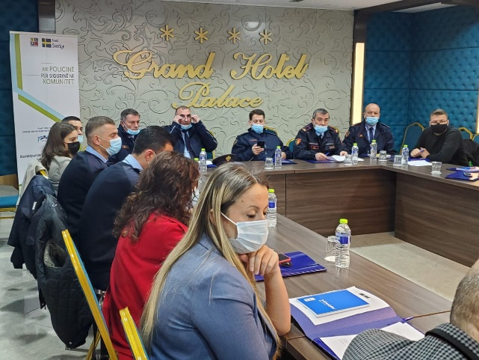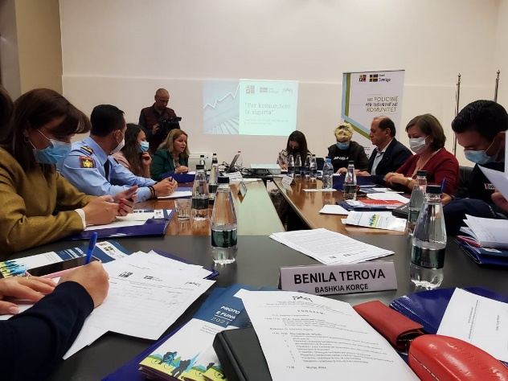

In accordance with the Work Plan the sixth call for grant applications was launched at end of November 2021 in four regions: Vlora, Fier, Durres and Shkodra. The terms of the call were formulated to support the objectives of the program’s three components, aiming at increased synergy of interventions and efficient use of SCPA’s resources. The focus areas of this call are the same as for the previous ones, namely:
- Empowering civil society organizations to support the establishment and capacity building of Local Councils of Public Safety and community-based coalitions with a view to improving relations and continuous cooperation between the Albanian State Police and local communities and building mutual trust.
- Improving the interaction between the State Police and other local actors, through initiatives to support establishing and consolidation the local referral mechanisms to enhance the quality of preventive measures and the services in cases of domestic violence and gender-based violence.
- Establishing and consolidating partnerships between the Albanian State Police and local communities with a focus on youth, through main subjects such as conflict resolution, promotion of voluntarism, awareness on drug and substance abuse, road traffic safety, bullying and cyber-crime, human trafficking, homophobic crimes, etc. with an emphasis on prevention measures.
Locally based organizations were strongly encouraged to apply with the aim to maximize the use of local resources and capacities and fostering local ownership. The awareness campaign of this call consisted of broad information about the grant scheme and the fund opportunities offered to NGOs. The campaign involved a wide variety of media informing interested organizations and potential applicants about the Grant Scheme. This included sharing of information through newspaper advertisements, internet and social media/network as well direct notification by sending emails to NGOs.
The deadline for applications was the 17 December 2021. The selection process, managed by Local Selection Committees that are already established in each region, is expected to end in January and the implementation of the projects to start by February 2022.

Budget expenses
By end of December 2021 the aggregated spending of the extension period summarizes to 7 522 188 SEK. This equals 54% of the total extension period budget. The proportionally high figure comes from high utilization of the budget lines for infrastructure and equipment, which both have been exhausted during the reporting period.

As for the fees the 46% of the PMT budget and 40% of the short-term expert budget have been consumed. The turnover of short-term experts will increase in the forthcoming period and will balance the underutilization.

On the whole the budget is on par with the work plan and the remaining funds are foreseen to be fully utilized during 2022. However, there might be a need for reallocations between some of the budget lines to allow for an optimal use of the remaining budget resources.

Annex I – Updated Logical Framework

 | Intervention logic | Objectively verifiable indicators | Sources of information | Comments
Overall objective | Contribute in building mutual trust and partnership between police and communities in order to create safer neighborhoods. | Safety situation in Albania positively assessed | - Ministry of Interior reports  - ASP reports  - Statistics  - European Commission Progress Reports  - Project reports | Based on PSS of May 2018 cc. 66% of Albanian citizens consider the ASP is doing a “good” or “very good” job.  80% of Albanian citizens declare they feel “safe” or “very safe” walking in their neighborhoods at night.  Only 60% of citizens are willing to call the police when they see a crime committed on the streets.
Specific Objectives | - Accountable, capable and responsive institutions providing community safety & security  - Citizens play an active and positive role towards their personal & CSS | - Albanian agencies skills to address community safety issues enhanced  - Increased citizens personal engagement and through CSO in safety and security issues | - Ministry of Interior reports  - ASP reports  - Statistics  - Program reports | 655 CPOs trained by the program  40 Analysts  Workshop for 60 CPO-Youth Educators  Workshop for 171 School Security Officers and Psychologist  9 workshops for the managing staff and analysts  18 LCPS activated or established.  56 CSOs contracted to support safety initiatives in local communities.  Cross-Sector Strategy on Community Safety 2021-2025 and Work Plan approved

Mandatory outputs
 | Areas of Intervention | Objectively verifiable indicators | Sources of information | Outputs August ’21 - December ‘21 | Overall outputs
Pillar 1 | - Support the ASP in enhancing the efficiency of CP structure  - Strengthening local partnership  - Capacity building | - Thorough analysis of the TLPDs conducted.  - Identification of the elements best fitting to Albanian context done.  - Revised job description/job profile of the CPOs  - Revised SOP presented  - CPO work in two TLPDs is coached, monitored and assessed  - Elbasan LPD pilot related to CP replicated in other LPDs  - Material support provided to the selected CPOs of the TLPDs  - Virtual Police established in the TLPDs  - RH business processes enhanced and material support provided to RH of the TLPDs  - Traffic Police capacities strengthened and material support provided  - LCPSs in the two TLPDs revitalized and established.  - The police representatives in the LCPSs coached and sensitized on the police role in the forum  - Trainings and open lectures provided at the Academy on the role of LCPS  - Training curricula for all police officers on the CP principle developed and modernized. Staff trained  - CPOs curricula revised and enhanced; ToT training  - RH staff trained; ToT training  - CPOs Educators capacities reinforced and awareness raising campaigns implemented successfully in schools  - Summer camps for the pupils organized  - Study Visits carried out | - Programme reports  - ASP reports  - Surveys  - Statistics  - Meetings  - Minutes of Meetings  - No. of staff trained | Meetings in the LPD Elbasan and its commissariat to evaluate the sustainability of changes.  Replication of changes in the LPDs of Dibra, Lezha, Kukes and Shkodra (14 visits) and kick off in Tirana, Durres and Fier  Training of Public Safety Experts of Shkoder, Lezhe, Diber and Kukes. A total of 47 participants.  Workshop with Heads of the Community Policing and Public Safety Sections of the Commissariats from all 12 LPDs (48 in total)  Awareness raising activity “Apply the traffic rules, for a safe destination’ in Vlora  Awareness raising activities on road traffic behavior in 5 high schools in Tirana  Purchase of 110 sets of printers and smartphones and 6 Radars for Road Traffic Police  52 CPO educators had refreshing workshop  48.000 leaflets (12.000 per each topic) re-printed and distributed to ASP HQ and CPO educators  The Belsh Police Station fully reconstructed and made functional | The TWG started working on the assessment report recommendations  New CPO job description drafted Elements for CP fitting Albania case recommended.  15 job descriptions recommended for LPDs and Commissariat, including CPO position. New CPO and GP job descriptions approved by the DG.  60 bikes and other firefighter equipment provided. Command and Control Room in Elbasan & Reception Hall and other premises in Has Commissariat and Librazhd commissariat renovated.  Command and Control Room of Kukes LPD co-financed with the local businesses.  Prevention Room for Kukes LPD reconstructed and refurbished  Reception Hall and detention premises of Tropoja reconstructed  LCPS in Elbasan is active, while LCPSs in Has, Tropoja, Librazhd, Perrenjas and Gramsh, were established and supported.  Training curricula for CPOs drafted, ToT delivered and training provided to 55 officers. Coaching provided for Elbasan and Kukes LPDs. 650 CPOs trained in all LPDs in 5 days training for each group.  Study visit in Slovenia and Croatia focused on CP practice organized in June 2018 and study visit to Germany organized in May 2019.  Regulation on the Technical Working Group in charge of piloting the changes in Elbasan LPD established.  Changes implemented in Elbasan LPD. Online coaching on the changes in LPD Elbasan. Continuous coaching on the consolidation of the changes in Elbasan LPD and preparation of the report Monitoring visits and online coaching of the TLPD Elbasan on change management  Reconstruction of 7 rural offices of CPOs in LPD Elbasan.  70 laptops and 40 video projectors distributed in all LPDs for the CPO educators and rural CPOs (Elbasan LPD)  The development of the RH software for business processes concluded and started the piloting and testing phase. Continuous coaching and monitoring on the use of the RH software  A review of the CP and Patrol Police curricula at the Academy of Safety carried out. Updated curricula prepared.  Donation of the minivan for the CP sector of ASP HQ. It will be used for awareness raising events  Online zoom meetings with the CPO educators and SSOs on updates  The shift leaders of Elbasan TLPD trained on new changes

Pillar 2 | - Strategic Planning and performance evaluation  - Coordination between stakeholders  - Communication | - Progress report and lessons learned on the Policy Document 2015-2017 conducted; New Policy Document 2018-2021 drafted  - New Strategy of Public Safety 2021-2026 drafted; Action plans and progress reports periodically prepared;  - Capacities of the organization at all levels to effectively monitor and assess implementation of policy documents and action plans increased  - An efficient monitoring system put in place  - The two TLPDs supported to draft periodic progress reports and identification of bottlenecks  - Capacities to externally monitor and evaluate the work of the police increased; national and local surveys conducted  - LCPS used an efficient mechanism to address local issues  - Partnerships with citizens and other local contributors increased  - Integrated Communication Strategy of ASP implemented  - National Awareness Campaigns of different topics carried out  - LPD spokespersons trained and their job description/profile reviewed.  - The PR/Communication curricula of the Academy of Security for initial and continuous training reviewed | - Documents, reports, interviews  - Notes from TGPM  - Assessment of Community Policing practice  - Monitoring and Evaluation  - Surveys  - Statistics  - ASP reports  - Visibility materials | Assistance to establish or strengthen the LCPS in Kukes, Elbasan, Korçe, Pogradec, Gjirokaster, Kelcyre, Permet and Libohove  Assistance to the newly established MoI working group on the drafting of the legal rules on the functioning of the LCPS | CP Document 2018-2020 approved. Monitoring plan drafted. A report of key actions and measures taken during the old strategy 2015-2020 has been produced  A Draft Policies /Priorities and strategic objectives for the new Public Safety strategy 2021-2026 was produced.  The Intersectoral Strategy for Safety in the Community 2021-2026 and the Action Plan 2021-2023 approved by the Government.  Analysts and managers in 2 TLPDs trained (25 participants in 10 training days). Coaching delivered (20 coaching days).  A workshop for all the LPD directors related to role and functions of Sector for Analysis and Monitoring organized. 16 analysts in other LPDs trained in 8 days modules. SOP for the new sector proposed by the program and approved by the ASP  Police Satisfaction Survey 2018 completed and results shared with stakeholders. PSS 2020 completed and results shared with stakeholders. Information used to feed the Strategy for Safety in the Community.  LSMS I & II for Elbasan and Kukes completed and results shared and discussed with stakeholders. Results of PSS presented in Elbasan LCPS and members invited to take measures.  LCPSs established and supported in Laç, Lezha, Patos, Kavaja, Selenica, Vlora, Korça, Berat.  12 LPDs spokespersons trained in 3 days training and coaching provided as follow up.  Newsletter for Elbasan and Kukes LPD produced and web constable launched.  Manual for the CPOs Educators prepared; 5 days training for 60 participants delivered. 3 awareness campaigns developed. Web Forum for Educators developed. Leaflets and booklets printed and distributed.  152 School Security Officers and Psychologists trained on the awareness raising topics to be held at schools. 18 days of training in total.  36 candidates for High School Security Officers Trained on the awareness campaigns. (6 days)  Monitoring of the Educators Online Forum and advising them.  Three rounds of training of the spokespersons of TLPDs regarding newsletter preparation and web constable.

Pillar 3 | - Strategic Level Interventions  - Capacity Building and Strengthening  - Infrastructure and Logistics support | - Report on Prevention Approach completed  - Legal and by-legal framework on DV revised  - SOPs on DV cases enhanced  - Data collection system for the ASP, Prosecution Office and Courts established  - Referral Mechanisms established and functional in TLPDs  - Awareness campaigns in TLPDS against DV and gender based violence  - Capacity Building Plan on DV elaborated  - Training curricula and modules on GBV and DV upgraded  - Training for CPOs and CIDs delivered in 8 LPDs, including sexual and psychological violence  - Monitoring in practice the implementation of new legal provisions in 8 LPDs  - The DV interviewing areas in the TLPDs commissariats restructured and reconstructed  - Material support for the CPOs and CIDs in agreed commissariats provided. | - Project Reports and documentation;  - UNDP, UN Women, OSCE reports ;  - Ministry of Health reports;  - MoJ and Prosecution Office Statistics.  - Police reports/statistics;  - Project Reports;  - Assessment reports & Surveys;  - Monitoring & Evaluation Plan;  - UNDP & UN Women databases, maps and reports  - The Ombudsman /Internal Control Service /M. of Health /M. Education and Sciences / Local Government reports | Consolidation of the established Referral Mechanisms in the Municipalities of Belsh, Librazhd, Gramsh and Peqin in Elbasan region.  Training of 219 officers (Durres 45, Gjirokaster 44, Berat 45, Shkoder 42 and Vlore 43) on the recent legal amendments to the DV law and the risk assessment.  Awareness raising events within 16 days of Activism against GBV in 5 districts Tiranë, Elbasan, Kukës, Korçë, and Pogradec, which were attended by students of 16 high schools.  Design and printing of promotional materials on DV such as posters, flyers, pens, ribbons and bracelets  The report on the evaluation of the risk assessments prepared by TLPDs issued and shared. Recommendations provided. | Referral Mechanism established in Gramsh, Belsh and Kukes and continuous support provided. Referral mechanism established in Librazhd and reactivated in Peqin.  DV Awareness Campaign implemented in November-Dec. 2017, 2018 and 2019. Awareness raising campaign during 16 days of activism against violence against women in 6 districts Vlore, Elbasan, Kukes, Lezhe and Pogradec during November 2020.  300 logged masks were donated to LPDs to be used during the awareness raising days on DV and GBD.  The report on Prevention Approach finished and submitted. Capacity development plan drafted  72 CPOs and CIDs in Kukes and Elbasan LPDs trained on the legal amendments of the DV law and the risk assessment  Friendly interview room in Librazhd and Comm. 4 in Tirana completed. Interview room created in Has.  Interview Unit for minors and DV victims in LPD Elbasan created (works + equipment) and staff trained  DV awareness event in Elbasan city center involving local NGOs, Police and institutions.  Production of 200 copies of printed posters to be put on commissariats which include the obligations of the police and the rights of the victims
Grants | Empower civil society organizations to embrace and implement the CP philosophy and support to combat DV. | - Grants Scheme implemented as planned and scheduled | Grantees reports  Program Reports  Surveys  ASP reports | Sixth round of GS launched | 66 grants’ contracts signed, covering 11 regions in Albania  556,320 Euro contracted.

Annex 2 Risk Matrix
 | Risk Factor  (security, political, operational , financial, reputational) | Impact | Likelihood | Mitigation Strategy and Responsibilities
 | High-level buy in
1 | Overburdened national partners / lack of resilience  - Political unrest especially during the pre-election period  - Excessive demands of national partners results in them losing interest or willingness to participate in program  - Other demands results in low priority of community policing  - National counterparts may not be able to operate at the speed desired of the PMT to design and set up specific activities within the program streams  - Pressure by senior leadership to produce results within unreasonable timeframes (including pressure focusing on outputs, rather than outcomes) | Medium | High | - Pay attention to specific local deadlines or other demands  - Use existing local systems and procedures (i.e. monitoring systems, rather than setting up parallel structures)  - Sida/PMT to ensure that international community is communicating and cooperating with each other and ensure common interest and objectives in community policing  - Capitalize on the demonstrated interest from senior MoI and ASP leadership in the program  - PMT to ensure sensitization across senior MoI and ASP leadership of the program work plan and estimated timelines
2 | Lack of, or unwillingness of, stakeholders to participate and cooperate  - Resistance or mistrust from communities and local government / decentralized institutions to cooperate with police  - Partners within the regions do not feel they are part of a process | Low | High | - Ensure transparent processes and encourage local partners to actively participate  - Support for partnership approaches can be developed with the relevant line ministries (advocacy and liaison)  - Risk management matrix and development of mitigating strategies is carried out collectively by the SC  - Capitalize on the excellent partnerships developed during the first phase of the program
3 | Major reshuffle of key police personnel  - Key personnel are moved to other positions before progress can be institutionalized within the ASP or LPDs  - Long term vacancies in key positions – The Chief of Sector for the CP Sector at the Headquarters is vacant since 8 months and staff is overburdened with tasks | Medium | High | - PMT to monitor personnel shifts and timely reporting to SC  - Explicit approach by the SCPA to strengthen institutional capacity not just focus on individuals
4 | Lessons and progress made as a result of the program are not recognized by decision-makers and do not inform future policy development  - The SCPA seeks to develop institutionalized behavioral change. The gains of the program will not be sustainable if the changes remain solely at the individual level and do not influence policy changes that support cultural shifts in the way of working | High | High | - Sensitization activities on key lessons to be incorporated into the PMT program monitoring process  - M&E program stream to include creating or developing mechanisms to ensure that the lessons are fed into MoI/ASP policy making bodies  - The SMS Coordination stream will encourage cross-departmental cooperation and cohesion  - PMT to be prepared to provide summaries of key lessons and changes to the MoI if/when a process to develop an MoI policy on safety and security commences
5 | Program loses coherence  - Pressure by the MoI/ASP to provide support to ad hoc activities outside the planned design  - Program impact becomes diluted / program loses focus as a result of reacting to new/additional requests for individual activities from the MoI/ASP | Medium | Medium | - SC consent to be required, in addition to Sida’s, for any substantial deviations or requests for new assistance  - Requests should be accompanied by clear analysis of how the new request contributes to achieving the program’s direct outcomes  - PMT to ensure that requests for new activities are included in the preparatory documents for the SC
 | Program processes
6 | Corruption or allegations of corruption in program (particularly relevant for the Grants Scheme)  - Misuse of funds and poor accounting  - Favoritism of particular groups for projects | High | Low | - The SCPA shall continue the excellent transparent practices for their GS  - Emphasis on transparency throughout program  - Clear and transparent selection procedure for all projects  - Allegations of corruption to be followed up immediately by the PMT and the Embassy/ the SC informed
7 | Experts are not of a sufficiently high quality  - PMT staff members do not have the capacities to deliver the required quality of work  - Short-term experts do not provide work of a sufficient quality / relevance to the Albanian context | High | Medium | - FCG / the Embassy / ASP / MoI quality control of program’s outputs  - Use of the monitoring mechanism to track performance and follow up with feedback from the beneficiaries on expert performance  - Clear terms of reference and expected deliverables to be developed for short-term experts etc.
 | Sustainability
8 | ASP and MoI do not follow the recommendations regarding budget allocations and staff reshuffle after TLPDs piloting  - Diversion of ASP funds to the TLPDs in order to ensure their short-term success  - Diversion of ASP funds away from the TRPDs because they are covered by the program  - ASP/ MoI do not systematically provide support to TLPDs | Medium | Medium | - Relative allocation of funding to ASP LPDs (including the TLPDs) to be monitored as part of the PMT monitoring mechanism  - Concerns to be raised to the SC  - Clear and transparent selection criteria for the TRPDs  - Sensitization process across the ASP on the program – especially regarding progress being made, lessons learned, and dissemination and replication activities
9 | Lack of responsiveness to adapt proposed models to Albanian specific situation  - Models provided by PMT for Pillar I do not fit with specific conditions | Medium | Low | - PMT will not design a “model” for the community policing in Albania, but will provide different elements of a model  - The elements will be illustrated by international examples and provided with their “pros” and “cons”, aiming to develop an Albanian model.
10 | Shift in international engagement  - International development programs fail to achieve stated aims and objectives in areas linked to the SCPA  - Sida project overlaps or competes with other international project/demands and overburdens local partners | Medium | Medium | - Key international community (IC) actors have been informed/consulted throughout the design process  - PMT to map out what key deliverables from other programs will influence their activities  - Program proposal and future program activity documents to be shared widely with DDPFFA and the IC
11 | Albanian authorities do not start to take on elements of budgetary responsibility  - Whilst the SCPA will absorb the costs for monitoring activities in the early stages of the program (e.g. citizen perception surveys) these will need to be taken on by the MoI/ASP progressively as the program unfolds  - Any budgetary impacts for new procedures for the LPDs will also need to be incorporated into MoI/ASP budget planning | Medium | High | - Exit strategy contains clear mechanisms for the GoA to adopt gradually increasing funding responsibilities throughout the program – framework to be developed during the inception phase and built up over years 1 and 2  - Constant monitoring
12 | Transfer of procedures, skills and expertise to other LPDs is not done in a sustainable way  - Pressure to replicate TLPD processes and approaches to other LPDs before they have been monitored, evaluated and proven  - Lessons and new/updated ways of working are never transferred | Low | Medium | - Role of the IPA in advising on time lines  - SC consensus on large scale replication activities  - Continuous monitoring on progress and development of when aspects will be disseminated  - Selection for LPDs based on international good practice  - Individual risk analysis / mitigating strategies to be developed for specific dissemination/replication activities
 | Force majeure
13 | Covid 19 pandemic conditions implementation of activities | High | high | - Continuous monitoring of the situation  - Adopting a flexible approach in adapting the activities to the new conditions

Annex 3 - Participants/beneficiaries in SCPA activities
During this semester, like in the previous reporting period, the PMT organized the work with the aim of giving beneficiaries the opportunity to actively participate in almost all the activities. PMT noted that this approach helped build a sense of ownership on the outcomes of the project.
Participation of stakeholders and beneficiaries in all the groups of activities, was also used as a tool in which beneficiaries were empowered to have their voices heard and to strengthen relationships between the project and the stakeholders. Increasing participation in program’s activities has always been considered by the SCPA as a useful tool in enhancing the effectiveness, efficiency and coverage of project benefits.
For SCPA, high participation is seen to potentially release and bring in additional resources to the project. All participation approaches were designed to generate an active participation with the intention to make stakeholders feel that they were collaborators in the project, not just simple recipients or contributors, but active partners in the activities at every phase. It should be noted that during this reporting period, activities within the 3 pillars and especially the activities supported by the Grants Scheme, involved a considerable number of participants/beneficiaries who operate in many public and state organizations and institutions and are located all over the country.
Even during this reporting period of time, the COVID-19 pandemic presented challenges and difficulties for both the SCPA project and ASP. This was mostly felt in the last months of 2021. Despite these difficulties, PMT managed to sustain the work plan and reassess on best ways how to proceed with implementation of activities.
SCPA program has closely monitored participation and number of beneficiaries in program’s activities as a whole. Below is a brief description of activities managed by PMT:
During this reporting period PMT achieved organizing in total 115 activities; 52 were regular meetings with the MOI, ASP HQ, LPDs, Local Police commissariats, Academy of Security, Local government and other stakeholder representatives.
PMT managed to organize 1 PSC meeting, 4 trainings that involved Patrol Police Shift leaders/experts of public safety and Command and Control staff of LPD Kukes, Shkoder, Lezhe and Diber. 1 training delivered in 6 groups of 120 Traffic Police Officers as users of donated radars, tablets and thermal printers; 1 training involving 52 Youth Educators (CPOs) of 12 LPDs. PMT also organized 1 workshop at the Academy of Security with the heads of Public Safety sections and heads of Community Policing section of all 12 LPDS.
All training and workshop sessions were developed under strict protection measures against Covid -19.
SCPA also organized or attended 3 ceremonies: the first one being ceremony on the occasion of the completely reconstructed Police Station building of Belsh. This ceremony was also attended by the representative of the Swedish Embassy to Tirana. The other ceremonies in which SCPA participated was the 50-th anniversary of the founding of the Academy of Security and the ceremony on the occasion of the 103-rd anniversary of the creation of the Albanian State Police. Within the variety of activities SCPA organized a joint activity with a Kosovar - NGO “Angels of Traffic”. This successful activity that started in Prizren and was finalized in Vlora was supported by the SCPA Grant scheme and involved participants form the civil society of Kosova, Albania, Local institutions, Local ASP of Vlora and Kukes, as well as traffic police officers at ASP HQ and at local relevant bodies.
During this reporting period, PMT also organized 22 field visits which included 4 northern LPDs (Kukes, Shkodra, Diber and Lezha) and LPDs of Tirana, Durres and Fier. 9 visits out of the total were dedicated visits to LPDs, commissariats and police stations of Tirana, Durres and Fier in order to introduce, set up the project change management working groups and later to start implementing the changes in accordance with the GD’s order. The rest was subsequent field visits to monitor the progress and sustainability of implemented changes either in the Commissariats of the Northern LPDs in which piloting phase was over and final reports were submitted or in the commissariats of central Albania in which this process is in its initial stage.
Regarding the DV Pillar of the program, PMT in cooperation with DV sector at ASP HQ has delivered 2-days training for 5 LPDS, namely LPD of Durres, Gjirokastra, Berat, Shkoder and Vlore.
In the frame of the annual campaign of 16 days of activism against violence against women, the SCPA Program joined the UN SG’s campaign UNiTE to End Violence against Women. Hence awareness activities were organized in 5 districts, Tiranë, Elbasan, Kukës, Korçë, and Pogradec, which were attended by students of 16 high schools.
Within the grant scheme component PMT has also been active. During this reporting period, 5 meetings of the Coordinated Referral Mechanisms in the four municipalities were organized; four meetings of the Multidisciplinary Technical Team members (one in each municipality of Belsh, Librazhd, Gramsh and Peqin) and one meeting of the Steering Committee in Librazhd, where local GB–DV cases were discussed.
Conveyed in figures, activities involved a total of 1435 persons out of which 381 were ASP personnel, 35 were senior ASP police officers, 65 midlevel police officers and 281 grass root police officers who took active part in the activities. The Grant scheme activities were kept a high level both in terms of number of activities and participants.
PMT has emphasized the importance of a good gender balance in all three component areas. Gender indicators were assessed in all of the activities, meetings, workshops, seminars and trainings.
Over all, the PMT assessed that:54.9 % or 579 out of 1054 direct community beneficiaries were girls and young women; 41 % of the members in the implementing/core working groups of projects were/are women; 24 % or 92 police officers out of the total that have benefited from the activities were women police officers.
Program’s visibility and outreach with the public
During this reporting period the PMT succeeded in increasing the visibility of each component. PMT applied several ways and means to expose the program. Some of the effective ways to increase the program’s visibility were the following:
- The online forum of CPOs – Youth Educators and the forum for Security Officers in schools, continues to be a proven efficient tool to engage not only the assigned CPOs for education and work with youth but also ASP HQ and Academy of Security experts in exchanging experience with each other but also creating a network of CPOs and Security officers. Almost all the trainees have now joined the forum. It is worth mentioning that the CPOs working as Youth Educators in commissariats of Durres, Fier, Kukes, Cerrik, Lezha, Pogradec Shkodra and Saranda have been very active. Their activities are displayed both in SCPA website but also in the ASP one. These activities involve over 231 photos and videos uploaded and have maintained regular communication, exchange of experience and work plans. We observe a slight decrease of activity of the CPOs/Youth educators in commissariat of Elbasan, Peqin and Librazhd, Korca, Mat, Mirdita and almost no activity in commissariats of Gjirokastra, Permet, Tepelena, Vlora, Dibra, Bulqiza , Kurbin etc. Also, it is worth mentioning that due to the fact that there is not, yet, dedicated CPOs to work with the awareness campaigns in Tirana Commissariats, the situation is not to the desired level.
- Workshops and training sessions were used successfully as an already proven networking facility.
- Meetings with community-based organizations and other stakeholders in the framework of LCPS, and Grant scheme activities. These meetings were considered as an important way to expose the program’s objectives and philosophy but also as a base for establishing networks in order to cultivate long-term relationships.
- The program’s web page, which is user-friendly, accessible and provides open, consistent and searchable information about all programs. The activity on the program’s web page has increased substantially. During the past six months the web page was visited by 8567 viewers. We notice a slight decrease of viewers on our web site. The Program’s social network accounts in Facebook, Google LinkedIn, and Twitter remain quite active. The web page has been very helpful, especially in relation to the GS

PMT has continued the appreciated practice of producing and distributing a short excerpt of activities, summarized in the Monthly Newsletter of the Program. The Newsletter is distributed to almost 285 receivers, including ASP counterparts, international partner organizations, NGOs and other Program’s stakeholders.

