***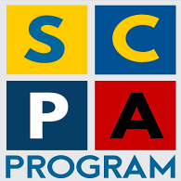***

**STRENGTHENING COMMUNITY POLICING IN ALBANIA**

**FORCIMI I POLICIMIT NË KOMUNITET NË SHQIPËRI**

**Implemented by:**

**C:\Users\HP\Desktop\templates\Templates & Logos\se_logo-FCG.png**

**BI-ANNUAL PROGRESS REPORT**

**(January 2021)**

|  |  |
| --- | --- |
| **Project title** | **Strengthening Community Policing in Albania, 2nd phase, Program implementation 2017-2020** |
| **Project No.** | UF2014/52825/TIRA |
| **Country** | Albania |
| **Funding Agency** | Sida |
| **Implemented by** | FCG Swedish Development AB |
| **Address** | Dalagatan 7, 111 23 Stockholm, Sweden  Web: [www.fcgsweden.se](http://www.fcgsweden.se)  ++46 8 406 76 20 |
| **Contact person** | Mr. Pontus Förberg, Project Director FCG  Cell: +46 70 214 21 81, Office: +46 8 406 76 20 [pontus.forberg@fcgsweden.se](mailto:pontus.forberg@fcgsweden.se) |
| **Date of report** | 30 January 2021 |
| **Reporting period** | 1st July 2020 – 31 December 2020 |
| **Chair of Project Steering Committee** | General Director of Albanian State Police |
| **FCG Project Team Members** | Mr. Ansi Shundi, Team Leader  Mr. Ulrich Dugas, International Police Advisor  Mr. Enri Hide, Long Term Advisor  Mrs. Eldisa Zhebo, Long Term Advisor  Mrs. Miranda Fishka, GS Manager, DV Expert  Mr. Arian Braha, Program Coordinator  Mrs. Jolanda Gugaj, Program Officer |
| **SCPA Contacts** | Address: Blv “Zhan D’Arc”, Nd. 61, H.5, K. 5, Ap. 6, Tirana, Albania. Tel + 355 44 511 340  Mail: [info@cp-project.al](mailto:info@cp-project.al)  Web: [www.cp-project.al](http://www.cp-project.al) |

Table of Contents

[ACRONYMS AND ABBREVIATION 4](#_Toc66289275)

[1. Introduction 5](#_Toc66289276)

[2. Progress achieved based on Program Pillars 6](#_Toc66289277)

[2.1 Pillar I – Local Police Directorate Community Policing Support 6](#_Toc66289278)

[2.2 Pillar II – Strategic Management Support 11](#_Toc66289279)

[2.3 Pillar III – Domestic Violence Support 13](#_Toc66289280)

[2.4 Horizontal Activity - Grants Scheme 14](#_Toc66289283)

[3. Budget expenses 16](#_Toc66289284)

[Annex I – Updated Logical Framework 17](#_Toc66289285)

[Annex 2 Risk Matrix 25](#_Toc66289286)

[Annex 3 - Participants/beneficiaries in SCPA activities 29](#_Toc66289287)

# ACRONYMS AND ABBREVIATION

ASP - Albanian State Police

CP - Community Policing

CPO - Community Policing Officer

CSS - Community Safety and Security

DV - Domestic Violence

DVS - Domestic Violence Support

ESS - European Social Survey

EU - European Union

EUR - Euros

GD - General Director [of the ASP]

GoA - Government of Albania

GS - Grants Scheme

HQ - Headquarters

ICITAP - International Criminal Investigative Training Assistance Program

IOM - International Organization for Migration

IPA - International Police Advisor

ISSAT - International Security Sector Advisory Team

SC - Steering Committee

JWG - Joint Working Group

LCPS Local Council on Public Safety

LPD - Local Police Directorate

M&E - Monitoring and Evaluation

MoI - Ministry of Interior

MoJ - Ministry of Justice

NGO - Non-Governmental Organization

NSDI - National Strategy for Development and Integration

OSCE - Organization for Security and Cooperation in Europe

PAMECA - Police Assistance Mission of the European Community to Albania

PMS - Performance Management System

PMT - Project Management Team

SACP - Swedish Support to the MoI / ASP on Community Policing

SAPEMR - Sector of Strategic Analysis, Planning, Evaluation, Monitoring and Reporting

SCPA - Strengthening Community Policing in Albania

Sida - Swedish International Development Cooperation Agency

SMS - Strategic Management Support

SSR - Security Sector Reform

SOP Standard Operating Procedure

TLPD - Target Local Police Directorate

TWGs - Technical Working Groups

UNDP - United Nations Development Program

UNHCR - United Nations High Commission for Refugee

UNICEF - United Nations Children’s Fund

USAID - United States Agency for International Development

# Introduction

Sweden has a long and successful record of support for the Ministry of Interior and the Albanian State Police in the area of community policing. The support started with the first phase of the community policing program in 2012 until 2015. After the positive impact of the first program, a second phase of intervention started in 2017, the current Strengthening of Community Policing in Albania (SCPA) Program, widely known as the Swedish Program on Community Policing.

After almost 3 years of implementation, results achieved through an excellent cooperation between the expert team and the beneficiaries, first of all the ASP, are tangible and in some cases constitute turning points in ASP practice. Some interventions require change of administrative practice or mentality of staff, both managers and executive, therefore practical improvements are yet to be seen. The activities of the current SCPA second phase were designed as a natural continuation of the outputs from the first phase. The program had the same structure and areas of intervention. The core of the activities was concentrated under Pillar I, Support for the implementation of the community policing philosophy in Albania.

# Progress achieved based on Program Pillars

The activities of the Program were implemented in line with the Inception Report and the Action Plan approved by the JWG and the SC. The activities of Pillar 1 were severely affected by the Covid-19 pandemic. During this semester the project planned to implement the changes in the TLPD Elbasan and closely follow the progress, in order to foster the practice and prepare the ground for expanding in other LPDs in the next phase.

During this period, the negotiations between the Albanian State Police and the Swedish Embassy for an extension phase were concluded and the decision to extend the project with two additional years was taken during December. Preparations for the extension phase started from Autumn 2020 and the extension proposal was submitted to the beneficiary (ASP and MoI) and the Swedish Embassy in November. The proposal was accompanied with a detailed working plan for the next two years.

## Pillar I – Local Police Directorate Community Policing Support

Pillar I constitutes the core of the project and many of the activities implemented during the reporting period are part of this pillar. The activities under this pillar are grouped in three sub-components:

In implementation of Pillar I activities, the program supported all the elements of the “circle” of intervention. As by design, the activities were mostly concentrated in TLPDs Elbasan and Kukes, although some of them had a national scope.

**Framework intervention**: Initially the program completed an analysis of the situation of community policing practice. This joint activity - with the ASP Technical Working Group created for this purpose - produced several recommendations that constituted the basis of the work program completed later. The experts provided advice on the reorganization of the LPDs, on the implementation of the “police zone” concept and on elaboration of the job descriptions for the newly created positions and revision of the existing ones. Support was provided for the revision of the SOP of the police zone and an agreement was reached to pilot the concept in Elbasan LPD, with the intention to spread the practice to other LPDs as well.

With the new structure, the Sector for Command and Control was strengthened and a new Sector for Analysis and Monitoring was created in each LPD to support the director with information and analysis and to prepare strategic documents at the local level. A new position of CPO Educator and Work with the Youth was established in most commissariats to support preventive activities and run awareness raising campaigns.

The new job descriptions for the CPOs, general patrol and the CPO Educator were approved by the General Director in February 2020. A draft SOP for the CPOs and General Patrol is currently discussed with the ASP, while the program has prepared a concept for a CPO’s Handbook. Both have to be approved by the ASP.

During this reporting period, the technical working group in Elbasan successfully implemented the project for making functional the Police Zone and redistribution of tasks among its police units. New job descriptions for CPOs and general patrol, were applied and the members of the working group monitored in the ground the implementation of such responsibilities.

There has been a focus on the main tasks of CPOs in urban areas, transferring to the general patrol functions which were not essentially to be performed by the CPOs (delivery of notifications and summons issued by the prosecution office / courts of law, conducting urgent/immediate actions at the scene, etc.). This led to the fact the CPOs focused on prevention functions and community relations. They have been more present in their zone and more efficient at work.

LPD Elbasan drafted a monitoring report on the results of piloting the change management project and concluded that the proposed approach has brought positive results and therefore recommended to work further to address the shortcomings observed at this stage and to replicate such actions in other LPDs.

**Capacity building**: the design phase made clear that the envisaged changes had to be accompanied with massive trainings, for different levels of police officers. A specific training program for the CPOs was designed and a group of trainers from the Academy of Security was trained to deliver the training in cooperation with the experts. During 2018-2019 almost **650 CPOs** from all the LPDs were given a **5 days** training course on community policing. This massive training program was the first for many years specifically designed for the CPOs and focused on the CP philosophy. All the heads of sections for CP underwent the same training.

In Elbasan LPD the project supported a special coaching program specific for the implementation of the pilot program. The experts visited several times the commissariats and organized different discussions and workshops with the managers and the staff, to closely monitor the process. They prepared monitoring reports that were discussed with the experts.

**Infrastructure and equipment support**: the previous two sets of interventions have been accompanied with improvement of the work conditions and supply of equipment for the CPOs and the ASP in general. The infrastructure interventions have been focused on Elbasan and Kukes, but other LPDs have benefited as well. In the table below there is the list of all the interventions in the previous phase:

|  |  |
| --- | --- |
| No | Reconstruction or equipment |
| 1 | Reconstruction of Librazhd Reception Hall |
| 2 | Reconstruction of Has Reception Hall |
| 3 | Equipment for the Command and Control Room in Kukes LPD |
| 4 | Reconstruction of B. Curri Reception Hall & detention rooms |
| 5 | Reconstruction of Kukes LPD Prevention Room |
| 6 | Reconstruction of the Command and Control Room in Elbasan |
| 7 | Reconstruction of police offices in rural areas in Elbasan |
| 8 | 60 bicycles for all LPDs |
| 9 | 32 laptops for Elbasan and Kukes LPDs |
| 10 | 40 laptops and 40 projectors for the CPOs Educators in all LPDs |
| 11 | Minivan as mobile office for the CP Sector at HQ |

The project provided 32 laptops for the pilot LPDs Elbasan and Kukës and enabled that the rural CPOs in LPD Elbasan may access police IT systems directly from their zone office, thus increasing the service quality to citizens, but also by increasing their presence in the area. They need now to improve their IT skills to be able to use the full potential of the police IT systems.

To support the pilot in Elbasan there were reconstructed 7 CPO offices located in the respective administrative zones in rural areas. The offices are located in the premises of local government authorities. Better working conditions will allow the CPOs to spend more time in their zones, improve the service provided to the citizens and work on crime prevention activities.

The establishment of the specific position *CPO for Education and Work with the Youth* is a milestone in improving the implementation of awareness campaigns from the ASP. Continuing the good practice from the previous years, the project supported the ASP to implement the Communication Strategy and run three main awareness raising campaigns in schools: 1. Drugs, Alcohol and Tobacco, 2. Traffic Safety and 3. Safety in school, including cybercrime and bullying. All CPOs were trained for six days in Communication and Presentation Skills and preparation for upcoming campaigns. During 2019 these CPOs run almost 600 activities in 9-years schools and interacted with almost 23.000 pupils. The SCPA program equipped them with 40 laptops and 40 projectors to enhance their presentation potential.

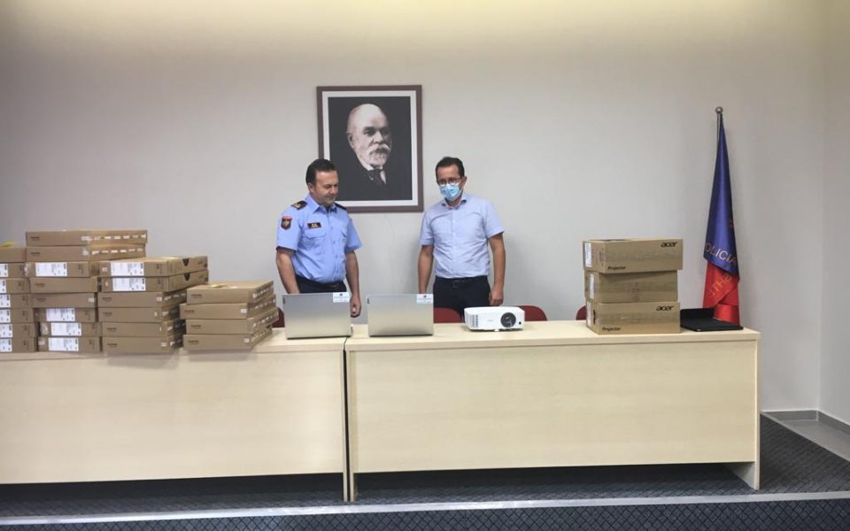

The Facebook Forum of Educators is a very important tool used to reflect their work and share experiences.

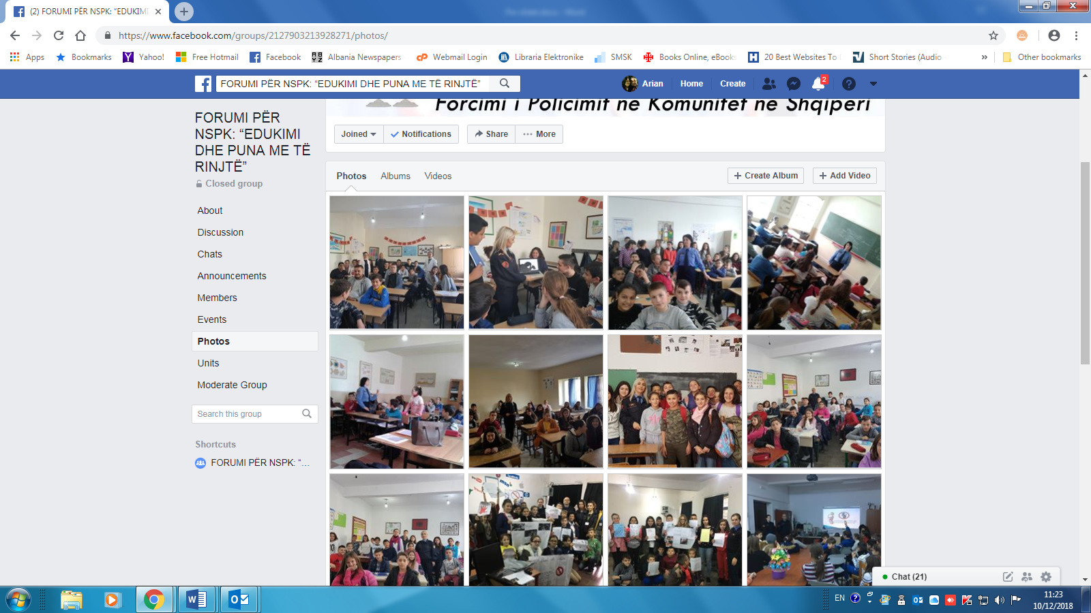

The program has also provided a minivan for the CP Sector in ASP HQ, which is adopted as a mobile office. It is being used by the sector to support the awareness raising activities in different cities of the country. This is a practice used in other countries and we expect to be a positive experience in Albania as well.

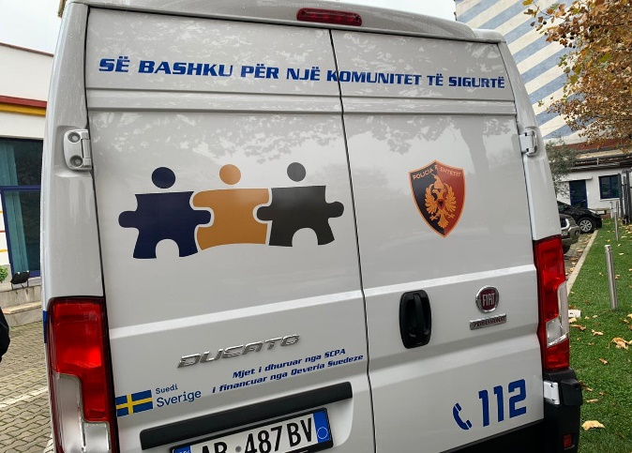 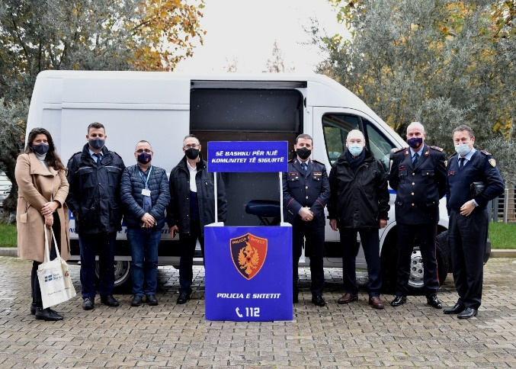

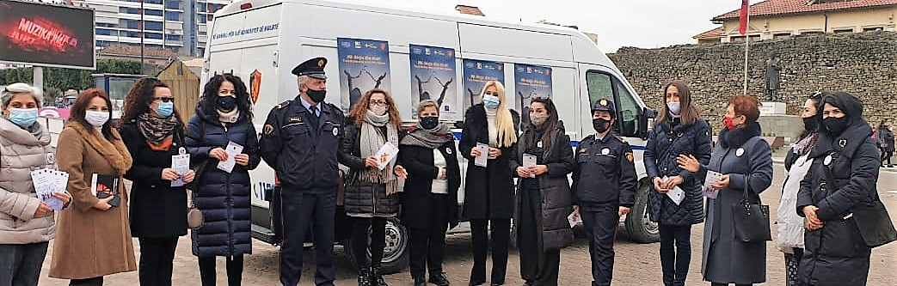

A special focus has been paid to the continuous improvement of the ASP service delivery to the citizens. Following the interventions from the first phase, to streamline business processes related to service delivery, a new software for business processes management was elaborated and is currently in a testing phase in Elbasan. It will allow for electronic management of most work processes, registration of different decision-making steps and the possibility to check the work performance of Reception Hall staff, but also the performance of staff involved in service delivery to the public. The “Reports” section of the software was developed to provide numerical and graphical representation of the work completed.

**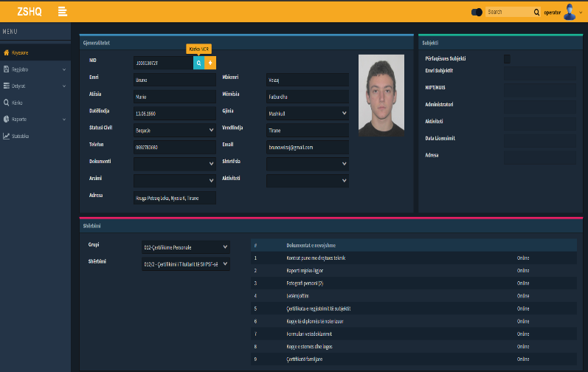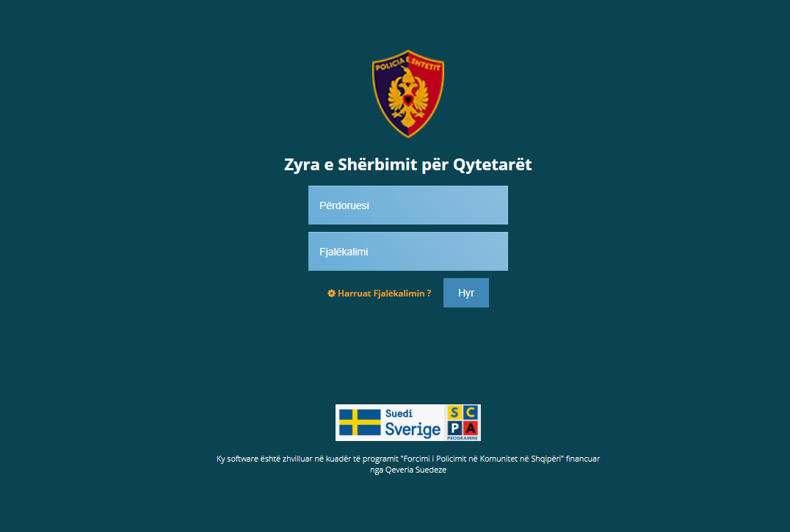**

**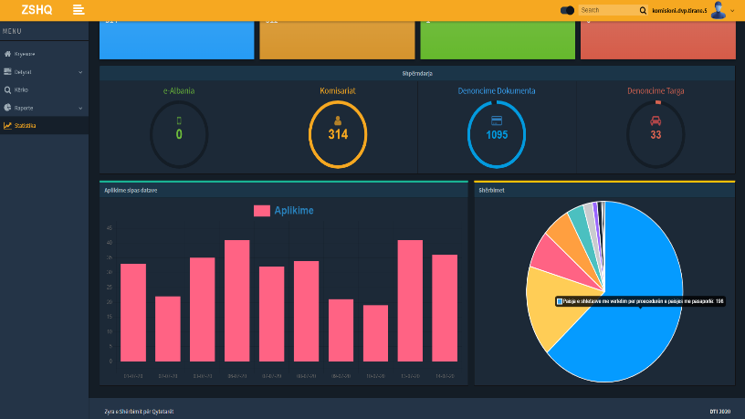**

## Pillar II – Strategic Management Support

The activities under this pillar focused on finalizing the new Public Safety Strategy 2021 – 2026 and the latest national survey on Police Satisfaction.

The experts supported the ASP to prepare the Community Policing Document 2018-2020 and also analyze the progress related to the Public Order Strategy 2015 – 2020. Recently, the Ministry of Interior requested the SCPA support in preparing the next Community Safety Strategy 2021- 2026. This was supposed to be a consultative process, albeit after the pandemic, it was transformed into desk work, combined with ZOOM meetings and consultations.

The project supported the work of the working group and the finalization of the strategy was possible in November – December 2020. The strategy was approved by the government in December 2020 and will guide the work of the police in this area for the upcoming period. The strategy has a special focus on community policing and many of the activities planed for the extension phase will implement objectives from the Strategy.

In November it was concluded the survey on the Public Police Satisfaction. Its results were shared with the stakeholders and police. The police used them to measure the performance since 2018 when the last survey was conducted. Some of the data will be used to measure the implementation of the Community Safety Strategy when the next survey will be carried out in 2022.

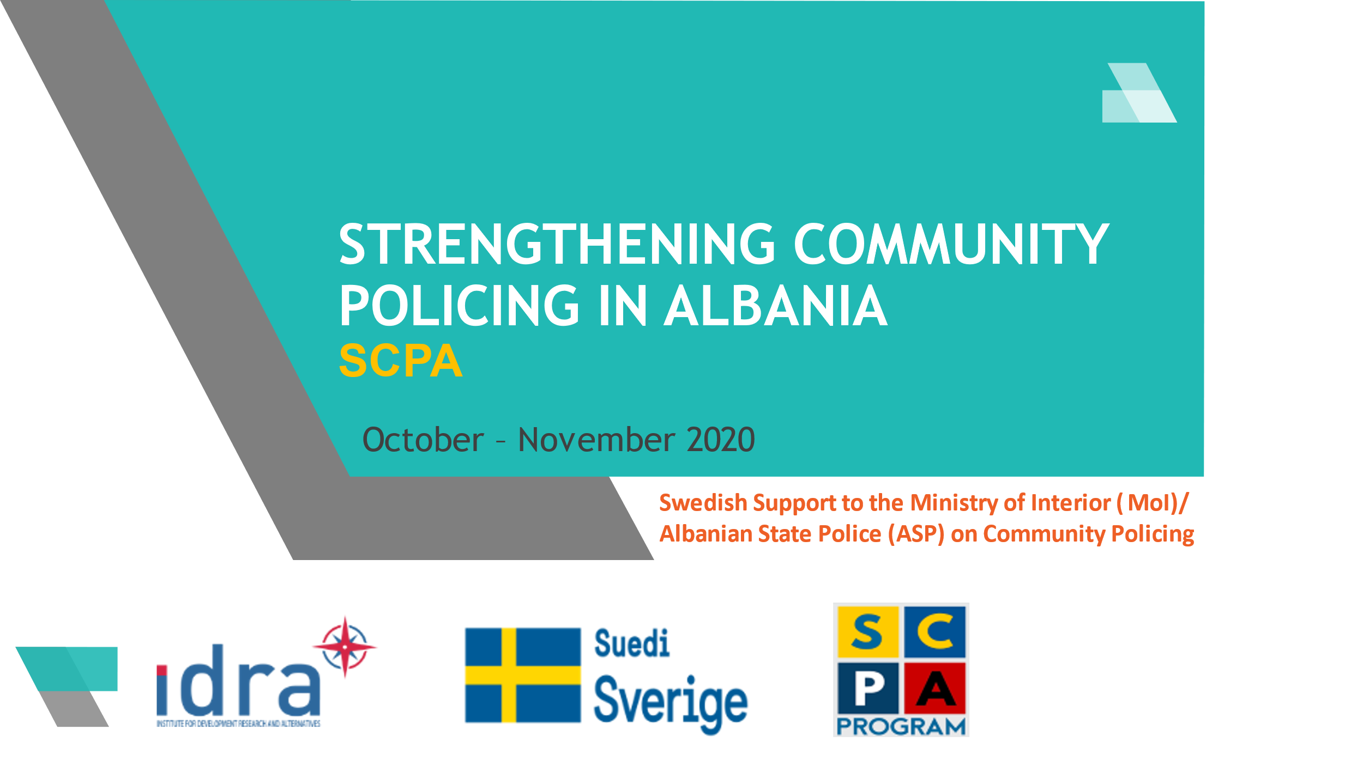 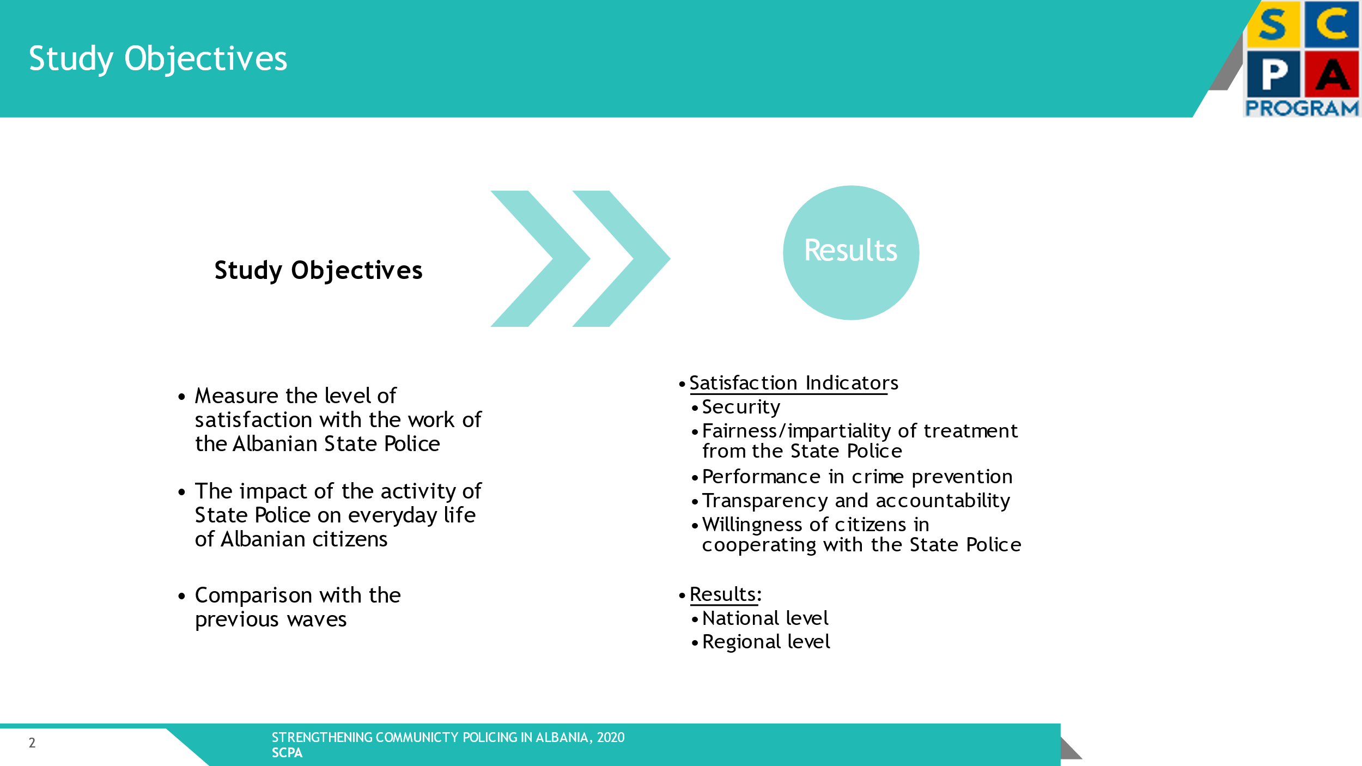

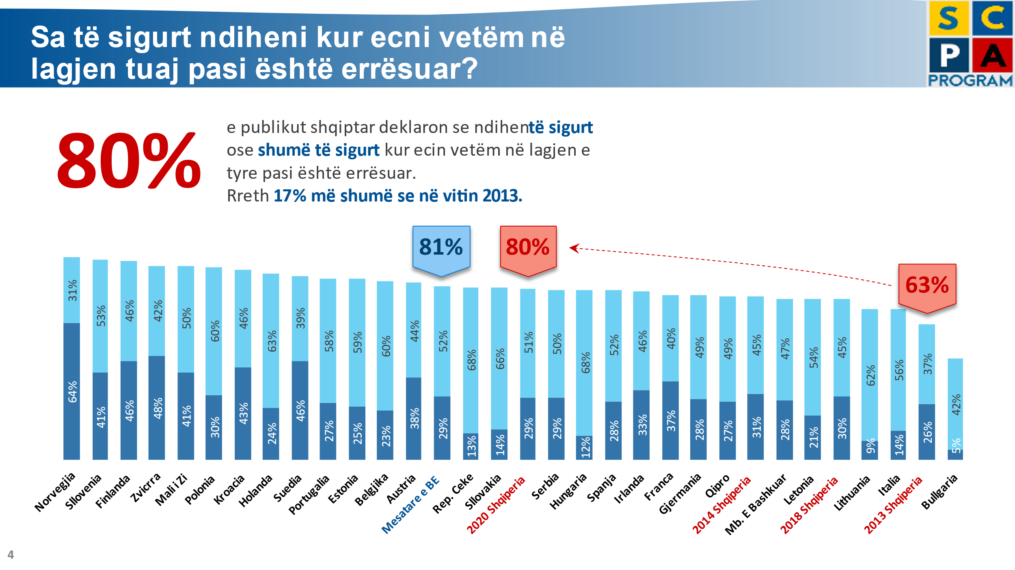

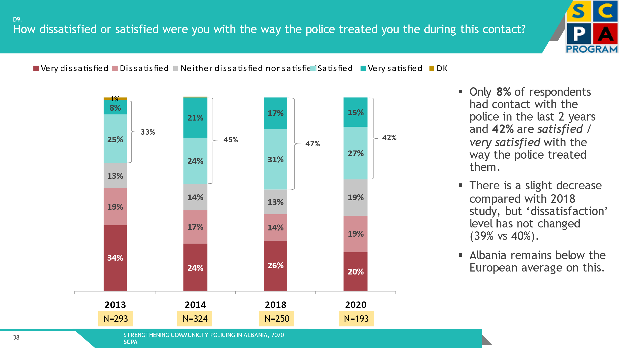

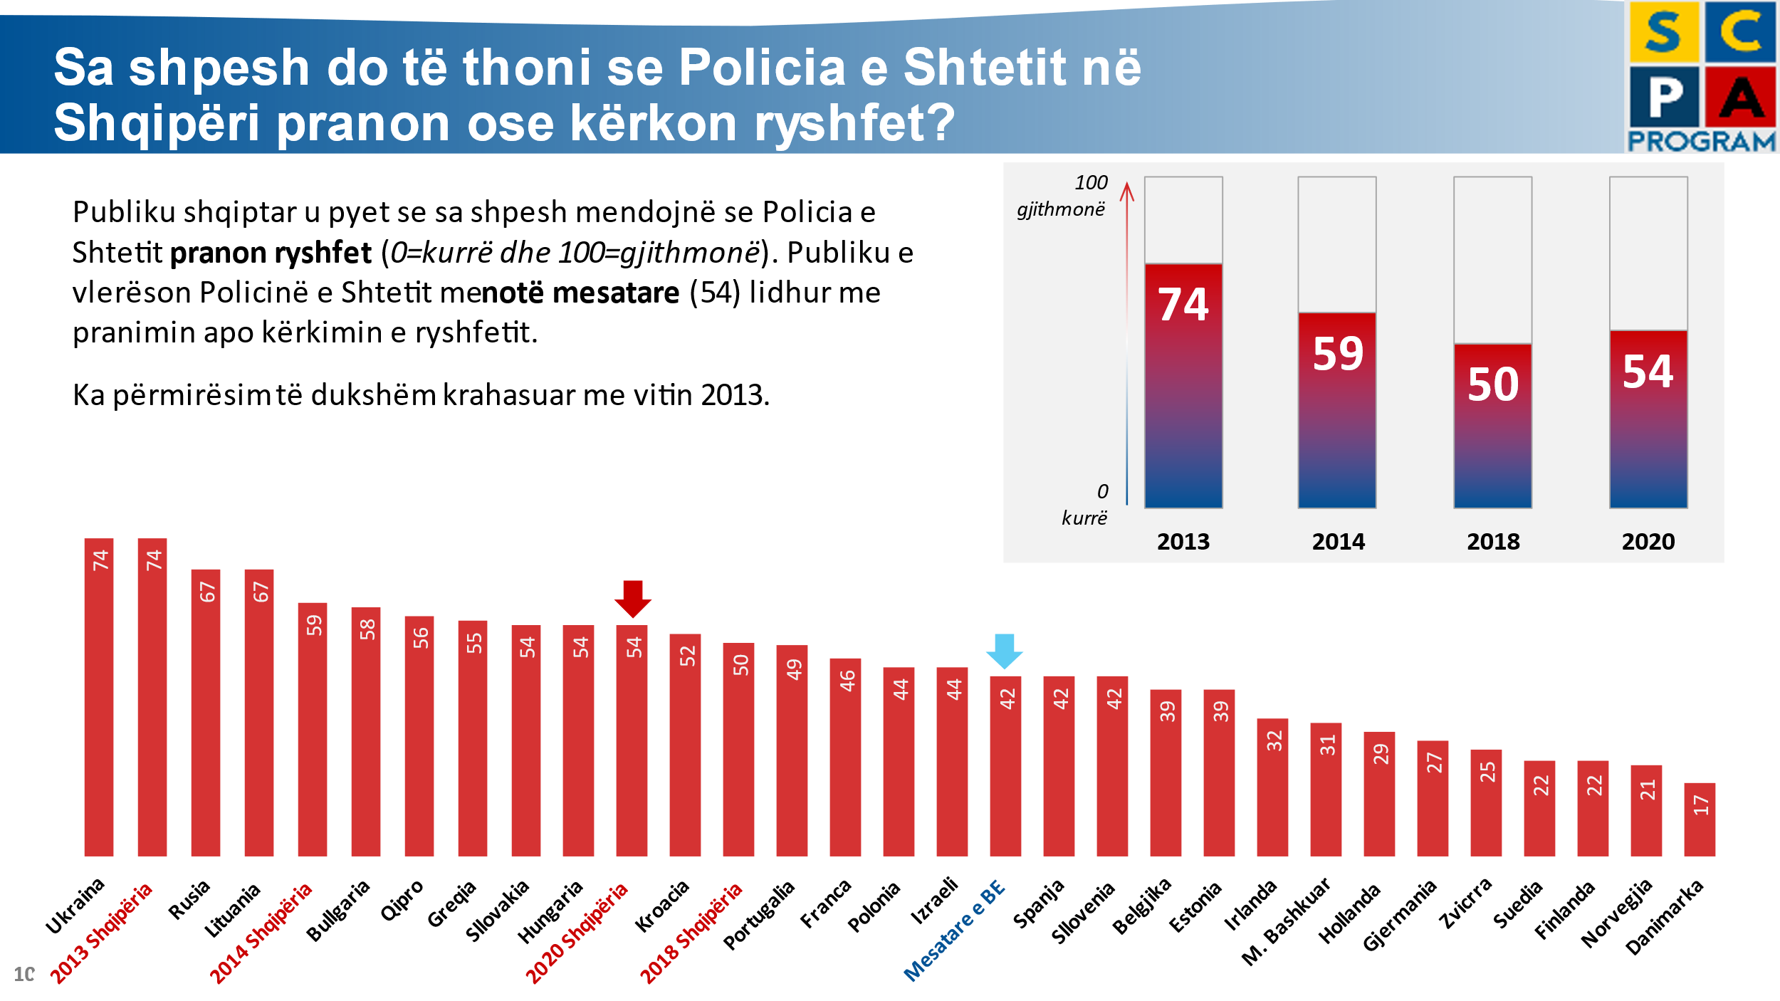

Other surveys of smaller scale have been organized by the grant scheme projects. The most notable surveyed the opinion of Tirana citizens regarding the role of the police in the municipality compared to the other regions from May 2018 to September 2020.

## Pillar III – Domestic Violence Support

Due to the covid-19 pandemic situation, the planned monitoring visits on the implementation of the provisions of the amended DV law and the risk assessment reports produced by police officers in the LPDs of Elbasan and Kukes, were postponed and rescheduled for the extension phase.

In the framework of the 16 days of activism against violence against women, a virtual campaign was carried out in cooperation with the ASP through the SCPA Program website and the police commissariats Facebook accounts. In addition, 300 face masks with counter violence logos were produced and distributed to the Tirana police officers.

In the same period, the construction of the house for the family of the martyred police officer, Shaqir Lleja in the village of Bushnesh was completed. Their house was damaged by the earthquake of November 2019 and via project funds it was possible to build a new house.

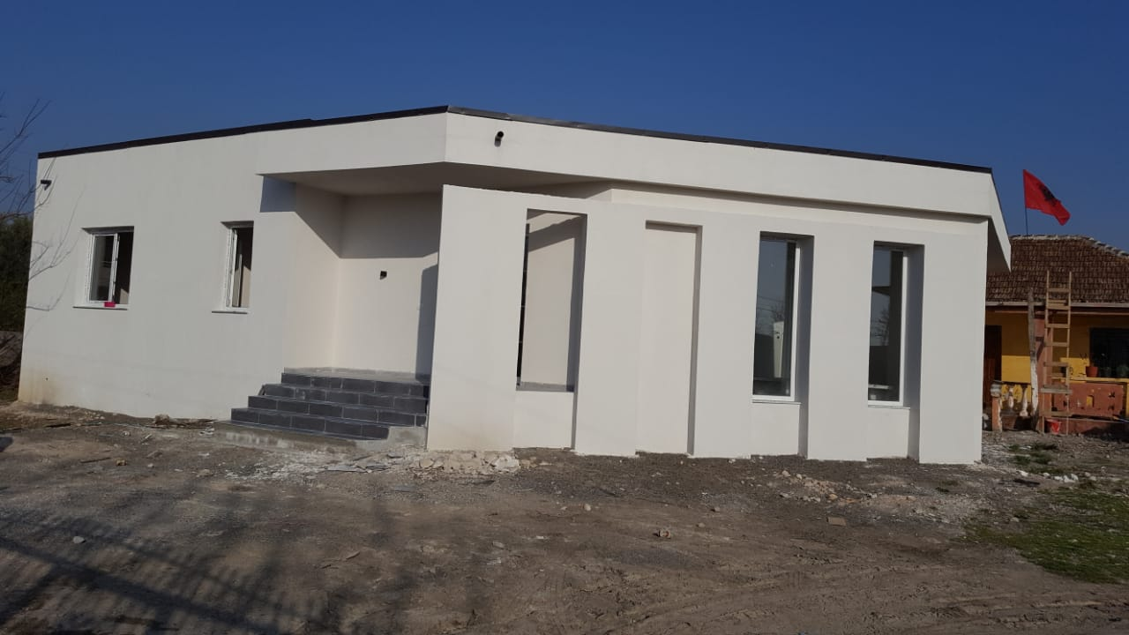

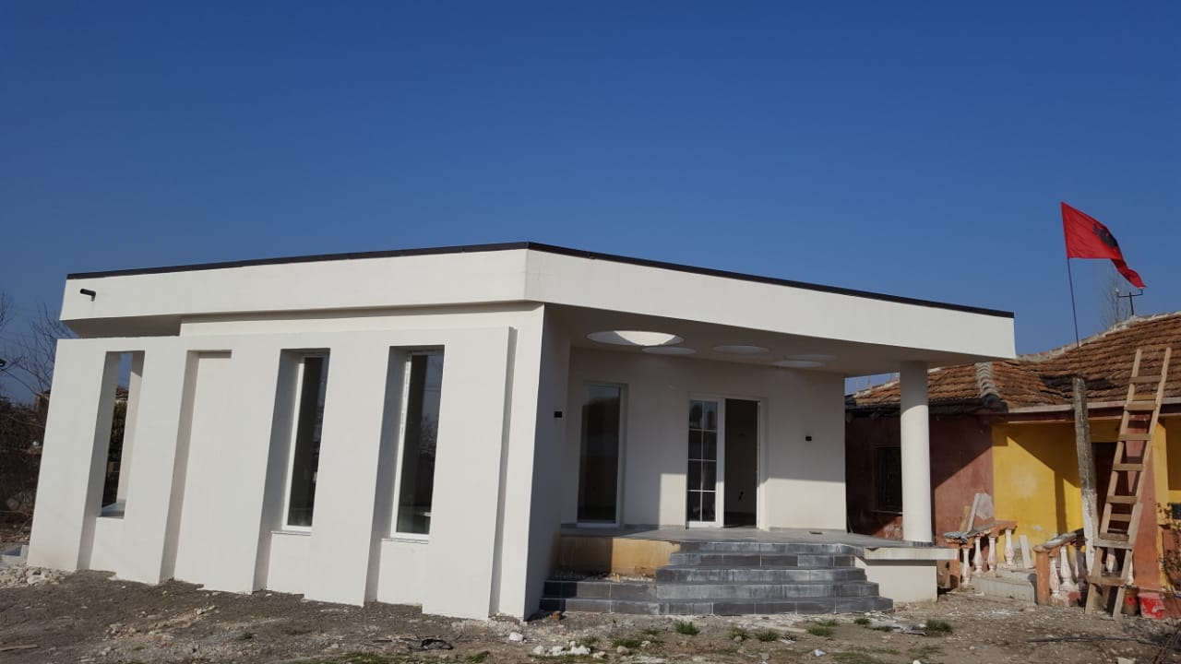

## Horizontal Activity - Grants Scheme

During the reporting period July – December 2020, the implementation of the projects of the round 4 continued. The focus of interventions of this round is mostly the establishment and consolidation of the Local Councils of Public Safety (LCPS) and the DV local referral mechanisms.

The thematic distribution of funds is as follows:

* 2 projects aiming at supporting efforts for DV awareness and establishing and consolidation the local referral mechanisms;
* 2 projects aiming at supporting the establishment and capacity building of four Local Councils of Public Safety;
* 6 projects aiming at consolidating partnerships between the ASP and local communities and schools.

It is to be mentioned that part of the activities of this round are carried out through Zoom platform and other online tools and in respect of the anti covid-19 measures and restrictions established by the government. The webinar training on online platforms and the individual coaching of the grantees organized and conducted at the beginning of this round resulted very useful.

Some of the activities implemented triggered a long lasting effect for the community and the institutions in that particular area. The establishment of Local Safety Councils in two municipalities (Berat and Kukes) created the bases for better coordination of local institutions in matters pertinent to public safety in the municipalities. It is premature to judge on future impacts and efficiency of these mechanisms. However, we are confident the grants started processes that local institutions will move forward.

The bond between police and NGOs is consolidated in local level, pools of common expertise are created and made available for both counterparts for future activities. Dedicated social media created over the projects’ lifespan are still functioning and the NGOs share threads and keep the followers activated.

Besides, the program did indeed create a general environment of cooperation between the participating NGOs in the designated district, whereby they were able to network some of their activities to support each other.

**Some of the highlighted outputs of the 4th round projects are:**

* Local Councils of Public Safety (LCPS) have been established and validated in two other municipalities with efforts and contribution of two NGOs, grantee of the 4th round of the Grant Scheme (Center for Youth Progress in Kukes and ACEG Center in Berat) and an Action Plan is drafted in each established LCPS.
* A permanent interlocutory group of citizens established in administrative units 9 and 10, Tirane, in regards of community safety issues.
* The setup of a pool of qualified young talents in informatics and cyber safety and the establishment of contacts between them and the ASP Section against Cyber Crime. The ASP can now use their services in need-to-be cases and the students agreed to provide their support.
* 1856 girls and women victims of domestic and gender-based violence are supported through 24 hrs psycho-social counselling service provided by “Counselling Line for Women and Girls” organisation.
* There have been 189 educational and preventive joint activities that NGOs have organized jointly with the police at the local level. Part of these activities are carried out through zoom platform and other online tools and respecting the anti covid-19 measures and restrictions established by the government:
  + There were 134 information and awareness sessions on community policing organized with students of 36 high and 9- years schools;
  + There were 13 training sessions and 14 round tables conducted with community policing officers, local stakeholders and peer educators;
  + There were 28 community meetings and public forums organized in the designated districts.

Further details can be found in the “Grants Scheme Monitoring Report-4th Round”, annexed to this report.

# Budget expenses

The total invoiced amount up until end of December 2020 amounts to 28 070 931 SEK, which corresponds to 94% of the total contract budget of 30 000 000 SEK.

The unspent funds amount to 1 929 069 SEK. This unspent amount was a direct consequence of activities that could not be implemented due to Covid 19 pandemic. In this amount it is added the repayment of VAT from the Albanian authorities. As agreed with the Swedish Embassy, this whole amount is added to the additional 12 Million SEK allocated for the extension phase so that the total budget for 2021 – 2022 sums up to 13 929 069 SEK.

# Annex I – Updated Logical Framework

|  | ***Intervention logic*** | ***Objectively verifiable indicators*** | ***Sources of information*** | ***Comments*** |
| --- | --- | --- | --- | --- |
| **Overall objective** | Contribute in building mutual trust and partnership between police and communities in order to create safer neighborhoods. | Safety situation in Albania positively assessed | * Ministry of Interior reports * ASP reports * Statistics * European Commission Progress Reports * Project reports | Based on PSS of May 2018 cc. 66% of Albanian citizens consider the ASP is doing a “good” or “very good” job.  80% of Albanian citizens declare they feel “safe” or “very safe” walking in their neighborhoods at night.  Only 60% of citizens are willing to call the police when they see a crime committed on the streets. |
| **Specific Objectives** | 1. Accountable, capable and responsive institutions providing community safety & security 2. Citizens play an active and positive role towards their personal & CSS | * Albanian agencies skills to address community safety issues enhanced * Increased citizens personal engagement and through CSO in safety and security issues | * Ministry of Interior reports * ASP reports * Statistics * Program reports | 655 CPOs trained by the program  40 Analysts  Workshop for 60 CPO-Youth Educators  Workshop for 171 School Security Officers and Psychologist  9 workshops for the managing staff and analysts 16 LCPS activated or established.  45 CSOs contracted to support safety initiatives in local communities.  Cross-Sector Strategy on Community Safety 2021-2025 and Work Plan approved |

| **Mandatory outputs** | | | | | |
| --- | --- | --- | --- | --- | --- |
|  | ***Areas of Intervention*** | ***Objectively verifiable indicators*** | ***Sources of information*** | ***Outputs August-December 2020*** | ***Overall outputs*** |
| **Pillar 1** | 1. Support the ASP in enhancing the efficiency of CP structure 2. Strengthening local partnership 3. Capacity building | * Thorough analysis of the TLPDs conducted. * Identification of the elements best fitting to Albanian context done. * Revised job description/job profile of the CPOs * Revised SOP presented * ASP HRM assisted to assess current CPOs against new job profile * CPO work in two TLPDs is coached, monitored and assessed * Material support provided to the selected CPOs of the TLPDs * Virtual Police established in the TLPDs * RH business processes enhanced and material support provided to RH of the TLPDs * LCPSs in the two TLPDs revitalised and established. * The police representatives in the LCPSs coached and sensitised on the police role in the forum * Training curricula for all police officers on the CP principle developed and modernised. Staff trained * CPOs curricula revised and enhanced; ToT training * RH staff trained; ToT training * Study Visits carried out | * Programme reports * ASP reports * Surveys * Statistics * Meetings * Minutes of Meetings * No. of staff trained | Continuous coaching on the consolidation of the changed in Elbasan LPD and preparation of the report  Workshop in Elbasan LPD on the updated RH software  Continuous coaching and monitoring on the use of the RH software  70 laptops and 40 video projectors distributed in all LPDs for the CPO educators and rural CPOs (Elbasan LPD)  Reconstruction of 7 rural offices of CPOs in LPD Elbasan  36 candidates for School Security Officers trained on the awareness campaigns  Monitoring visits and online coaching of the TLPD Elabasan on change management  Donation of the minivan for the CP sector of ASP HQ. It will be used for awareness raising events | The TWG started working on the assessment report recommendations  New CPO job description drafted Elements for CP fitting Albania case recommended.  15 job descriptions recommended for LPDs and Commissariat, including CPO position.  60 bikes and other firefighter equipment provided. Command and Control Room in Elbasan & Reception Hall and other premises in Has Commissariat and Librazhd commissariat renovated.  Command and Control Room of Kukes LPD co-financed with the local businesses.  Prevention Room for Kukes LPD reconstructed and refurbished  Reception Hall and detention premises of Tropoja reconstructed  Web constable established in TLPDs.  LCPS in Elbasan is active, while LCPSs in Has, Tropoja, Librazhd, Perrenjas, Gramsh, Patos, Kavaja, Peqin, Selenica and Vlora established.  Training curricula for CPOs drafted, ToT delivered and training provided to 55 officers. Coaching provided for Elbasan and Kukes LPDs.  Study visit in Slovenia and Croatia focused on CP practice organized in June 2018 and study visit to Germany organized in May 2019.  New job descriptions for CPOs and Patrol Officers compiled  Regulation on the Technical Working Group in charge of piloting the changes in Elbasan LPD established.  Kick off meeting with managerial staff on the changes held.  Online coaching on the changes in LPD Elbasan  Logistics need assessment for CPO rural offices in LDP EL conducted, Procurement of the laptops finalized.  The development of the RH software for business processes concluded and started the piloting and testing phase.  A review of the CP curricula at the Academy of Safety carried out. Future actions defined. |

|  |  |  |  |  |  |
| --- | --- | --- | --- | --- | --- |
| **Pillar 2** | 1. Strategic Planning and performance evaluation 2. Coordination between stakeholders 3. Communication | * Progress report and lessons learned on the Policy Document 2015-2017 conducted; New Policy Document 2018-2021 drafted * Capacities of the organization at all levels to effectively monitor and assess implementation of policy documents and action plans increased * An efficient monitoring system put in place * The two TLPDs supported to draft periodic progress reports and identification of bottlenecks * Capacities to externally monitor and evaluate the work of the police increased; national and local surveys conducted * LCPS used an efficient mechanism to address local issues * Partnerships with citizens and other local contributors increased * Integrated Communication Strategy of ASP implemented * National Awareness Campaigns of different topics carried out * LPD spokespersons trained and their job description/profile reviewed. * The PR/Communication curricula of the Academy of Security for initial and continuous training reviewed | * Documents, reports, interviews * Notes from TGPM * Assessment of Community Policing practice * Monitoring and Evaluation * Surveys * Statistics * ASP reports * Visibility materials | Technical Assistance of national and international experts in preparing the Cross-Sector Strategy on Community Safety for 2021-2022 and its Work Plan  The strategy was approved in December 2020  The results of Police Satisfaction Survey November 2020 were launched  The results were discussed with the managers of the MoI and ASP to feed into Strategy of 2021-2026  Three rounds of training of the spokespersons of TLPDs  Newsletters of TLPDs for Sep-Dec 2020 produced  First meeting of the LCPS in Berat  Kick-off meeting of the LCPS in Lezhe | CP Document 2018-2020 approved. Monitoring plan drafted.  Analysts and managers in 2 TLPDs trained (25 participants in 10 training days). Coaching delivered (20 coaching days). 16 analysts in other LPDs trained in 8 days modules.  Police Satisfaction Survey 2018 completed and results shared with stakeholders.  LSMS I & II for Elbasan and Kukes completed and results shared and discussed with stakeholders. Results of PSS presented in Elbasan LCPS and members invited to take measures.  12 LPDs spokespersons trained in 3 days training and coaching provided as follow up.  Newsletter for Elbasan and Kukes LPD produced and web constable launched.  Manual for the CPOs Educators prepared; 5 days training for 60 participants delivered. 3 awareness campaigns developed. Web Forum for Educators developed. Leaflets and booklets printed and distributed.  Workshop with managing directors of the LPDs  Workshops with analysts and managing staff of 8 LPDs.  A workshop for all the LPD directors organized  SOP for the new sector proposed by the program and approved by the ASP  Workshops with analysts and managing staff of Shkoder, Korca, Vlora, Fier, Elbasan, Kukes, Diber and Lezha LPDs  CPOs- Youth Educators participated in a workshop on the new themes and experience sharing  LSMS II for Elbasan and Kukes compiled and data to be shared in the upcoming period  Monitoring of the Educators Online Forum and advising them  A Draft Policies /Priorities and strategic objectives for the new Public Safety strategy 2021-2026 was produced  A draft report of key actions and measures taken during the old strategy 2015-2020 has been produced  Newsletter for Elbasan and Kukes LPD monthly produced  The Laç LCPS kick off meeting held.  152 School Security Officers and Psychologists trained on the awareness raising topics to be held at schools. 18 days of training in total |

|  |  |  |  |  |  |
| --- | --- | --- | --- | --- | --- |
| **Pillar 3** | 1. Strategic Level Interventions 2. Capacity Building and Strengthening 3. Infrastructure and Logistics support | * Report on Prevention Approach completed * Legal and by-legal framework on DV revised * SOPs on DV cases enhanced * Data collection system for the ASP, Prosecution Office and Courts established * Referral Mechanisms established and functional in TLPDs * Awareness campaigns in TLPDS against DV and gender based violence * Capacity Building Plan on DV elaborated * Training curricula and modules on GBV and DV upgraded * Refreshing training delivered in all LPDS on GBV and DV * Training for CPOs and CIDs delivered * The DV interviewing areas in the TLPDs commissariats restructured and reconstructed * Material support for the CPOs and CIDs in agreed commissariats provided. | * Project Reports and documentation; * UNDP, UN Women, OSCE reports ; * Ministry of Health reports; * MoJ and Prosecution Office Statistics. * Police reports/statistics; * Project Reports; * Assessment reports & Surveys; * Monitoring & Evaluation Plan; * UNDP & UN Women databases, maps and reports * The Ombudsman /Internal Control Service /M. of Health /M. Education and Sciences / Local Government reports | Information sessions with the pupils of high schools of Vora, Kamez and Kombinat on addressing DV and GBV  Training of the staff of the admin unit no. 8 on managing DV cases  Meetings with representatives of the administration units of Tirana on tackling and managing DV cases regarding economic support and shelter  Donation of 300 logged masks to the LPDs to be used during DV awareness days | Referral Mechanism established in Gramsh, Belsh and Kukes and continuous support provided.  DV Awareness Campaign implemented in November-Dec. 2017, 2018 and 2019.  Friendly interview room in Librazhd and Comm. 4 in Tirana completed.  Interview room created in Has.  The report on Prevention Approach finished and submitted Capacity development plan drafted  42 police officers of Kukes LPD trained on addressing DV cases and risk assessment.  Interview Unit for minors and DV victims in LPD Elbasan created (works + equipment) and staff trained  Consolidation of the DV Referral Mechanism in Belsh, Gramsh and Kukes through support  Awareness raising campaign during 16 days of activism against violence against women in 6 districts Vlore, Elbasan, Kukes, Lezhe and Pogradec.  Capacity development plan drafted  42 police officers of Kukes LPD trained on addressing DV cases and risk assessment.  Interview Unit for minors and DV victims in LPD Elbasan created (works + equipment) and staff trained  Referral mechanism established in Librazhd and reactivated in Peqin.72 CPOs and CIDs were trained on the legal amendments of the DV law and the risk assessment  Interview Unit for minors and DV victims in LPD Elbasan created (works + equipment) and staff trained |
| **Grants** | Empower civil society organizations to embrace and implement the CP philosophy and support to combat DV. | * Grants Scheme implemented as planned and scheduled | Grantees reports  Program Reports  Surveys  ASP reports | Fourth round 10 winners selected and contracted | 55 grants’ contracts signed, covering 10 regions in Albania  467,447 Euro contracted. |

# Annex 2 Risk Matrix

|  |  |  |  |  |
| --- | --- | --- | --- | --- |
|  | Risk Factor  (security, political, operational , financial, reputational) | Impact | Likelihood | Mitigation Strategy and Responsibilities |
|  | **High-level buy in** | | | |
| 1 | Overburdened national partners / lack of resilience   * Political unrest especially during the pre-election period * Excessive demands of national partners results in them losing interest or willingness to participate in program * Other demands results in low priority of community policing * National counterparts may not be able to operate at the speed desired of the PMT to design and set up specific activities within the program streams * Pressure by senior leadership to produce results within unreasonable timeframes (including pressure focusing on outputs, rather than outcomes) | Medium | High | * Pay attention to specific local deadlines or other demands * Use existing local systems and procedures (i.e. monitoring systems, rather than setting up parallel structures) * Sida/PMT to ensure that international community is communicating and cooperating with each other and ensure common interest and objectives in community policing * Capitalize on the demonstrated interest from senior MoI and ASP leadership in the program * PMT to ensure sensitization across senior MoI and ASP leadership of the program work plan and estimated timelines |
| 2 | Lack of, or unwillingness of, stakeholders to participate and cooperate   * Resistance or mistrust from communities and local government / decentralized institutions to cooperate with police * Partners within the regions do not feel they are part of a process | Low | High | * Ensure transparent processes and encourage local partners to actively participate * Support for partnership approaches can be developed with the relevant line ministries (advocacy and liaison) * Risk management matrix and development of mitigating strategies is carried out collectively by the SC * Capitalize on the excellent partnerships developed during the first phase of the program |
| 3 | Major reshuffle of key police personnel   * Key personnel are moved to other positions before progress can be institutionalized within the ASP or LPDs * Long term vacancies in key positions – The Chief of Sector for the CP Sector at the Headquarters is vacant since 8 months and staff is overburdened with tasks | Medium | High | * PMT to monitor personnel shifts and timely reporting to SC * Explicit approach by the SCPA to strengthen institutional capacity not just focus on individuals |
| 4 | Lessons and progress made as a result of the program are not recognized by decision-makers and do not inform future policy development   * The SCPA seeks to develop institutionalized behavioral change. The gains of the program will not be sustainable if the changes remain solely at the individual level and do not influence policy changes that support cultural shifts in the way of working | High | High | * Sensitization activities on key lessons to be incorporated into the PMT program monitoring process * M&E program stream to include creating or developing mechanisms to ensure that the lessons are fed into MoI/ASP policy making bodies * The SMS Coordination stream will encourage cross-departmental cooperation and cohesion * PMT to be prepared to provide summaries of key lessons and changes to the MoI if/when a process to develop an MoI policy on safety and security commences |
| 5 | Program loses coherence   * Pressure by the MoI/ASP to provide support to ad hoc activities outside the planned design * Program impact becomes diluted / program loses focus as a result of reacting to new/additional requests for individual activities from the MoI/ASP | Medium | Medium | * SC consent to be required, in addition to Sida’s, for any substantial deviations or requests for new assistance * Requests should be accompanied by clear analysis of how the new request contributes to achieving the program’s direct outcomes * PMT to ensure that requests for new activities are included in the preparatory documents for the SC |
|  | **Program processes** | | | |
| 6 | Corruption or allegations of corruption in program (particularly relevant for the Grants Scheme)   * Misuse of funds and poor accounting * Favoritism of particular groups for projects | High | Low | * The SCPA shall continue the excellent transparent practices for their GS * Emphasis on transparency throughout program * Clear and transparent selection procedure for all projects * Allegations of corruption to be followed up immediately by the PMT and the Embassy/ the SC informed |
| 7 | Experts are not of a sufficiently high quality   * PMT staff members do not have the capacities to deliver the required quality of work * Short-term experts do not provide work of a sufficient quality / relevance to the Albanian context | High | Medium | * FCG / the Embassy / ASP / MoI quality control of program’s outputs * Use of the monitoring mechanism to track performance and follow up with feedback from the beneficiaries on expert performance * Clear terms of reference and expected deliverables to be developed for short-term experts etc. |
|  | **Sustainability** | | | |
| 8 | ASP and MoI do not follow the recommendations regarding budget allocations and staff reshuffle after TLPDs piloting   * Diversion of ASP funds to the TLPDs in order to ensure their short-term success * Diversion of ASP funds away from the TRPDs because they are covered by the program * ASP/ MoI do not systematically provide support to TLPDs | Medium | Medium | * Relative allocation of funding to ASP LPDs (including the TLPDs) to be monitored as part of the PMT monitoring mechanism * Concerns to be raised to the SC * Clear and transparent selection criteria for the TRPDs * Sensitization process across the ASP on the program – especially regarding progress being made, lessons learned, and dissemination and replication activities |
| 9 | Lack of responsiveness to adapt proposed models to Albanian specific situation   * Models provided by PMT for Pillar I do not fit with specific conditions | Medium | Low | * PMT will not design a “model” for the community policing in Albania, but will provide different elements of a model * The elements will be illustrated by international examples and provided with their “pros” and “cons”, aiming to develop an Albanian model. |
| 10 | Shift in international engagement   * International development programs fail to achieve stated aims and objectives in areas linked to the SCPA * Sida project overlaps or competes with other international project/demands and overburdens local partners | Medium | Medium | * Key international community (IC) actors have been informed/consulted throughout the design process * PMT to map out what key deliverables from other programs will influence their activities * Program proposal and future program activity documents to be shared widely with DDPFFA and the IC |
| 11 | Albanian authorities do not start to take on elements of budgetary responsibility   * Whilst the SCPA will absorb the costs for monitoring activities in the early stages of the program (e.g. citizen perception surveys) these will need to be taken on by the MoI/ASP progressively as the program unfolds * Any budgetary impacts for new procedures for the LPDs will also need to be incorporated into MoI/ASP budget planning | Medium | High | * Exit strategy contains clear mechanisms for the GoA to adopt gradually increasing funding responsibilities throughout the program – framework to be developed during the inception phase and built up over years 1 and 2 * Constant monitoring |
| 12 | Transfer of procedures, skills and expertise to other LPDs is not done in a sustainable way   * Pressure to replicate TLPD processes and approaches to other LPDs before they have been monitored, evaluated and proven * Lessons and new/updated ways of working are never transferred | Low | Medium | * Role of the IPA in advising on time lines * SC consensus on large scale replication activities * Continuous monitoring on progress and development of when aspects will be disseminated * Selection for LPDs based on international good practice * Individual risk analysis / mitigating strategies to be developed for specific dissemination/replication activities |
|  | **Force majeure** |  |  |  |
| 13 | Covid 19 pandemic conditions implementation of activities | High | high | * Continuous monitoring of the situation * Adopting a flexible approach in adapting the activities to the new conditions |

# Annex 3 - Participants/beneficiaries in SCPA activities

Since the Emergency Situation was declared in Albania PMT made sure that rules and strict recommendations were observed in project events and activities.

Despite the unusual Covid-19 pandemic situation, PMT made all efforts to adopt a new strategy of implementing the planned activities and adjust its methods towards a better practical way of working. Doing so, PMT managed to maintain a good pace of implementing activities in accordance with the work plan and reassess on best ways how to proceed with implementation of activities.

By redesigning the work plan, where possible, SCPA encouraged beneficiaries and main stakeholders to participate in its activities when mass activities were in question. PMT managed to establish a base for sustained self-development efforts by involving participants in that approach.

Increasing participation in program’s activities has always been considered by the SCPA as a useful tool in enhancing the effectiveness, efficiency and coverage of project benefits. SCPA has a specific objective to help create new or strengthen existing self-formed and self-run groups and organizations through which local bodies gain access to various resources, inputs and services and participate actively in the project activities.

SCPA program has closely monitored participation and number of beneficiaries in program’s activities as a whole. Below is a brief description of activities managed by PMT:

During this reporting period PMT achieved organizing in total **114** activities; **75** were regular meetings with the MOI, ASP HQ, LPDs, Academy of Security, Local government and other stakeholder representatives. Unfortunately, PMT could not organize regular PSC meeting and JWG meeting due to restrictions of COVID-19 social distancing and protection protocol.

On the other hand, PMT managed to organize 4trainings/workshops that involved spokespersons of TLPD Kukes and Elbasan, working staff of Reception hall of Elbasan commissariat, and 36 Candidates for Security officers. 1 workshop on community policing with the staff of academy of security in relation to analyzing and improving the Curricula on CP and urgent police operations

Training/workshop sessions took place in Tirana and Elbasan. During this reporting period all training sessions were developed under strict protection measures against Covid -19. The PMT experts have taken an active part in supporting drafting the new Public Order Strategy. For that reason, they have participated in 2online meetings chaired by the Vice Minister of Interior and have organized 3 technical group meetings in the SCPA premises.

During this reporting period, PMT also organized 4 Technical Work group meetings for drafting the Strategy on Public Safety -2021-26., 6 direct meetings and 5 online ones with commissariats of Elbasan TLPD

PMT also organized 8 field visits in the area of TLPD Elbasan, out of which 3 were dedicated visits regarding monitoring of the situation of CPO offices and 1 field visit in TLPD Kukes in order to monitor the progress of the infrastructure support project in that area.

Regarding the DV Pillar of the program, 3 activities were organized. 4 activities aimed at either establishing or running existing DV referral mechanism committees in Tirana, Kukes and Berat.

Within the grant scheme component PMT has also been active in organizing online training with almost 10 NGOs. 4 LCPS meetings have taken place, as well

Conveyed in figures, activities involved a total of **1947** persons out of which **159** were ASP personnel, **17** were senior ASP police officers, **16** midlevel police officers and **126** police officers who took active part in the activities. The Grant scheme activities were kept a high level both in terms of number of activities and participants.

PMT has emphasized the importance of a good gender balance in all three component areas. Gender indicators were assessed in all of the activities, meetings, workshops, seminars and trainings. Exclusively, the PMT guided the activities of the Grants Scheme towards the establishment of gender indicators, including an understanding of how contacts between the police and young citizens might differ (pending not only on gender but also on ethnicity and geographical extent). Also, PMT noted a rather good gender balance especially for the LPDs of Tirana, Kukes and Berat

Over all, the PMT assessed that:42.5 % or **1022** out of **1947** direct community beneficiaries were girls and young women; 45 % of the members in the implementing/core working groups of projects were/are women; 31 % of 159 police officers that have benefited from the activities were women police officers.

**Program’s visibility and outreach with the public**

During this reporting period the PMT succeeded in increasing the visibility of each component. PMT applied several ways and means to expose the program. Some of the effective ways to increase the program’s visibility were the following:

* The online forum of CPOs – Youth Educators and the forum for Security Officers in schools were a proven efficient tool to engage not only the assigned CPOs for education and work with youth but also ASP HQ and Academy of Security experts in exchanging experience with each other but also creating a network of CPOs and Security officers. Almost all the trainees have now joined the forum. They have been very active to display their activities (over 958 photos uploaded) and have maintained regular communication, exchange of experience and work plans. The upcoming school year will show how this forum works and to what degree and quality the experience exchanging will develop.
* Meetings with community-based organizations and other stakeholders in the framework of LCPS, and Grant scheme activities. These meetings were considered as an important way to expose the program’s objectives and philosophy but also as a base for establishing networks in order to cultivate long-term relationships.
* Workshops and training sessions were used successfully as an already proven networking facility.
* The program’s web page, which is user-friendly, accessible and provides open, consistent and searchable information about all programs. The activity on the program’s web page has increased substantially. During the past six months the web page was visited by 15.622 viewers. The Program’s social network accounts in Facebook, Google LinkedIn, and Twitter have also been quite active. The web page has been very helpful, especially in relation to the GS

PMT has continued the appreciated practice of producing and distributing a short excerpt of activities, summarized in the Monthly Newsletter of the Program. The Newsletter is distributed to almost 300 receivers, including ASP counterparts, international partner organizations, NGOs and other Program’s stakeholders.